Updates to Payroll Forms:
Please see the below updates (2) to Payroll Forms:

I-9 Updates

The I-9 DocuSign form has been updated in accordance with the revised federal forms. Please note the following changes:

On the I-9 screen three additional questions have been added as required fields:

- Question: How Many Additional Preparer/Translators?
If selected additional preparers/translators will complete a section on the I-9.

- Question: Is this a Reverification or Rehire?
If selected, the recertification/rehire fields on the I-9 via DocuSign become a required
field. The revised I-9 moved the recertification/rehire information to a supplemental section of the form.

- Question: In-Person Signing at UMBC?
With the prior approval of HRSTM Payroll Management preparers may virtually examine
employment authorization documents, instead of reviewing documents in person. If
selected the additional information section in Section 2 becomes a required field. Payroll
Preparers should document in this field what documents were virtually examined and that it was done via two-way video (i.e. WebEx, Google Meet, Zoom, etc.)

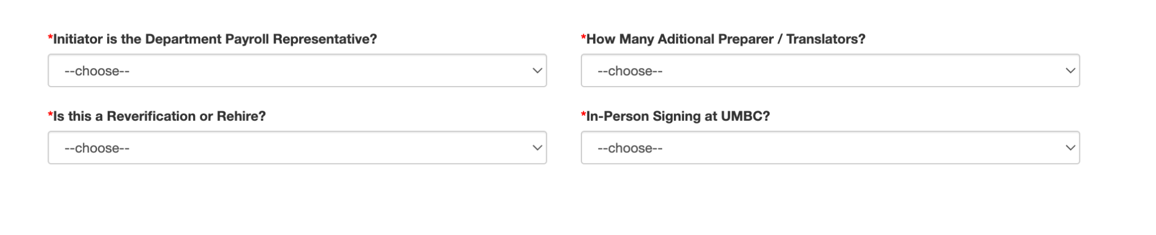

Updates to CI Contract Forms

When background checks are required the signature/acknowledgement of the Authorized Program Authority must now be included on the form. This signature/acknowledgement verifies that the CI has cleared the background check process.

