Dear UMBC Adjunct Faculty,

Whether you’ve been here 20+ years or have just finished your first semester at UMBC, on behalf of the Adjunct Faculty Advisory Committee (AFAC) and the University administration, thank you. You all provide a valuable service to our students and the university as a whole. Your efforts are truly appreciated.

I’d like to share The Chair’s Report (last two pages) that I presented last week at AFAC’s meeting with Senior Administration. The committee and I felt it was important to keep all of you abreast of our work and the issues that we are working on. If you know of an issue that is not on this report, and that you think we should address, please let us know.

I’d like to highlight some of the things we are working on:

Working with the Faculty/Staff Advisory Group addressing campus issues and policy around Title IX, and the proposed changes from Department of Education to that policy.

The Adjunct Visibility Campaign which will directly affect you. This campaign’s primary goal is to build better awareness of adjuncts to the broader campus community. As we will be featuring adjuncts as a part of that campaign, let me use this opportunity as a first request for volunteers who are willing to share their story.

The Best Practices document continues to grow. It looks at how every department treats adjuncts and takes the best practices from that research to help guide Deans and Department Chairs in how they manage their adjunct staff.

And coming in fall 2019, we are planning a UMBC Adjunct Faculty Conference. This will be an opportunity for all of us to learn through academically focused workshops, socialize and strengthen our adjunct community.

Finally, as a part of our mission is shared governance, we are working towards to better adjunct representation on two important elements of that governance, the University Steering Committee and The Faculty Senate.

Please don’t hesitate to contact any of our committee members if you have any questions or issues that you feel we need to address. We are here to represent you and your needs.

Thank you again for all that you do and see you in 2019. Hope you all a joyous and happy holiday season.
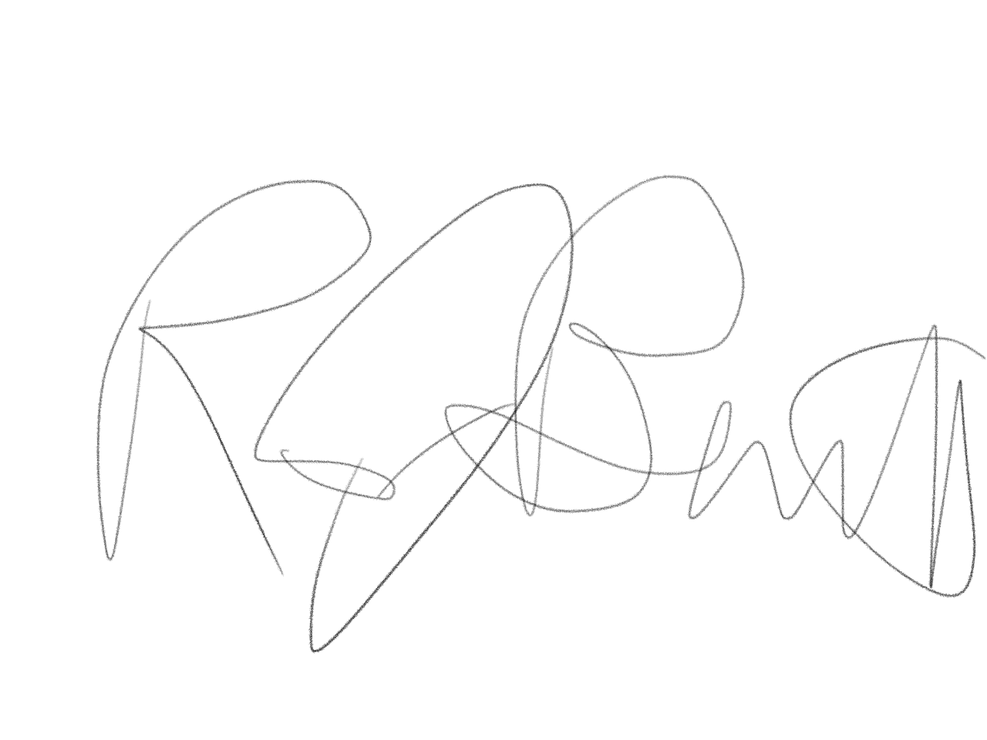

Best regards,

Rob Bennett, MA
Chair, AFAC

The Chair’s Report (Fall 2018)

AFAC work ongoing or accomplished:

- Updated AFAC by-laws to allow better operation of Chair position (1 yr. to 2 yr. position)
- AFAC adjunct awards 2018 (one given Fall, promoting better in Spring 2019)
- Continued work on Best Practices (Maggie has been heading this up)
- Semester gathering with adjunct faculty (November 30)
- Held two Unemployment Workshops for Adjuncts (will repeat in Spring)
- AFAC survey of adjunct stipends by department (have CAHSS, COEIT and CNMS expected early 2019)
- Semester meetings held with deans/program heads
- AFAC participation in faculty orientation
- AFAC presentation to University Steering Committee (USC), Fall 2018
- Met with Chair of USC and Chair of Faculty Senate, Faculty Affairs Committee to discuss more communication between AFAC and the FS and USC in terms of adjunct concerns and how best to address those.
- Meeting with Senate President on 12/18 to do the same
- Attended/Joined the Faculty Staff Advisory Group (Title IX)
- Met with OIA (Roland King/Dusten Wolff) beginning work of adjunct visibility campaign

AFAC work proposed/goals:

- AFAC gaining a seat at the table with USC and FS
- AFAC developing a UMBC Adjunct Conference for Fall 2019 (Sandra and Paul)
- Moving long-term adjuncts to PT employee from contractor
a. Minimum of ADJ II to qualify?
b. Benefits seem to outweigh the costs
c. Needs further study/analysis
- Eligibility for retirement for adjuncts (something UMD-CP has in place)
- Looking for more complete data on adjunct longevity at UMBC
- Getting list of current adjunct faculty sooner each semester?
- Emeritus status for retiring adjuncts

2018-2019 AFAC members:

CAHSS
Robert Bennett, Chair (English) bennerob@umbc.edu;
Margie Burns, (English) mburns@umbc.edu;
Sandra Dawson (History) dawsons@umbc.edu;
Maggie Grieves Knisley (Sociology) megknisley@umbc.edu

CNMS
Bonnie Kegan (Mathematics); bkegan1@umbc.edu;
William Slowikowski (Mathematics); slowikow@umbc.edu

COEIT
Paul Comitz (IS); pcomitz@umbc.edu
Jon Squire (CSEE); squire@csee.umbc.edu

NON-COLLEGE AFFILIATED
Norman Prentiss (IS); prentiss@umbc.edu

