Art 498 Internship & Employment Application & Agreement
Center for Art, Design and Visual Culture, UMBC

Art 498 Internship (1 - 6 credits, variable, repeatable to 12, letter grading)

The 498 Internship provides a student with practical and professional skills related to the fields of Contemporary Art and Museum Studies. The internship requires permission of the instructor and is to be undertaken with the consent of the student’s Visual Arts faculty advisor. It is strongly recommended that students work closely with a staff member of the Center for Art, Design and Visual Culture in structuring their workload and areas of interest.

If a student works eight (8) hrs/wk (or a total of 120 hours) that student is eligible to enroll for three 3 credits; 16 hours per week (or 240 hours) equals six (6) credits. Only in justifiable situations will 12 credits be awarded for the same internship. Repeating Art 498 allows the student to experience different professional environments. Visual Arts Majors who are concentrating in Design and who have not taken ART 334 are ineligible to receive credit for this internship. Visual Arts majors are not able to receive credit for this internship before they are juniors. Other majors should check their departments’ rules regarding the allowance of internship credits or internships as electives.

Semester & Year for Proposed Internship: PLEASE FILL OUT THIS PAGE ONLY
BEFORE YOUR INTERVIEW.
Name: FORMTEXT _______________

Address: _____________________________________________

Phone: ______________________________

Email: ______________________________

Expected Graduation Date: _______________

Class Standing at Start of Internship (Frsh/Soph/Jr/Sr): Major: Emphasis:

Second Major: Minor:

Is student enrolled in PRAC 098 with the Shriver Center? Yes No
CADVC requires that students seek recognition from the Career Center for their internship on their transcripts by enrolling in PRAC 098. Students should consult the Career Center website for full details, and then contact specified Career Center staff for an interview and paperwork. Be advised: early deadlines apply!

Has student enrolled in Art 498 Internship previously? Yes No
If Yes: Previous credits earned:
Semester & Year:
Visual Arts Advisor Name:
Use the back of this form or an additional page if you need to add more than one internship.

Internship Partnership
This section only applies when there are institutional partnerships/supervisors involved, such as K-12 schools/teachers.

Agency or Company: _____________________________________________

Address: _____________________________________________

Supervisor: ______________________________

Phone: ______________________________

Email: ______________________________

Schedule: (3 credits = 8 hrs/wk, 6 credits – 16 hrs/wk) Use a separate sheet if necessary.

Your full, anticipated availability, to the best of your knowledge at this point:
Days: _______________ Hours: _______________

Learning Objectives:

1. Special (porfolio-worthy) project based on intern's mutual interest and gallery's needs. List deadlines, basic expectations/specs, provide examples/samples if possible.
_______________________________________________________________________________________________

_______________________________________________________________________________________________

_______________________________________________________________________________________________

_______________________________________________________________________________________________

2. List possible additional duties expected as needed in the gallery and offices or elsewhere, and a basic percentage of time expected for each. Please note any special transportation needs, expenses to intern, required supplies and/or special attire.
_______________________________________________________________________________________________

_______________________________________________________________________________________________

_______________________________________________________________________________________________

_______________________________________________________________________________________________

3. List report and leave times expected on a regular basis. Also include any special events outside the regular hours, such as openings that are expected or recommended for the intern's experience.

_______________________________________________________________________________________________

Hours per week: __ Total hours: ___ hours by last day of classes for semester

Requirements

- Satisfactory completion of all assignments and duties on schedule as explained within this document
- Attendance at all official CADCV events, such as exhibition opening, lectures, screenings—exceptions only for those with scheduled class conflicts. PLEASE MARK YOUR CALENDAR WITH KNOWN DATES FOR THESE NOW!
- Regular logging and reporting of weekly hours on gallery timesheets
- Satisfactory completion of all required hours per registered credits as explained on page one of this document
- Satisfactory and timely mid-term reviews and exit interviews, which are the responsibility of the intern to schedule

Process for evaluation:
The process for evaluation begins with the intern's self-evaluation at both midterm and end of term. See evaluation guidelines for this on the following page. The intern’s self-evaluation and a revised CV (now including the finished internship at CADVC) are due to the supervisor at the exit interview.

It is the intern’s responsibility to make an appointment with the supervisor for the exit interview within four days of the last day of internship. At the exit interview, the intern will receive feedback on the her/his revised CV an on her/his general performance. The intern will then be given a grade for the course.

STUDENT SIGNATURE: ________________________ DATE: _________
(Faculty) ADVISOR SIGNATURE: _________________________ DATE: _________
ON-SITE SUPERVISOR SIGNATURE IF NOT CADVC: _________________________ DATE: _________
(CADVC) SUPERVISOR SIGNATURE: _________________________ DATE: _________

(Student must provide final, signed copies to all three parties. CADVC retains original.)
Self Evaluations, Supervisor Assessments, and Recommendations
Why spend time doing a thoughtful evaluation? Because you will be participating in your grade!
Grading Policy: The internship coordinator or supervisor will determine the student’s final grade. The grade will be based on a qualitative assessment of the student’s performance, taking into account the student’s self evaluation, the student’s supervisor’s assessment, and any other assignments or documents that are available. It is your responsibility to schedule an appointment the internship coordinator /supervisor during final exam week for a closing interview. At this time the student will receive their grade and oral feedback, and/or the student may submit a draft of and request for their statement of support at this time.
To receive academic credit, each student must submit a self-evaluation. This report should be about 500-to 1000 words. It is due on or before 5pm of the last day of regular classes in the fall or spring semester.
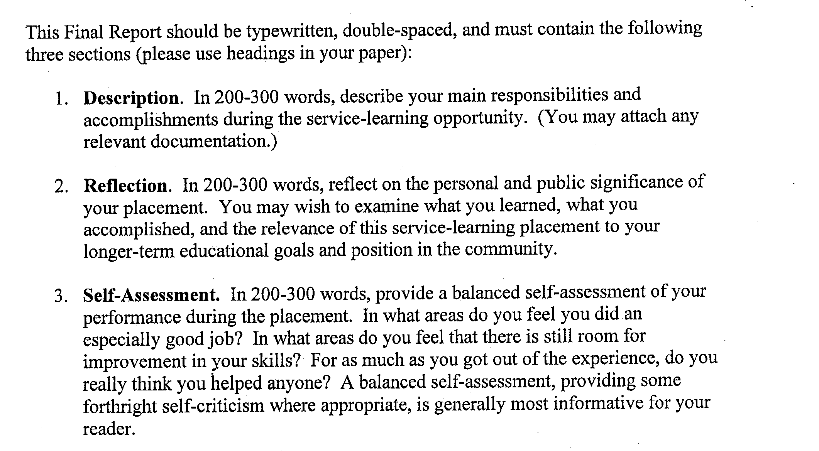
Need help getting started on your internship evaluation? Try to complete these sentences, and then organize them into paragraph/essay form. Some questions are specific to those placed with schools in CADVC’s K-12 Ed Outreach Program.
What I valued most about this internship was… _________________________.
The hardest thing to do was… _______________________________________.
I felt _______________________________ was unresolved because ___________________________________.
It would have been a better program if I ______________.
It would have been a better program if my CADVC supervisor or the CADVC had _____________.
It would have been a better program if the teacher or the school (for interns involved in ed outreach program) had ___________________________.
The thing I found particularly useful in preparing me for teaching or doing ________________ on my own was _______________________.
The thing I found least useful in preparing me for ________ on my own was… _________________________.
If teaching is a goal, I might be interested to try teaching (subject) _(grade level)_ in the future because ___.
If no you have no further interest in teaching, explain if there was something that this experience offered that helped you to make that decision. ___________________________________________________________
Name five essential qualities of a good teacher.
Recommendations
Recommendations are typically given for internships in the months and years immediately following the internship. Recommendations may be either verbal (over the phone references for employment, for example), written (formal letters, or forms), or through on-line submissions. Increasingly graduate schools and granting institutions are using on-line recommendation formats, and they typically include filling out a form and/or an opportunity to upload a document of support.
Interns are encouraged to seek a “Statement of Support” immediately upon the close of the internship, directly from the internship supervisor. The idea behind this statement is that it functions as documentation and assessment appropriate for several uses: future employment, contractual reference, or as a letter of endorsement for future grant applications and/or for applications for admission to graduate schools. The reason you should obtain the letter immediately upon the close of the internship, is obviously so that the coordinator/supervisor can make a better statement about your contribution while memory is fresh.
To request a letter of support, you should provide the following, together at once, via email within thirty days of the last day of the semester for which you received a grade:
- A written request for a letter of support stating all the essentials of what you are requesting
- Your Internship Self Evaluation
- Any additional written assessments you have received from CADVC staff, faculty, or partners
- Your BEST draft (spell/grammar checked) of the Letter of Support you are requesting. If you would like this letter to be addressed to a particular individual, please provide that individual’s full name, title, and address at the top of the letter in a formal, block style.
- Any information pertaining to your future goals, job prospects, grad school major, etc. that would assist the supervisor with personalizing the letter of support in a way that applies to either a current or anticipated use
Note: Waiting until you have a job interview, a year after your internship ends, to ask for a statement of support may yield an unsatisfactory statement of support or none at all. If you want a statement of support, request it within 30 days of the last day of your internship. If you were a decent intern, chances are you will get a great letter. If by chance a year later, you need a slightly different letter, or a letter that is addressed to a particular individual, or a letter that is sent directly to a graduate school admissions office with a signature over the seal, you will have no problem getting another one, IF YOU SEND THE ORIGINAL STATEMENT OF SUPPORT ALONG FOR THE WRITER’s REFERENCE.
Please inquire further if you have any questions.

