POLI 371 – Comparative Asian Politics: Central Asia

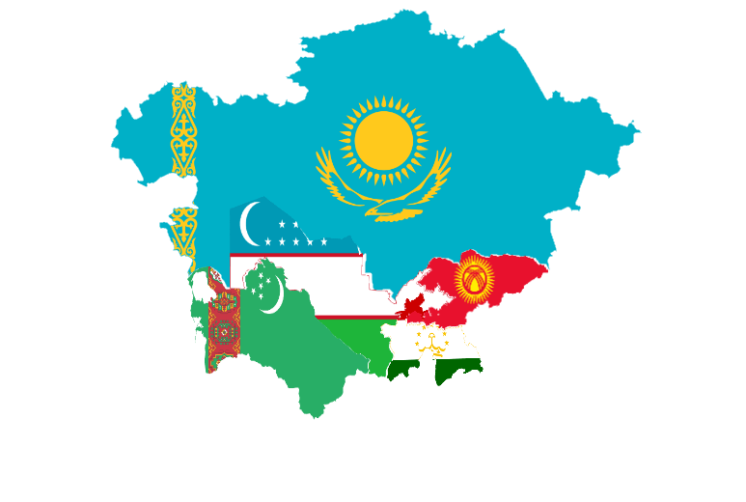
With the U.S. military withdrawal from Afghanistan, the historic “great game” competition for Central Asia has turned a corner, giving Russia and China an undeniable edge. But Central Asia is more than a battlefield for outside influence and geopolitical advantage. It is a vibrant region of largely Turkic and Persian peoples who, after centuries of imperialism, have spent three decades struggling to establish their new place in the world. The goal of this course is to introduce students to the politics and societies of contemporary Central Asia and, in the process, provide a detailed case study of independence, de-colonization and democratization processes that play out across the world. If you would like to learn more about this class, please contact Dr. Grodsky (bgrodsky@umbc.edu).

