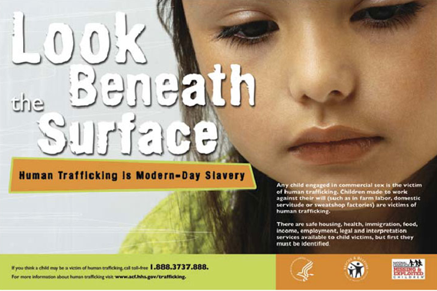

***Purpose:* To raise awareness of child sex-trafficking on the global, national, and local (Baltimore, MD) level.**

***When:* April 24, 2013 at 12:00 PM and 8:30 PM**

***Where:* At the Breezeway (at 12:00 PM) and LH 5 (at 8:30 PM)**

**In the Breezeway during free hour, we will be providing information of the extent and pervasiveness of sex trafficking. In addition, we will be showing iHeart Revolution, a documentary on social injustices at 8:30 PM in LH 5 (Engineering Building).**

**Bethel Campus Fellowship: Child Sex-Trafficking Awareness**