Changing Course
Progressive Solutions to Institutional Racism
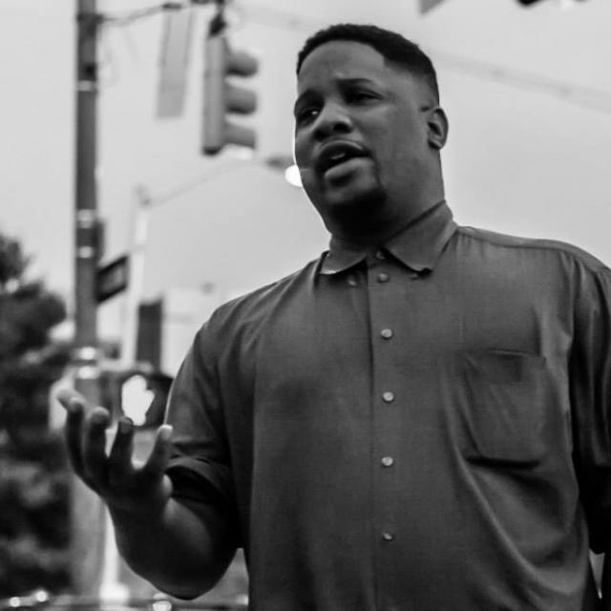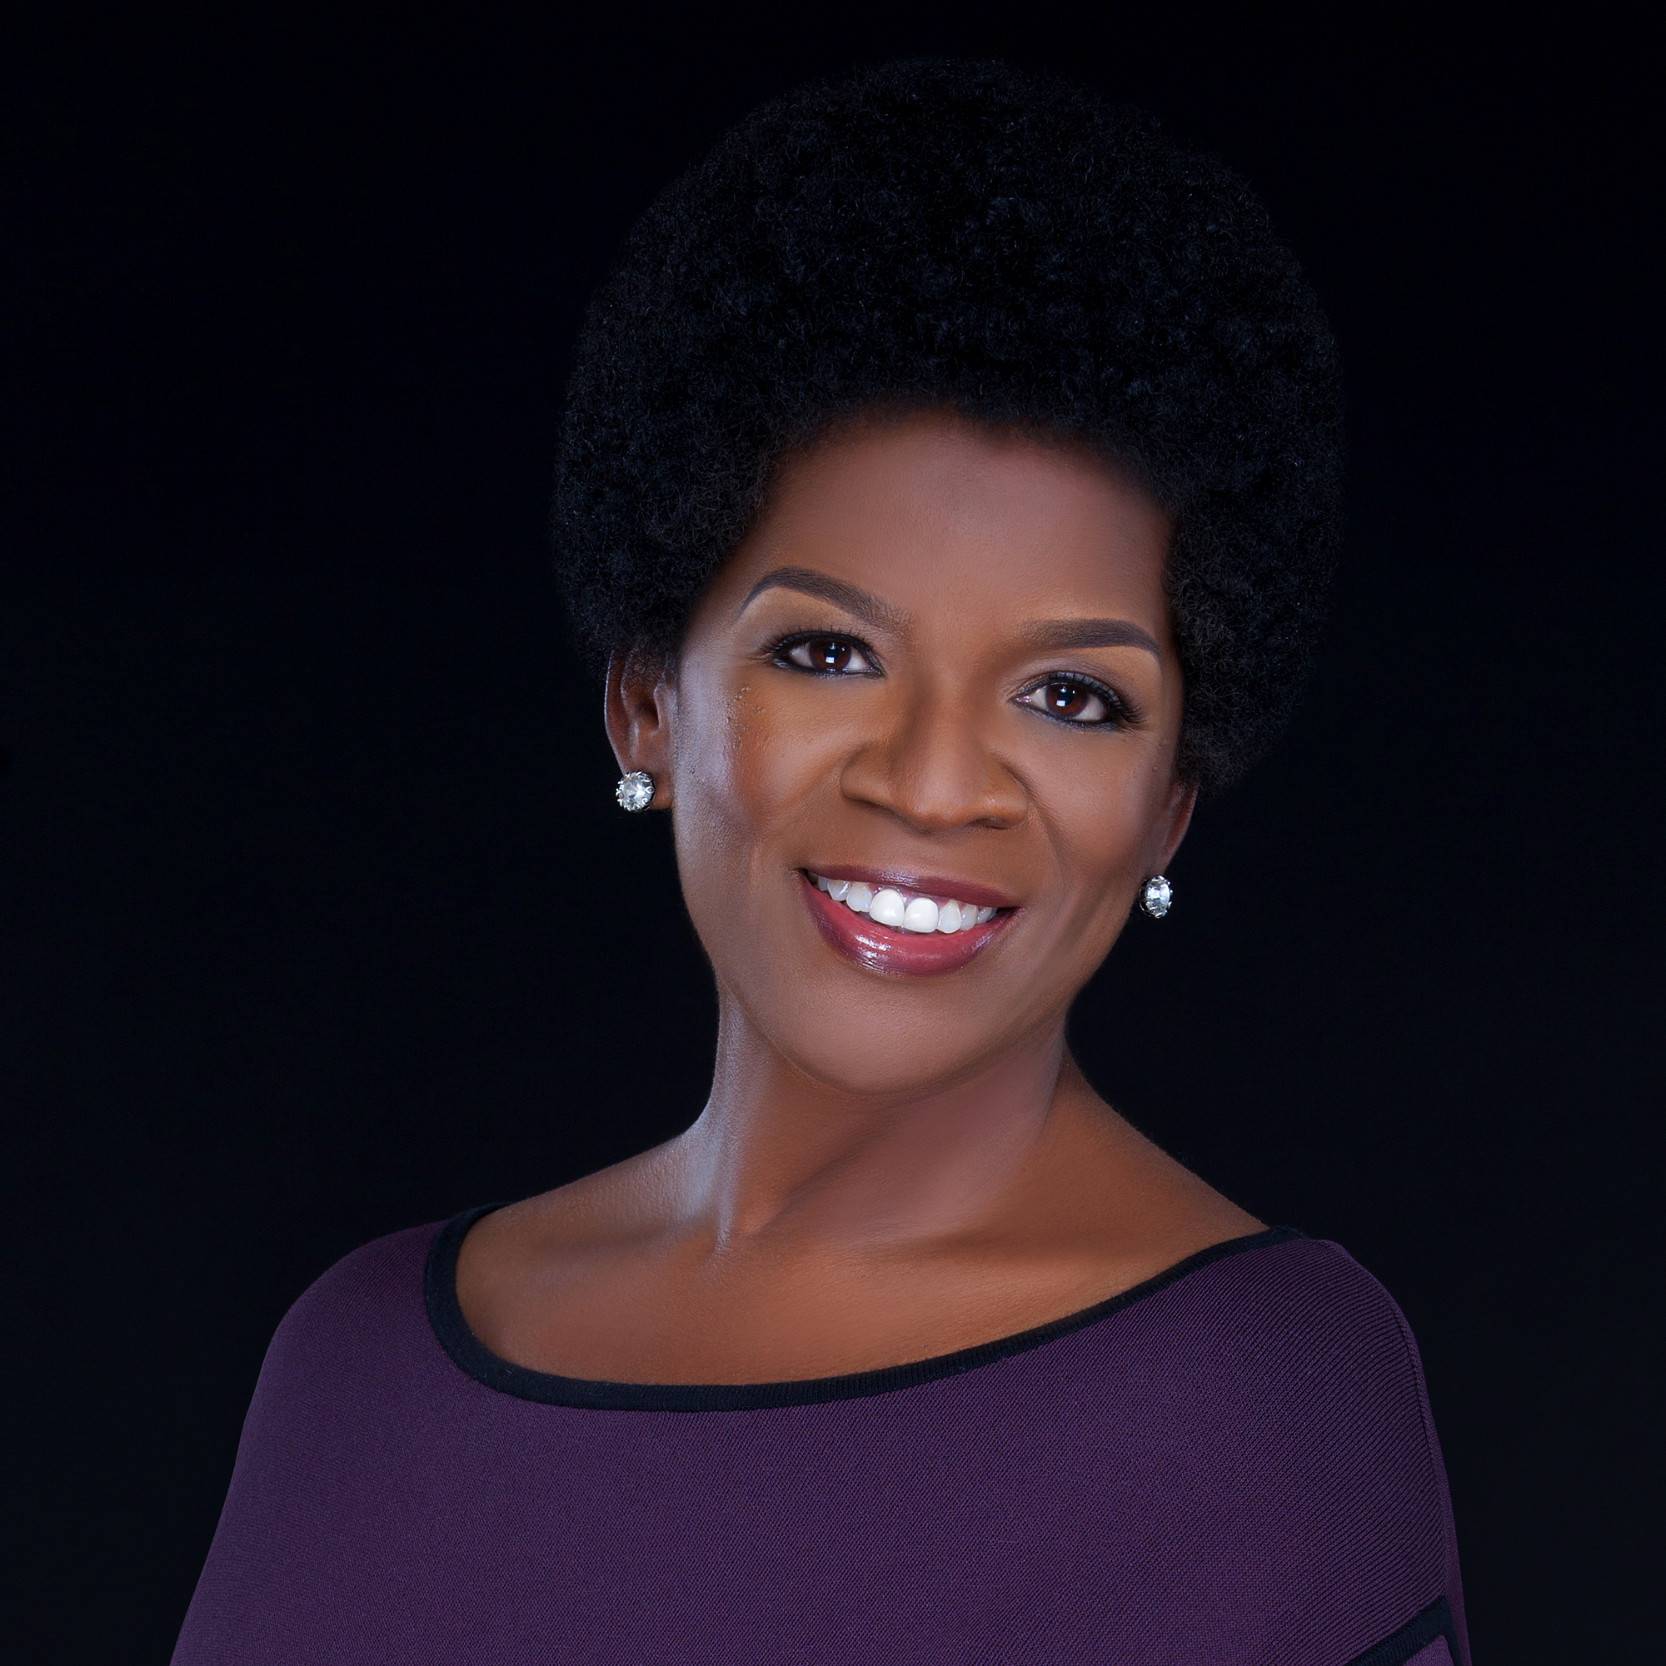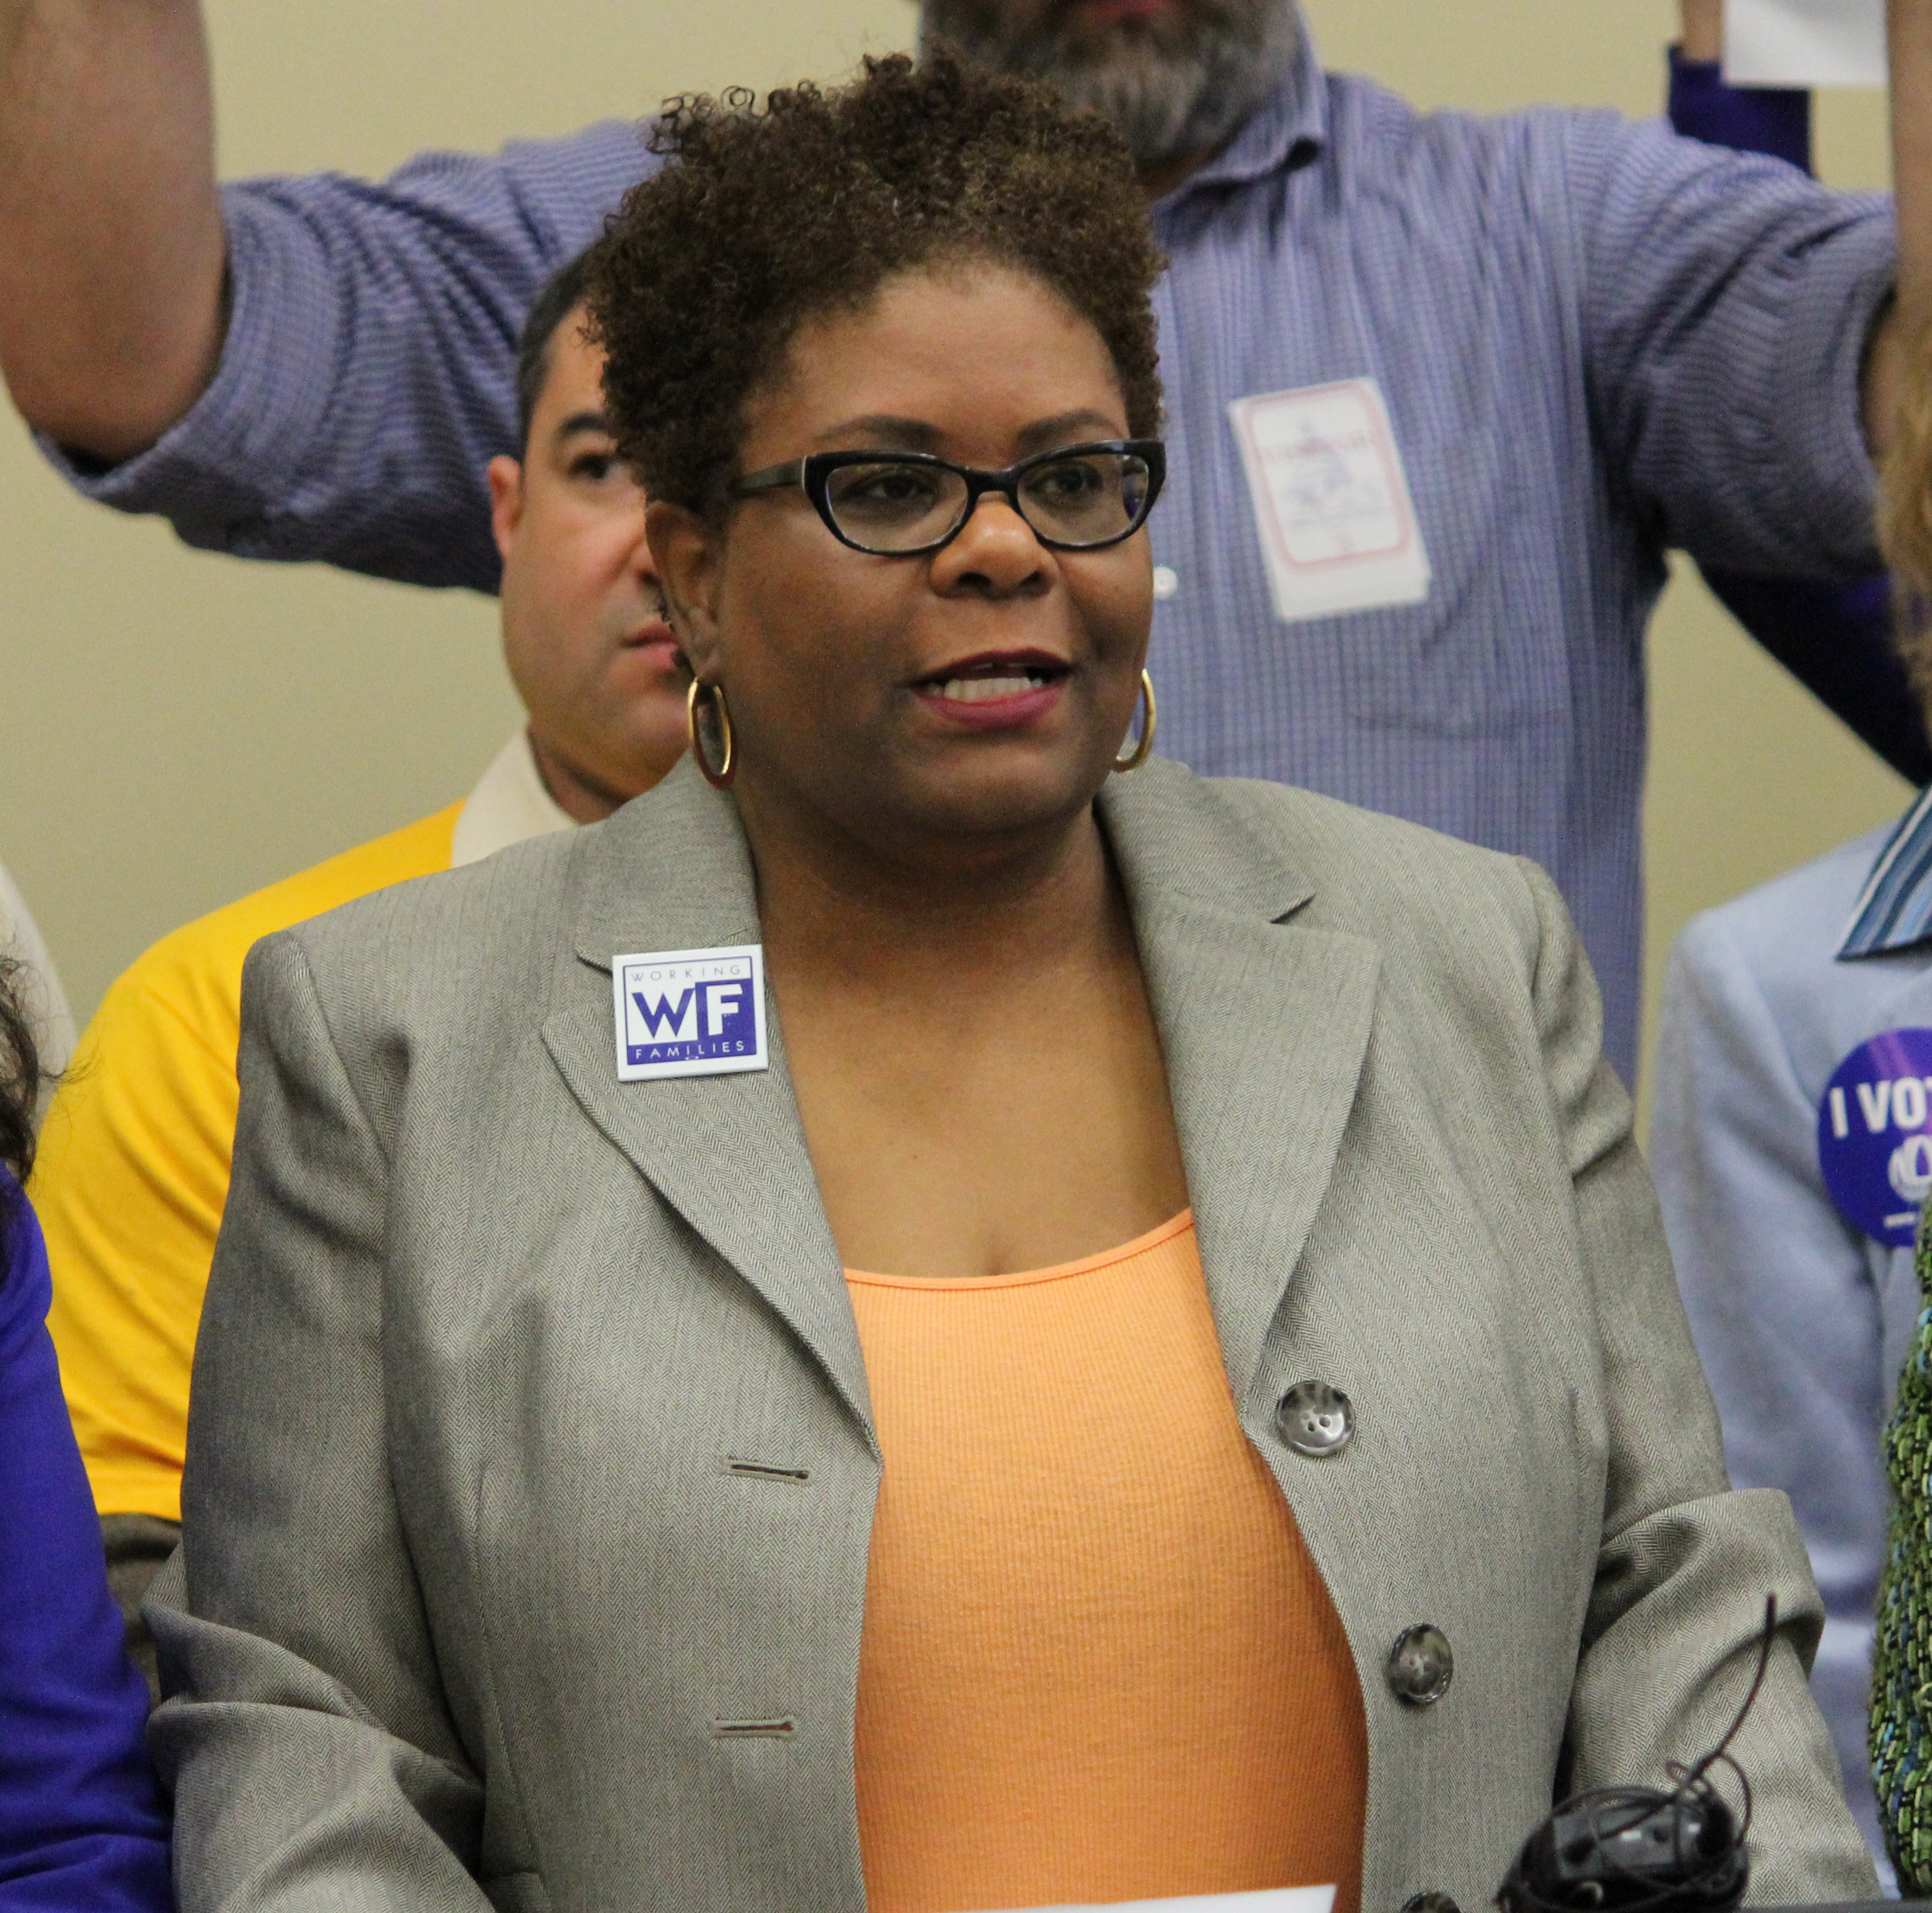
Dayvon Love Valerie Ervin Charly Carter

The Baltimore County Young Democrats invite you to join us as we welcome three distinguished panelists to talk about institutional racism and how to best tackle the issue.

Our panelists include:

Dayvon Love
Director of Public Policy & Research for Leaders of a Beautiful Struggle

Valerie Ervin
Executive Director of the Participatory Democracy Project at the Working Families Party

Charly Carter
Executive Director of Maryland Working Families

When: Wednesday, April 6th at 7:00 pm
Where: 301 Allegheny Ave., Towson, MD 21239

No RSVP required, all are welcome
Questions? Email Matt at matt@bcyd.org
Check out the Baltimore County Young Dems on Facebook!

