**EFFECTIVE   
STUDY HABITS**

**WORKSHOP**

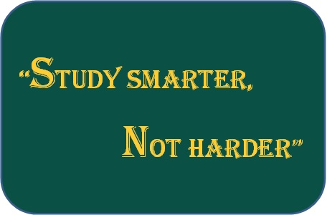

Students in the College of Arts, Humanities, and Social Sciences are invited to attend a brief workshop to discuss and implement effective study habits. This workshop will provide an opportunity to learn more about how students can improve their current studying techniques, reduce distractions, and organize a study plan that works for your schedule. Learning how to study effectively can indeed have a significant impact on receiving improved grades for course assignments and tests.

As we approach mid-term exams, CAHSS would like to ensure that our students have the necessary tools needed to be academically successful. Please join us for an interactive discussion about how to study smarter, not harder!

***Wednesday, October 11, 2017***

***12:00 p.m.-12:45 p.m.***

***Fine Arts Bldg. 5TH Fl. (5-South) Room 559***

**James Hamilton**

**Academic Advising Coordinator**

**College of Arts, Humanities, & Social Sciences**

[**jamham@umbc.edu**](mailto:jamham@umbc.edu)