BIOL 251 Anatomy & Physiology I

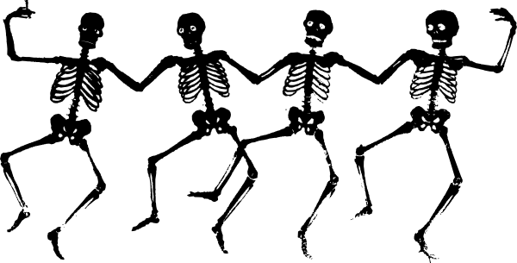

Why are we here?

Course Objectives: The purpose of this course is to help you:

- Understand the fundamental concepts that underlie the structure and function of the human body
- Apply these concepts to understand some major injuries, diseases and illnesses
- Begin to develop an integrated “picture in your head” of how the inside of the body works
- Prepare for settings in the health professions in which you will be called on to apply your understanding of the human body
- Improve your ability to work productively in a team (perhaps the most important career skill you will need!)

How will we do all that?

Using a learning method called Team-Based Learning, our learning activities will follow a particular sequence, which will be repeated 7 times throughout the semester:
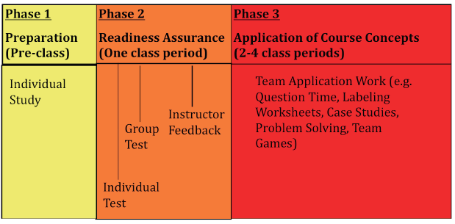
Here’s how it works:

- In order to get the basic factual information needed to operate, you read the book (using the reading guide I give you) and prepare for the Readiness Assurance Test (using the goal sheet I give you).
- In class, you take the individual Readiness Assurance Test (iRAT), turn it in, and re-take the same test as a team (tRAT).
- For the next 2-4 classes, you work on increasingly complex application exercises, in your teams, in class.
- The unit concludes with an individual test, or an individual quiz followed by a team quiz/application (see below for details).

In addition, 2 homework assignments are due on Blackboard, one each in weeks 3 and 7. This allows some reading to be “assurance tested” separately from the RATs, which means you never have to read more than 100 pages of text at once. It also is an extra feedback mechanism, as you get used to the TBL process.

Here’s the semester plan:

Week | Tuesday | Thursday
1/23 | -------- | Intro to TBL, form teams
1/30 | RAT (Chs 1 &2); Intro to the Body (1) | Chemistry (2)
2/6 | HW #1 Cells (3) | Quiz + Team Application (Ch 1-3)
2/13 | RAT (Chs 4 and 5); Tissue (4) | Skin (5)
2/20 | Review Chs 1-5 | Individual Test (Chs 1-5)
2/27 | RAT (Ch 6 and 7); Bones (6) | Skeleton (7)
3/5 | HW #2 Joints (8) | Quiz + Team Application (Chs 6-8)
3/12 | RAT (Chs 9 and 10); Muscle function (9) | Muscle function (9) and Muscle Structure (10)
3/26 | Muscle structure (10);  Review Chs 6-10 | Individual Test (Chs 6-10)
4/2 | RAT (Ch 11 and 12); Neurons (11) | Neurons (11)/CNS (12)
4/9 | Central Nervous Sys. (12) | Quiz + Team Application (Chs 11-12)
4/16 | RAT (Chs 13 and 14); PNS (13) | PNS (13)/ ANS (14)
4/23 | ANS (14);  Review Chs 11-14 | Individual Test (Chs 11-14)
4/30 | RAT (Ch 15) | Eye
5/7 | Ear | Quiz + Team Application (Ch 15)
Comprehensive Individual + Team Final Exam: Tuesday, May 15, 10:30 am

The Details

Class meeting time: Tuesday and Thursday 10:00-11:15 a.m.
Instructor: Sarah Leupen
Office #: BS 467
Office hours: Monday and Wednesday 1:00-3:00
Phone #: 455-2249
Email: leupen@umbc.edu

Text: Human Anatomy and Physiology by Marieb & Hoehn, 8th edition, Benjamin Cummings, 2010. Unlike some other classes you’ve had, you will need to actually read this book. Consider it a wonderfully well-organized and comprehensive set of lecture notes + PowerPoint figures, the authors of which are expert on every aspect of anatomy and physiology-- and who repeat what they said exactly as many times as you need to “hear” it.

Evaluation: Grade weights are as follows:

Individual Performance: 60%
Homework (2) 2.5%
Individual RATs (7) 10%
Quizzes (4) 10%
Tests (3) 25%
Individual Final Exam 12.5%

Team Performance: 40%
Team RATs (7) 10%
Team Application Exercises (4) 10%
Team Final Exam 10%
Peer Evaluation 10%

Letter grades will be assigned on a straight 90+ = A, 80+ = B, etc. basis, except that you can’t get a D unless your individual performance is at least a 50%. My hope is for every one of you to get an A, since that means you learned a lot of A&P!

Attendance and late work policy: If you miss a class, you miss whatever your team did. Most teams, in real life and here, will forgive a single absence for which you have a really good reason, and be less forgiving of multiple or casual absences. Late homework is 25% off per day late.

If you require accommodation for any physical or learning disability, please see me.

