What are you doing summer 2014?
Interested in a PAID summer internship in the multimedia and entertainment industry?

T. Howard Foundation is visiting University of Maryland, Baltimore County!

Tuesday, October 1st, 2013
5PM- 7PM
Public Policy Building 107
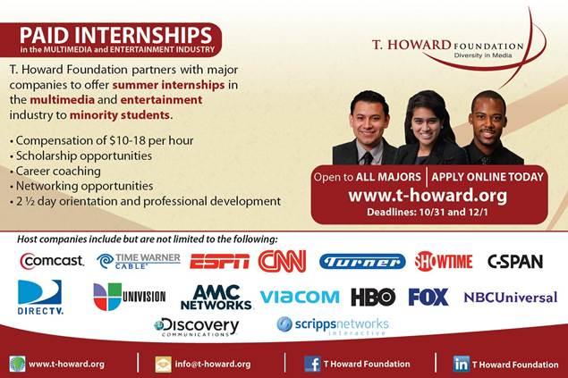
The T. Howard Foundation partners with top media companies including HBO, DirecTV, Discovery Communications, CNN, ESPN, Viacom, NBC Universal and many more!

T. Howard not only places students into paid internships where they can build their tangible skills, the Foundation also provides interns with:
An experienced mentor
Networking opportunities with industry executives
1 on 1 Career Coaching
2 ½ Day Orientation of professional development training
Access to an exclusive job board
And much more!

For more information, visit www.t-howard.org
Application Deadlines:
October 31st . December 1st

