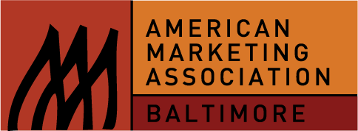 The Baltimore Chapter of the American Marketing association’s

23rd ANNUAL STUDENT JOB SEARCH WORKSHOP

Date: Saturday, April 18, 2015

Time: 1 p.m. - 5 p.m.
General Registration: 1:00 p.m.-1:20 p.m.

Location: Loyola College Graduate Center, Timonium, MD
(directions provided upon registration)

Cost: $25* (includes light refreshments)
*Any proceeds from this workshop will benefit the AMA’s marketing education scholarship awards

At this event, you may meet the executives who could launch your career…all majors are welcome!

“An amazing opportunity to meet with executives in so many industries!"
--Senior

“I was the one of the youngest students there, but this made a strong impression on company executives. The contacts I made helped me kick start my marketing career. It is never too early to start networking!
--Freshman

“Getting to talk to real marketers about their experiences and how they got there is a valuable resource!”
--Junior

Local Companies tentatively Scheduled to attend this year’s workshop include:

Under Armour Baseball Factory Weber Shandwick IMRE
McCormick Spice TBC AOL Digital The Baltimore Ravens
WB&A T. Rowe Price Stanley Black & Decker

Executive-Moderated Discussion Groups On These Topics:

Marketing Management Advertising Public Relations/Social Media
Market Research Sales

Schedule of Events:

1:00 p.m. - 1:20 p.m. General & Walk-in Registration (space permitting)
1:20 p.m. - 2:00 p.m. Welcome, Overview and Panel (“What I Do and How I Got Here”)
2:00 p.m. - 2:30 p.m. Networking Break
2:30 p.m. - 3:00 p.m. Discussion Groups, 1st Session
3:00 p.m. - 3:30 p.m. Networking Break
3:30 p.m. - 4:00 p.m. Discussion Groups, 2nd Session
4:00 p.m. - 4:30 p.m. Discussion Groups, 3rd Session
4:30 p.m. - 5:00 p.m. Networking Break

