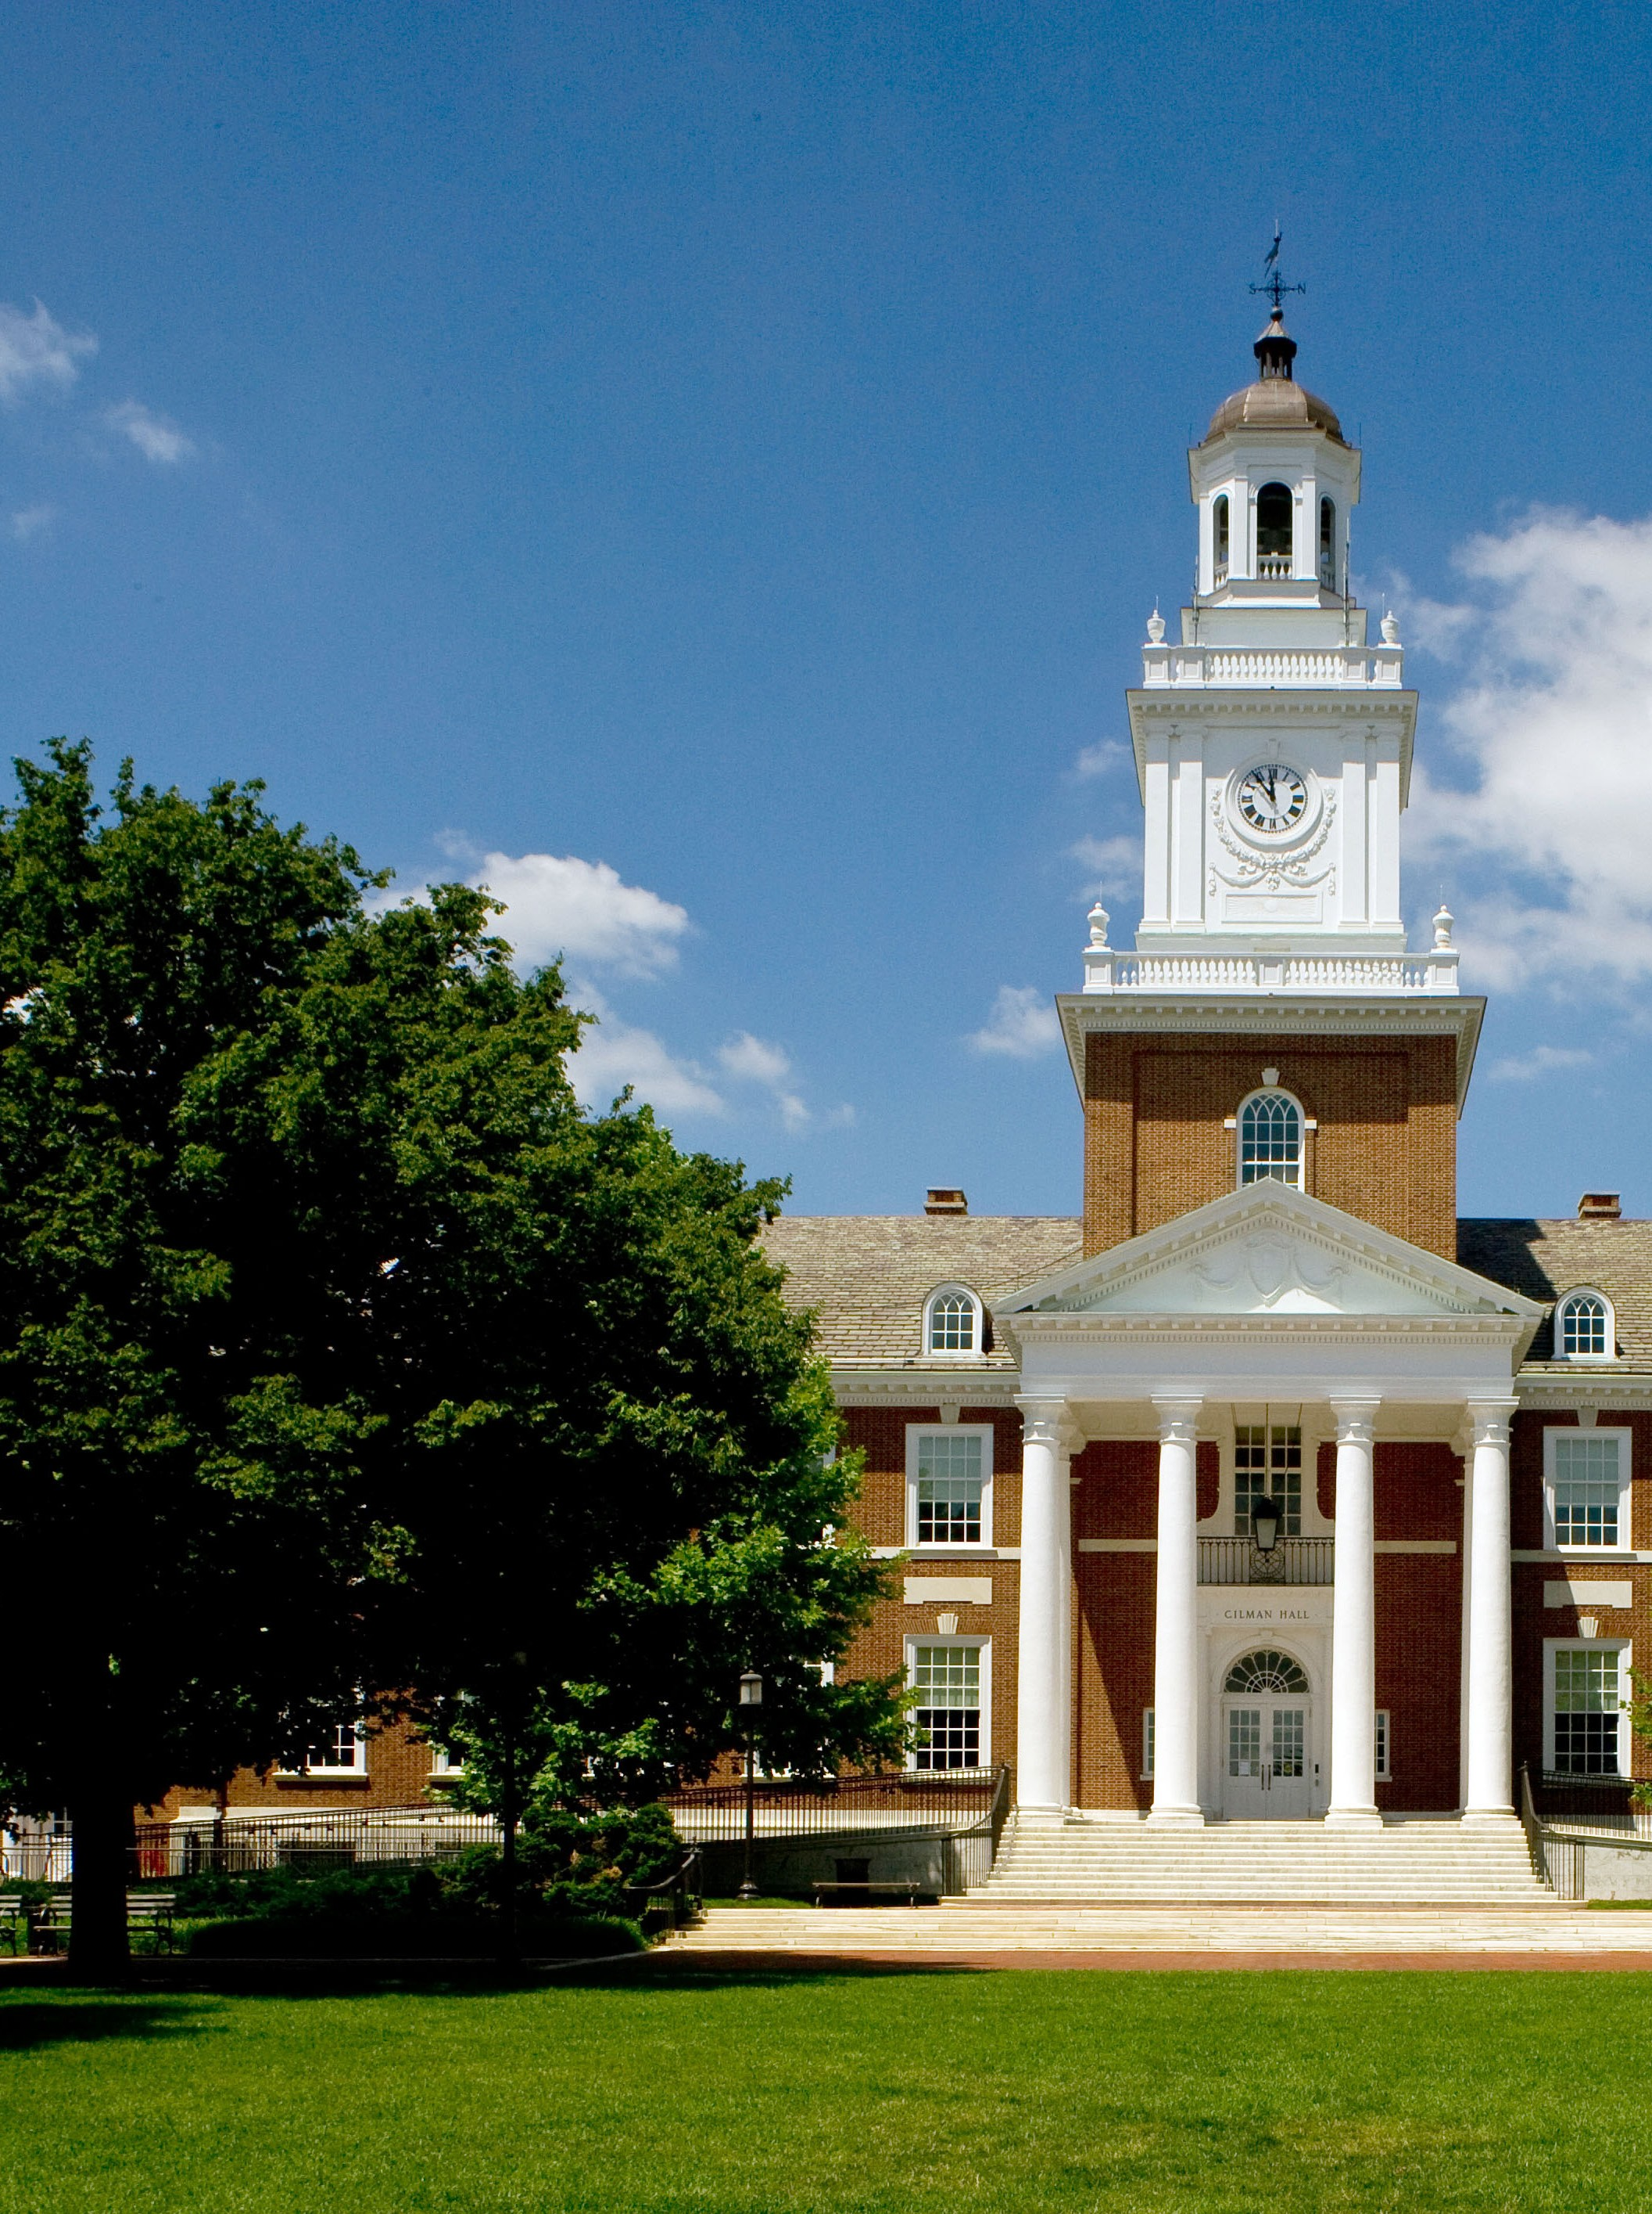

Graduate School Visit
University of Maryland Baltimore County

Come join admissions representatives from Johns Hopkins University graduate schools who will offer tips and resources on how to find the right program to meet your personal and professional goals, successfully navigate the admissions and financial aid process, and help you prepare early to be a successful graduate candidate. After a brief presentation, representatives will be on hand to speak with students one-on-one about program offerings and answer specific questions. Students from all disciplines are welcome.

Date: Monday, October 23, 2017
Time: 12:00pm – 1:00pm
Information Session

1-1:30 pm
Meet and Greet with
Admissions Representatives

Location: University Center Building
Room 312

Divisions represented:

Advanced Academic Programs
Carey Business School
School of Advanced International Studies
School of Education
School of Medicine
School of Nursing
School of Public Health

For more information contact the Office of Career Services at careers@umbc.edu or 410-455-2216
Lunch Will Be Provided

