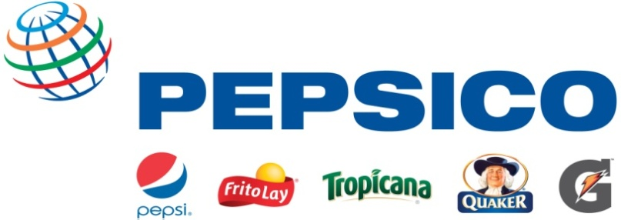

Recruiting Event:

PepsiCo will be hosting a recruiting event on October 9th at our Pepsi Facility. The event will provide pre-selected students with information about our company, information on the position and on-site interviews. You must be pre-selected to attend the event. Please follow the application instructions at the end of this job description for an opportunity to attend our event.
Job Title: Sales – Beverage Division
Why PepsiCo?
PepsiCo offers the world's largest portfolio of billion-dollar food and beverage brands, including 22 different product lines that generate more than $1 billion in annual retail sales each. Our main businesses -- Quaker, Tropicana, Gatorade, Frito-Lay, and Pepsi Cola – also make hundreds of other enjoyable foods and beverages that are respected household names throughout the world. With net revenues of approximately $65 billion, PepsiCo's people are united by our unique commitment to sustainable growth by investing in a healthier future for people and our planet, which we believe also, means a more successful future for PepsiCo. We call this commitment Performance with Purpose: PepsiCo's promise to provide a wide range of foods and beverages for local tastes; to find innovative ways to minimize our impact on the environment, including conserving energy and water usage, and reducing packaging volume; to provide a great workplace for our associates; and to respect, support and invest in the local communities where we operate.
Functional Description:

The Pepsi Americas Beverages’ Sales Organization provides a demanding, fast-paced environment in a competitive industry, where growth equals opportunity and fun accompanies the challenge. Decisions are made “real time” to maintain and grow an existing account base with a strong focus on customer relations. We are looking for future leaders of the company. Assignments are based on functional knowledge vs. defined time periods. Based on performance, candidates will have the unique opportunity to move rapidly to increasing levels of responsibility leading to leadership positions in sales, sales operations, food service and possible cross functional and enterprise wide roles.

What you can expect:

While we will provide you with an initial onboarding training and ongoing function specific development, we also encourage you to develop yourself through our vast learning labs. Keep in mind, when you work for PepsiCo, you will have access to a variety of operating environments within the Beverage, Foods and Corporate environments – Just think you can work for power brands such as Tropicana, Gatorade, Quaker & Frito-Lay and still work within the same company!

In this role, you will be called upon to:
- Demonstrate strong leadership skills to coach & develop teams as well as influence
- Learn the PepsiCo selling foundation; use fact based selling skills and deliver exceptional customer service
- Use your creativity and entrepreneurial mindset to grow volume & revenue to achieve profitability goals for the assigned territory
- Activate local and national marketplace initiatives and promotions through merchandising products and building creative displays
- Perform at fast pace, with self-motivation, and strong initiative
- Be flexible – you may at times need to work various schedules, including early mornings, evenings and/or weekends

What we’re looking for:
- Preferred majors include: Business Administration, Marketing, Management, Communications, Organizational Leadership, Entrepreneurship
- Others Majors considered: All majors may apply
- Involvement in a minimum of one extracurricular activity
- Previous selling / customer service experience (on or off campus; either through part time jobs or through academic clubs)
- Leading people or leading projects throughout your academic career (on or off campus)
- Availability to work flexible schedules
- Flexibility for relocation will allow for greater advancement opportunities

Minimum Qualifications:

- Bachelor’s degree completed by August 2014
- Valid Driver’s License
- Applicants must be US citizens or permanent residents
- Eligible to work in United States without work authorization sponsorship

How to apply:

To be considered for an interview at our recruiting event, you must complete an online application on OUR WEBSITE as well as e-mail your resume to pepsico@recsolu.com by October 7th.

To apply for the position, please follow the instructions at the link below:

https://xjobs.brassring.com/TGWEbHost/jobdetails.aspx?partnerid=25331&siteid=5015&AReq=32603BR

