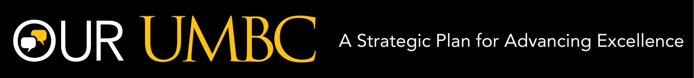
Attention UMBC Undergraduate and Graduate Students
We need your input and suggestions.
Join us to discuss strategies to enhance applied learning including internships, research, service-learning, study abroad, performance, etc. Your recommendations may help guide our University over the next decade beginning in 2016.
Tuesday, December 9th
3:30pm to 5pm, Commons 331
Snacks provided
RSVP via the following form: http://goo.gl/u015ik

If you cannot attend the session but would like to contribute, please indicate so in the RSVP. A survey will be sent to you at a later date.
We look forward to seeing you!
Christine Routzhan, Craig Berger, Michael Moubarek, and Ally Yang
Student Experience Strategy Group
Our UMBC: A Strategic Plan for Advancing Excellence

