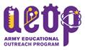

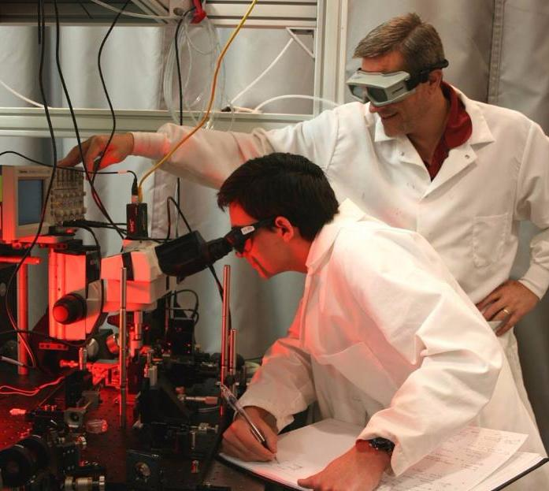Did you know that the US Army sponsors summer apprenticeships for undergraduate students? Are you interested in a paid summer apprenticeship?

**NOW OPEN FOR ENROLLMENT – APPLY:** [**http://www.usaeop.com/programs/**](http://r20.rs6.net/tn.jsp?f=001SEy8KH7Y_4jSMLUcaNGLgM65pumoOjl3v_9iPGZQ5Dh09BMz4bGtqYqbPhuab2QITHwbLztGp3YmU9BO9TodI8c1Zith_9zhyvAeLnlGIaGOX4Oft0_KZUY4UM0orQTaQlCK5EAiiXsPqpdxqGw1veSoye5abp-H&c=9BI9Bbk556DWh9Yl_oBd0lnYbO1RW_bop3sh2VHA4KNnxcEjBSmeXQ==&ch=io-iV7QMfdBe_kjbgx25fxDOksMR2-1z2EM7s7_JkqbwKBqOq_rmlg==)

**The College Qualified Leaders Program (CQL)** is a program that matches practicing DoD scientists with talented undergraduate students creating a direct mentor-student relationship, providing participants with training that is unparalleled at most colleges. CQL students receive firsthand research experience and exposure to DoD laboratories. CQL fosters desire in its participants to pursue further training and careers in STEM. Participants receive a stipend based on education and experience and may participate year-round. **This application is open now through February 28, 2017.**

**Spaces are limited; we encourage you to apply early**.

For more information, please contact the Academy of Applied Science

College Qualified Leaders Team:

Sheila Avery

[savery@aas-world.org](mailto:savery@aas-world.org)

Jody Fortin

[jfortin@aas-world.org](mailto:jfortin@aas-world.org)

603.228-4530

_AAS-Logo_Horiz