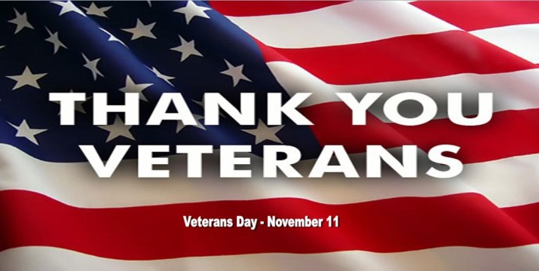

Veterans Day Celebration
Come and celebrate Veterans Day with a free

lunch in the Skylight Room.

When- November 11th from 11:30 a.m. – 1:30 p.m.
Where- The Skylight Room (3rd floor of The Commons)
Who- All UMBC students, staff and faculty veterans are invited to attend.

This event is informal and veterans are invited to come and

go as is convenient.

A UMBC Veterans t-shirt, American flag pins, and other assorted gifts will be given away in appreciation.

For additional information, please contact

Sandy Vance at 5-2912 or Dan Thrift at 5-3852

Sponsored by Veteran Student Services and Human Resources.

