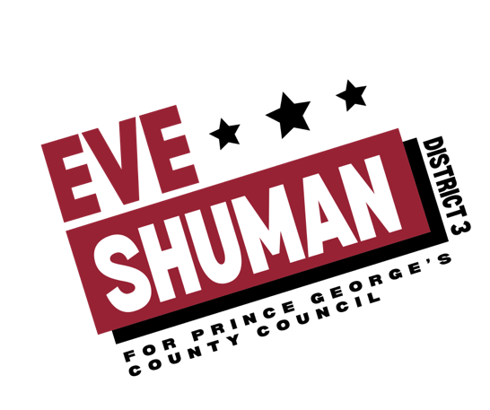
Campaign Canvassers needed!!

Eve Shuman, a mother, lawyer, former US Senate staffer and resident of Riverdale Park is
running for the District 3 seat on the Prince George’s County Council and needs campaign
volunteers to help knock on residents’ doors, hand out literature, and grow support for next
summer’s election!

Canvassers will be assigned to a specific area of District 3. Canvassers will work in areas such as
Beacon Heights, Berwyn Heights, College Park Estates, College Park, East Pines, Glenn Dale,
Glenridge, Landover Hills, Lanham, New Carrollton, Riverdale Heights and Hills, Riverdale
Park, Seabrook, Templeton Knolls, University Park, West Lanham Hills, and Woodlawn.

The ideal candidate is vaccinated, outgoing, engaging, driven, and interested in local politics.
They should want to make a difference in their community by helping get a progressive
Democratic candidate elected to Prince George’s County Council.

This is an in-person, 5-10 hour/week part-time position that is envisioned to last until December,
2021. After the fall, successful canvassers may have the opportunity to join the campaign as a
full-time paid staffer. Stipends available.

Send your interest and resume to info@evefordistrict3.com. Applications accepted on a
rolling basis.

#Eve4District3
https://www.eve4district3.com

