ISSA: Tech Bytes

SeeFuture Visits UMBC
When: Wednesday March 4, 2015 @ 5:30pm
Where: ITE 459
Who: Founder and Co-founder Maneet Sarai and Torin Ellis

What is SeeFuture?
An Accelerate Baltimore Company, a Career Development Platform for college students to apply for corporate mentorship, trainings, private career networks and gain hard/soft skills while securing employment with a desired company.
What Does SeeFuture offer me?
- Guaranteed Feedback From Top Employers
- Access to Professional Networks
- Personalized Growth
- SF helps you get noticed by Potential Employers
- And more. . . .
What Can I expect?
- Interactive presentation to learn how SeeFuture can help you get Employed.
- Discussion about their Entrepreneur Journey.
- Advice from a Talent Recruiting Expert.
A Few Companies Using SeeFuture:
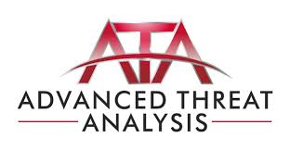

Free Pizza and Drinks will be served Please RSVP on ISSA Group Page

