DCOM Clothing Order Form
Please hand in completed forms to a DCOM officer by Friday October 7^{h}, 2016!
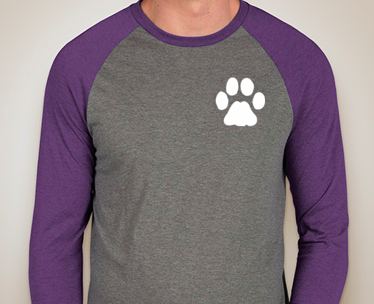
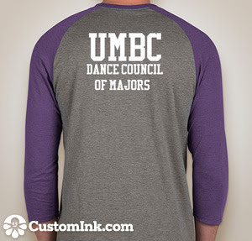

Gray and Purple Baseball T-Shirt with White Text
#_____ Adult Small x $22 = $______

#_____ Adult Med x $22 = $______
#_____ Adult Large x $22 = $_____
#_____ Adult X Large x $22 = $_____
Total = $________
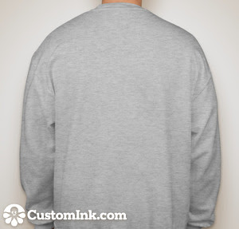
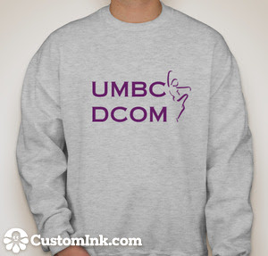

Ash Gray Crewneck Sweatshirt with Purple Text
#_____ Youth Small x $22 = $______

#_____ Youth Med x $22 = $______
#_____ Youth Large x $22 = $_____
#_____ Adult Small x $22= $_____
#_____ Adult Medium x $22= $_____
#_____ Adult Large x $22= $_____
#_____ Adult X Large x $22= $_____
Total = $________

Name: _________________________ | Shirt Total | = $________
Email: _____________________________ | Sweatshirt Total | = $________
Phone Number: _____________________ | Grand Total | = $_________

Cash or check only, cash preferred. Please make checks out to Maia Schechter. You can give the completed form and money to Sarah Schmitz, Nerissa Vasconcells, Maia Schechter, or Melissa Hudson.

