

rsmus.com/careers



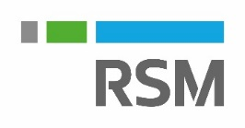\

**2020 PATHWAYS PROGRAM: MAY 20- MAY 21**

**Join us for a 2-day Summer Leadership Program!**

Looking for a sneak peek inside our firm and our industry? Join us to experience RSM through our 2020 Audit & Tax Pathways Summer Leadership Program. You’ve worked hard your first few years in school. Now you’re ready to explore the accounting profession further.

**Program Components:**

* Firm Overview
* Client Experience
* Talent Experience
* Business Simulation

**Program Requirements:**

* Accounting Major
* Must be within two years of CPA eligibility (150 credits) (typically sophomores on the 4-year track and juniors on the 5-year track)
* GPA of 3.0 or higher
* Be a team player who is motivated to work in a fast-paced environment
* Show a desire to be client focused
* Possess strong communication and technical skills

**Additional Application Instructions:**

* Apply through Handshake by **Sunday, February 16th**
* If you are selected to join us for the Pathways Program, you will also receive an offer for a 2021 Tax or Audit Internship!
* If you are junior or senior looking for full time or internship opportunities, please reach out to Meera Desai at [meera.desai@rsmus.com](mailto:meera.desai@rsmus.com)

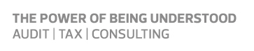

**CONTACT:**

Meera Desai

Senior Campus Recruiter

meera.desai@rsmus.com

(267) 515-5143