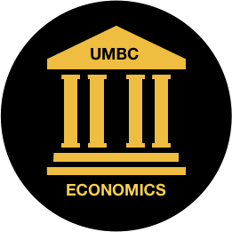
UMBC Economics Council of Majors List of Resources Spring 2021

Economics Council of Majors Mentorship program: We are seeking out mentors and mentees. You can be a mentee if you are a freshman, transfer student, or new to the major. We would like mentors to be junior or senior class standing. This is an informal program meant to connect students! This is open to both econ and financial econ majors. This is volunteer experience you can put on resume. You will need to be logged into your myumbc account to fill out the form.
Link: https://forms.gle/GKs7CwNNYKFqPKLj8

Discord: Online Community for those taking economics classes. It is a UMBC economics channel, open to all to meet people in your classes, utilize online study space, and stay up-to date on news from ECOM and the Econ department.
Link: https://discord.gg/C2FrMck
Economics Council Club of Majors Club Meetings: Meet other econ majors, attend workshops, and hear guest speakers! Our meetings will be on Fridays during free hour (12-1pm). More information/dates will be on the Econ myumbc and the club myumbc.
Link: https://my3.my.umbc.edu/groups/economicscouncil

General Campus Resources
UMBC Academic Success Center: Free tutoring for most econ classes and SI Pass sessions for selected economics courses.
For more information: https://lrc.umbc.edu/tutor/
Academic Success Meetings: “An Academic Success Meeting is a diagnostic measure to not only help you identify issues in your academic life but also show you how to leverage strengths and be successful. Academic Success Meetings can help you with the following things: Finding Resources on Campus, Time Management, Study Skills”
For more information: https://lrc.umbc.edu/academic-success-meeting/

