**You’re a POET**

**and you KNOW IT!**

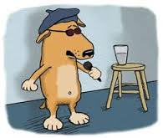

win **$200** or other prizes

at the BIG PRIZE Poetry Slam

* October 9th, 6-8 pm PAHB Atrium –
* to audition, send a print & video version of no more than 5 minutes of original poetry to HomecomingSlam@gmail.com **by 9/21** !!

brought to you by the English Department, UMBC’s creative arts journal *Bartleby*, and the UMBC Homecoming Committee