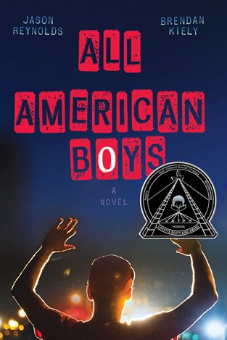

**Pizza and Panel Discussion of the Maryland One Book, *All American Boys* by Jason Reynolds and Brendan Kiely**

**The Panelists Include Dr. Christopher Varlack, English, and Students from the English Department.**

**When: October 24th 12 -1**

**Where: Library 767**

**Sponsored by the English Department and**

**The Albin O. Kuhn Library & Gallery**

**Please rsvp to** [**cherylee@umbc.edu**](mailto:cherylee@umbc.edu)

**PNC Bank has provided support for this program and copies of this book. For a free copy of this book, visit PNC in the Commons and present your campus ID. Copies will also be on reserve at theAlbin O. Kuhn Library for check out.**