Wine Tasting @ Flat Tuesdays with the Professional Staff Senate

Thursday, March 14, 2013
5:00pm—6:30pm

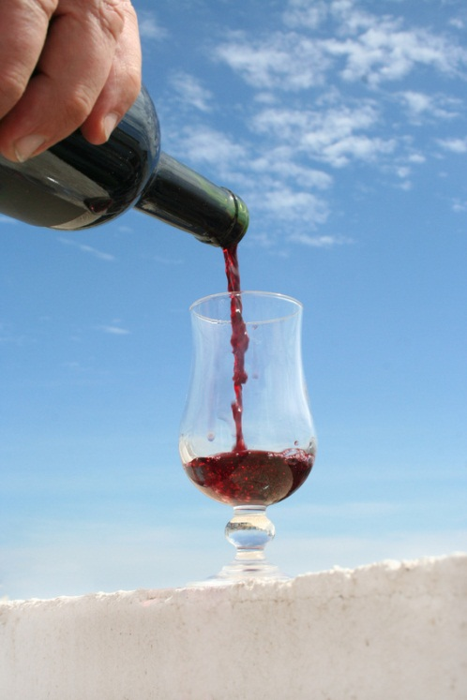

Flat Tuesdays and the Professional Staff Senate Outreach Committee invite you to a FREE Wine Tasting in Upper Flat Tuesdays



Elk Run Vineyards will provide a wine introduction and sample tasting. Light refreshments will be served as well.

Please join us!
RSVP at http://my.umbc.edu/groups/pss/events

