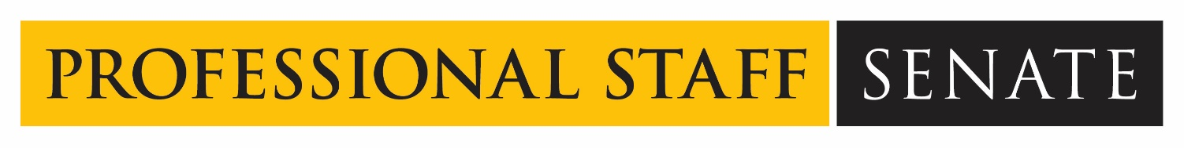  
  
**Professional Staff Senate Meeting Minutes**

**Thursday, May 13, 2021**

**2:30 – 4:30 PM – Virtual**

**In Attendance:**[**Link**](https://docs.google.com/spreadsheets/d/1W3SwiPQiHC1EY-Y7VXXm2___m4XrBLGyrsUUU8kzgHE/edit#gid=522842090)

**Non-Officer Staff In Attendance:** Ally Hepp, Amelia Meman, Caroline Mulcahy, Jennifer Moser, Sara Rolf, Elle Trusz, & Eleanor Lewis

1. Call to Order: 2:32pm
2. Approved May 2021 [Meeting Agenda](https://umbc.app.box.com/file/809759847566?s=vke4m7gveb3e5nlpig75xw20ftxf5k1u)
3. Approved April 2021 [Meeting Minutes](https://umbc.app.box.com/file/798648548587?s=3724brkz61vexw52nmkuedoc6o7oxuc0)
4. Self-Care Series – Jack Seuss, DoIT (2:35 pm)
   1. Who are you?
      1. Vice President of IT & CIO since 2005
   2. What does your unit do on campus?
      1. Provides faculty and staff with the best possible information and instructional technology services
   3. How are you actively taking care of staff in your area?
      1. Developing a culture where you’re giving positive feedback and giving people an opportunity to grow during PMP process
      2. Early adopter of telework and remote work, so the shift was more nuanced.
      3. Tried to regularly communicate with the team throughout the pandemic through “Take a Break with DoIT” (virtual activities and discussions)
      4. Thinking how to press the boundaries
   4. Do you have any personal self-care strategies you would like to share?
      1. Prioritize your health and family through your calendar. Carve out time on your calendar for yourself
      2. Understand how you do your best work and leverage that to your advantage
      3. Build your professional network – it’s personally and professionally rewarding!
      4. Leading is serving – work for people you believe in and serve the people you lead
5. Return to Campus Update – Valerie Thomas (3:05 pm)
   1. Over the past 14 months, we’ve had about 480 staff members working on campus who have been safe. Safety is the first consideration
   2. Formed a work group to ask the Deans and Vice Presidents what they would like to see as we return to campus.
      1. The consensus was that we slowly come back in early July
      2. The expectation is that we come back fully to what our schedules will permanently be by August
      3. Pre-Pandemic, HR had to sign off on telework permission. Now, we will be looking at what *jobs* can be done remotely vs. looking at the individual person
      4. The HR website will have information on office spacing procedures
      5. The expectation is that all staff and faculty will be fully vaccinated when they return, with exceptions for medical or religious concerns
      6. Vaccination card submission will be through DoIT. Staff can [visit this website](https://covid19.umbc.edu/reporting-vaccination/) to learn how to upload their cards.
      7. For staff members who do not wish to get vaccinated: each USM institution will be tasked with figuring out compliance for their own
      8. Student Staff will be tracked similarly and held to the same standards as professional staff regarding vaccinations.
      9. Vaccinated cards will be considered Institutional Data; only authorized people will be able to access information. The cards will be stored in an encrypted box and not long-term
      10. If you have a shared lounge space that students use, ask that building’s manager about what the policy will be
      11. Vendors and other guests coming into the buildings are still being discussed. Whether or not we have to symptom track is also TBD
6. Committee Updates
   1. SOD Return to Campus – Sue Plitt (3:25 pm)
      1. Pre-scheduled tours of the RAC for staff
      2. All new staff that was hired during pandemic may receive guided tours from other staff members
      3. Walking groups and coffee chats? Thinking through logistics of how we can get staff members, especially newer folks, connected in a safe way
   2. Mentoring - Laila Shishineh (3:35 pm)
      1. Closed the application for the program. We have a smaller cohort this year; 34 folks participating this year. Virtual meet and greet at the end of May and Bios will be sent out for pairing purposes
   3. CUSS – Laila Shishineh (3:45 pm)
      1. Remote work survey was sent out – already have almost 4k responses from all USM institutions. Exempt and non-exempt. Survey closes Monday the 17th
      2. Greg Simmons met with the Council and talked about how we will be accepting the largest freshmen class ever this fall!
      3. Shared governance survey – shared results with Freeman and he is happy to follow up with us if we have questions about shared governance
      4. CUSS is about to roll over in July – new CUSS roster will start in August. Potentially overhauling the committees to ensure its action-oriented vs reactive.
      5. Mike Walsh has been re-elected for CUSS but we still need an alternate representative! Anyone who is interested in CUSS please contact Laila and CC Bobby by Monday.
   4. Caregiving – Jess Wyatt (3:55 pm)
      1. 334 responses for the Caregiving survey!
      2. Main takeaways: people want flexibility. 33% people would leave UMBC if they found another position with more flexibility
      3. Working on a high-level teaser of data that will be sent to HR
      4. Then a higher-level multi page report will be released as a continuous reminder about how we’re phasing people back into campus
7. Diversity, Equity and Inclusion (DEI) discussion – Carlos Turcios (4:05 pm)
   1. A colleague did a brief write-up of a student for an article they were working on and another colleague asked whether the write-up reflected the student's preferred pronouns. Is it appropriate to go back to the student to ask their preferred pronouns? What is the best way to address this situation?
      1. Go ahead and email them and ask confirm with the student what pronouns they use. Never say preferred pronouns
   2. How are we addressing whiteness and structural racism on campus? How are we holding white students accountable when they state a racist thought? How are we facilitating learning when necessary? How are we working with UMBC leadership to explicitly state the harm that comes from micro and macro aggressions? How are we holding faculty accountable? staff? How can staff across campus collaborate with i3b so that we can build on and amplify their impact?
      1. I3b are not the only ones who should be monopolizing all cultural programs. How can we incorporate these practices in our daily work? Diversity doesn’t mean inclusion.
   3. What are we doing to retain BIPOC staff?
      1. BIPOC stands for Black Indigenous People of Color. Some of this was answered last time with HR. The reality is that staff doesn’t have the same support faculty has. Dr. Jasmine Lee has checked in with BIPOC staff members to make sure they feel supported.
8. Open Forum
9. Adjournment: 4:23

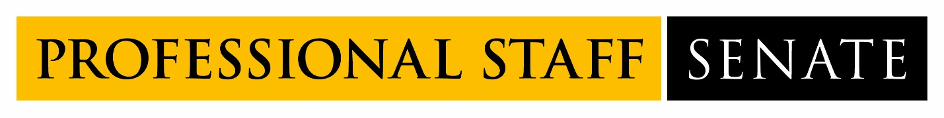

**2020-2021 SENATE MEETING SCHEDULE**  
  
*2021 meetings from 2:30PM – 4:30PM*

June 10, 2021