

**Professional Staff Senate Meeting Minutes**

**Thursday, MONTH DAY, 2022**

**2:30 – 4:30 p.m. – Virtual**

**In Attendance:** [**Link**](https://docs.google.com/spreadsheets/d/1W3SwiPQiHC1EY-Y7VXXm2___m4XrBLGyrsUUU8kzgHE/edit#gid=522842090)

**Non-Officer Staff In Attendance:**

***Land Acknowledgement***

*UMBC was established upon the land of the Piscataway and Susquehannock peoples. Over time, citizens of many more Indigenous nations have come to reside in this region. We humbly offer our respect to all past, present, and future Indigenous people connected to this place.*

* 2:30 p.m. Meet & Greet with Dr Sheares Ashby
  + Call to Order & Welcome (Jess)
  + Dr. Sheares Ashby Introduction (5 minutes) - Prompts below
    - She values her staff!
    - It’s her belief that she’s not capable of doing this job without great staff.
    - ‘Great’ means to her expertise that she doesn’t have.
    - She loves hearing staff voices, developing staff, growing staff, and wants to recognize the value of staff, as essential to campus as much as faculty.
    - She takes issue with people when they don’t treat her staff with respect.
    - She’s looking forward to meeting everyone.
    - She recognizes that faculty often get the praises and accolades, but in her last job, she helped to create ways to appreciate staff.
  + Senator Introductions (2 minutes)
    - Limit to name, pronouns, title
  + Exec + Chairs Introductions (2 minutes)
    - Name, pronoun, title, role in PSS
  + PSS Questions for VSA (10 minutes)
    - Poulomi - Describe your experiences with shared governance and what vision do you have for your relationship with shared governance, specifically PSS?
      * Experience in shared governance:
        + Last two institutions had very strong shared governance – UNC chapel hill & Duke.
        + She doesn’t believe the institution works well without healthy shared governance.

Unhealthy – when someone is doing my job

Healthy – when we collaborate to make something better than we could have done alone

* + - * Shared governance was left in a much better place than she inherited it at her previous institutions.
      * She had great experiences with shared governace previously – she brought her whole team (14 people) to each meeting
        + She learned more about how things were working around campus, had difficult and important conversations.
    - Tim Lynch - Could you please talk a little about your vision for UMBC in the next 5-10 years? How can we partner with you to accomplish your goals?
      * She's getting asked this a lot.
      * She doesn’t have a mapped out vision.
      * She has ideas about greatness and how we get there, but she wants to learn about.
      * Officially will be having topics and listening sessions – where anyone who is a member of the community will be invited.
        + There will be 3 questions about each topic:

What is there to know

What do you want the president to know about the topic

What do you want the outcome to be?

* + - * + Out of these listening sessions she will attend all of them and this is where she will formulate our next plan.
      * Examples:
        + Serious about inclusive excellence – how do we do that moving forward?
        + How are we going to prepare for the world that is changed from the past 3 years
        + How do you attract retain and grow students, staff, faculty.
        + What do you imagine? E.g. what do we do with Spring Grove?
      * There will be an inauguration and a celebration of UMBC.
    - Cael - Considering the staff retention climate globally and at UMBC, how does UMBC position itself to be a leading competitor in attracting and retaining ***fabulous*** and diverse talent?
      * Acknowledged that multiple external forces at work here.
      * Internal forces are things we can control.
      * She’s not sure why there’s attrition like this.
      * She wonders if there are issues on the individual unit levels that could be approached and solved.
      * She mentioned needing to be more flexible with staff.
      * Talking about new hires:
        + We just hired a great CHRO – she thinks about things like staffing, staff promotions
      * She noted that UMBC has outgrown its infrastructure possibly – and she sees staff carrying multiple jobs.
      * COVID is cumulative – the cost of carrying this extra work / different work / different staff around is not sustainable.
      * People keep saying how busy she is, but she acknowledges that we are all busy! 😊
      * Being thoughtful about what the environment is, and how it can be better.
  + Opportunity for her to ask PSS questions (10 minutes)
    - What are the topics that we should ask in a focus group around Staff?
      * Staff recruitment, sustainability and retention
      * Professional development
* 3:20 p.m. Call to Order
  + Approve [This Month’s Meeting Agenda](https://umbc.box.com/s/a1001s5dzkf0a0i9bkktmuq9x1od0kao)
    - Approved
  + Approve [Last Month’s Meeting Minutes](https://umbc.box.com/s/uxfzp8874i8dfbnh0wmgtaki3ca69pel)

* 3:20 p.m. Tori Heasley [Call for Student Org Advisors](https://docs.google.com/forms/d/e/1FAIpQLSc2yfPJgxB6dZI8Unz80EWEnUXentG_WpTyOYMimOIgXu1kzw/viewform?vc=0&c=0&w=1&flr=0)
  + What the groups need is someone who can go through the day to day – making appropriate decisions, not getting into any issues with planning or other situations that arise.
  + We are looking for advisors now! We have about 10 groups that need people now.
    - African Student Association
    - Alpha Omega Campus Ministry
    - Badminton Club
    - Caribbean Students Council
    - Food Recovery Network
    - National Alliance on Mental Illness
    - Nepali Student Association
    - Pakistani Student Association (PaskSA)
    - S.T.A.R. Program, The
    - South Asian Students Association
    - Sri Lankan Student Association (SLSA)
    - Table Tennis Club
    - UNICEF Club
  + [Sumbit your interest / availability for at this form](https://docs.google.com/forms/d/e/1FAIpQLSc2yfPJgxB6dZI8Unz80EWEnUXentG_WpTyOYMimOIgXu1kzw/viewform?vc=0&c=0&w=1&flr=0)
    - UMBC Astronomy club example: very rewarding and fun to work with students year after year.
      * Not a ton of work to do – they have their own processes and documentation
      * He advises things like finances
      * He goes to meetings
* 3:30 p.m. Melody Wright [USM Professional Development Week 2022](https://www.usmd.edu/learning-and-talent/)
  + Link: [www.usmd.edu/PDWeek2022](https://www.usmd.edu/PDWeek2022)
  + This is free!
  + It’s online!
  + October 17-21, 2022
  + Networking events each day
  + Four tracks to choose from
    - Diversity Equity & Inclusion
    - Personal Leadership Mastery
    - Workplace productivity – increase efficiency
    - Workplace wellness for managing colleagues
  + Upcoming UMBC learnings and trainings – Fall 2022 – will be mostly online, and Spring 2023 – will be mostly in person.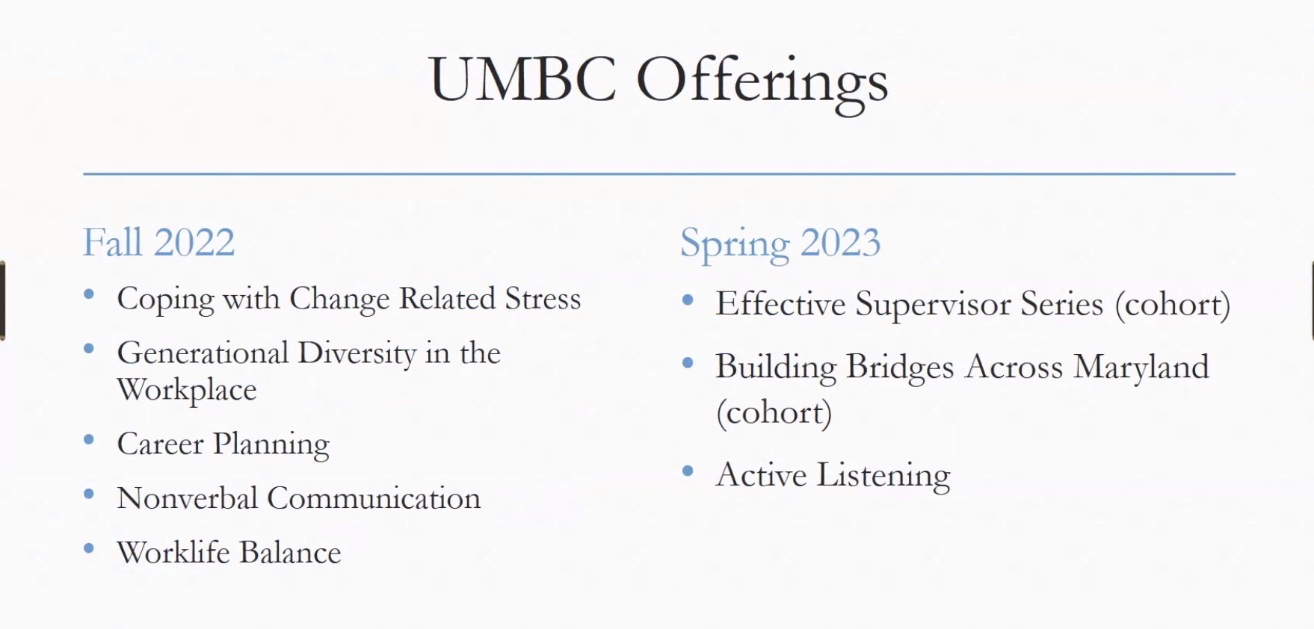
* 3:45 p.m. Retriever Essentials
  + Unexpected increase in volume
    - Every week we are setting records – for example 108 individuals visited the essentials space yesterday.
    - Every day this is increasing in people who are needing and taking items.
  + Why the jump in numbers?
    - Food is more accessible, space is better.
    - Inflation
    - Increased cost of living
    - Pell grants don’t cover as much
    - Increase in international students who cannot work off campus in year 1, but there aren’t enough jobs on campus
    - No access to grocery stores on campus
  + Most of the people who visit are Graduate Students – 66% - a lot of them are also international.
  + Is there a budget? We are not in the UMBC budget. In the future we have to partner with Maryland Food bank – we have to cost share.
  + **Monday at 5pm – volunteer opportunity to stock shelves, help however.**
  + Breakouts topics to brainstorm what we can do to support Retriever Essentials:
    - What can we do now?
    - What can we do next year?
* 4:15p.m.
  + Lori needs help with SOD and planning the staff & faculty social as part of homecoming

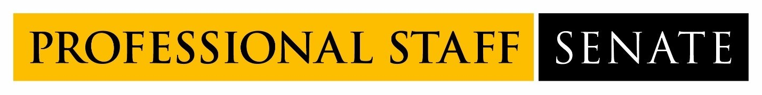

**2022-2023 Professional Staff Senate Meeting Schedule**  
  
**Meetings from 2:30PM – 4:30PM**

July 14, 2022

August 11, 2022

September 8, 2022

October 13, 2022

November 10, 2022

December 8, 2022

January 12, 2023

February 9, 2023

March 2, 2023

April 13, 2023

May 11, 2023

June 8, 2023