
Riparian Buffer
Tree Planting
White Hall, MD
Nov. 3rd,
10:00 am – 1:00 pm

Why: To restore a riparian buffer on a 23 acre conservation easement held by Gunpowder Valley Conservancy! We will be planting 125 native trees on half an acre on this easement along First Mine Branch. More than 29,000 trees have been planted in the Gunpowder Watershed by enthusiastic GVC volunteers since the early 1990’s and we need your help to plant even more!

Who: We are looking for students and adults who care about the Earth, our watershed, and the Chesapeake Bay! Do you like being outside in nature and don’t mind working hard? Do you have children who want to earn community service learning hours? Then come and join us, and make a difference for future generations!

When: RAIN or SHINE! Please Arive by 9:45 am to sign in. We will start planting at 10:00 am sharp to around 1 pm.

Where: North on I-83 to exit 27, Mt. Carmel Rd. Bear right onto Mt. Carmel Rd. At light turn right onto York Rd. Make first left onto Monkton Rd (Rt. 138) for .7 miles. Take 2nd left onto Big Falls Rd. for 2.8 miles-it turns into Hunter Mill Rd. Then go right onto Bacon Rd. House is on left, # 17925 just after stream crossing. Park along driveway or road off to side on grass.

Equipment: Remember to wear sturdy shoes, pants, long sleeve shirt, hat, gloves, and bring water bottle and rain gear. Refreshments will be provided.

To register for this event: Contact Peggy Perry, Program Director of Gunpowder Valley Conservancy at 410-692-0468 or at pperry@gunpowdervc.org.

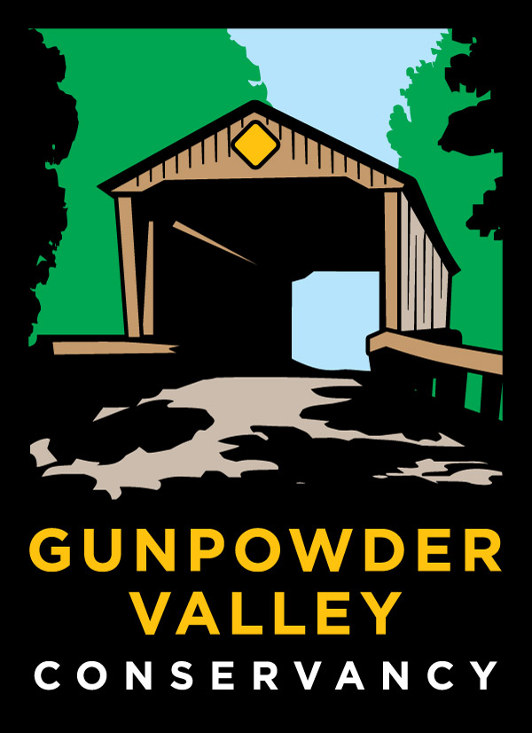
Funding provided by MD Dept. of Natural Resources.

