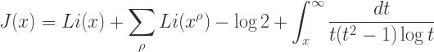
RELAX AND REFUEL
Games
Juice, Tea, Refuel Snacks
And More!
A

A
And More!

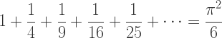

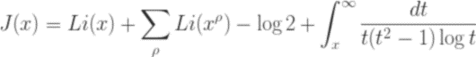
AOK Library Atrium and Gallery May17, 2017
12pm-3pm
Sponsors: Counseling Center, University Health Center & AOK Library & Gallery

