Council of Majors

HAPP COM MEETINGS

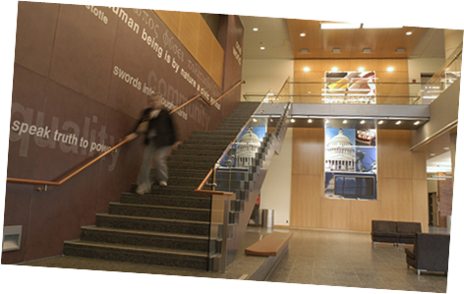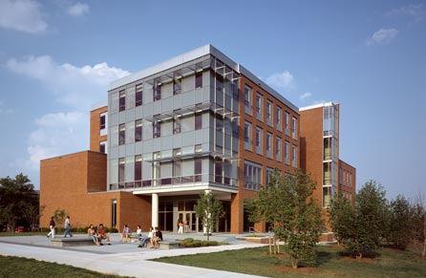

Every Wednesday @ 12 PM PUP 204
“It’s never too late or too early to get involved”

- Opportunity to meet and share information | - Discuss mutual interests.
- Resource of students seeking information regarding post-graduation goals | - Career networking and guidance with graduate school programs.
- Community Outreach Events | - Extra Credit Possibilities

The Council of Majors welcomes every Health Administration and Policy major to participate.

