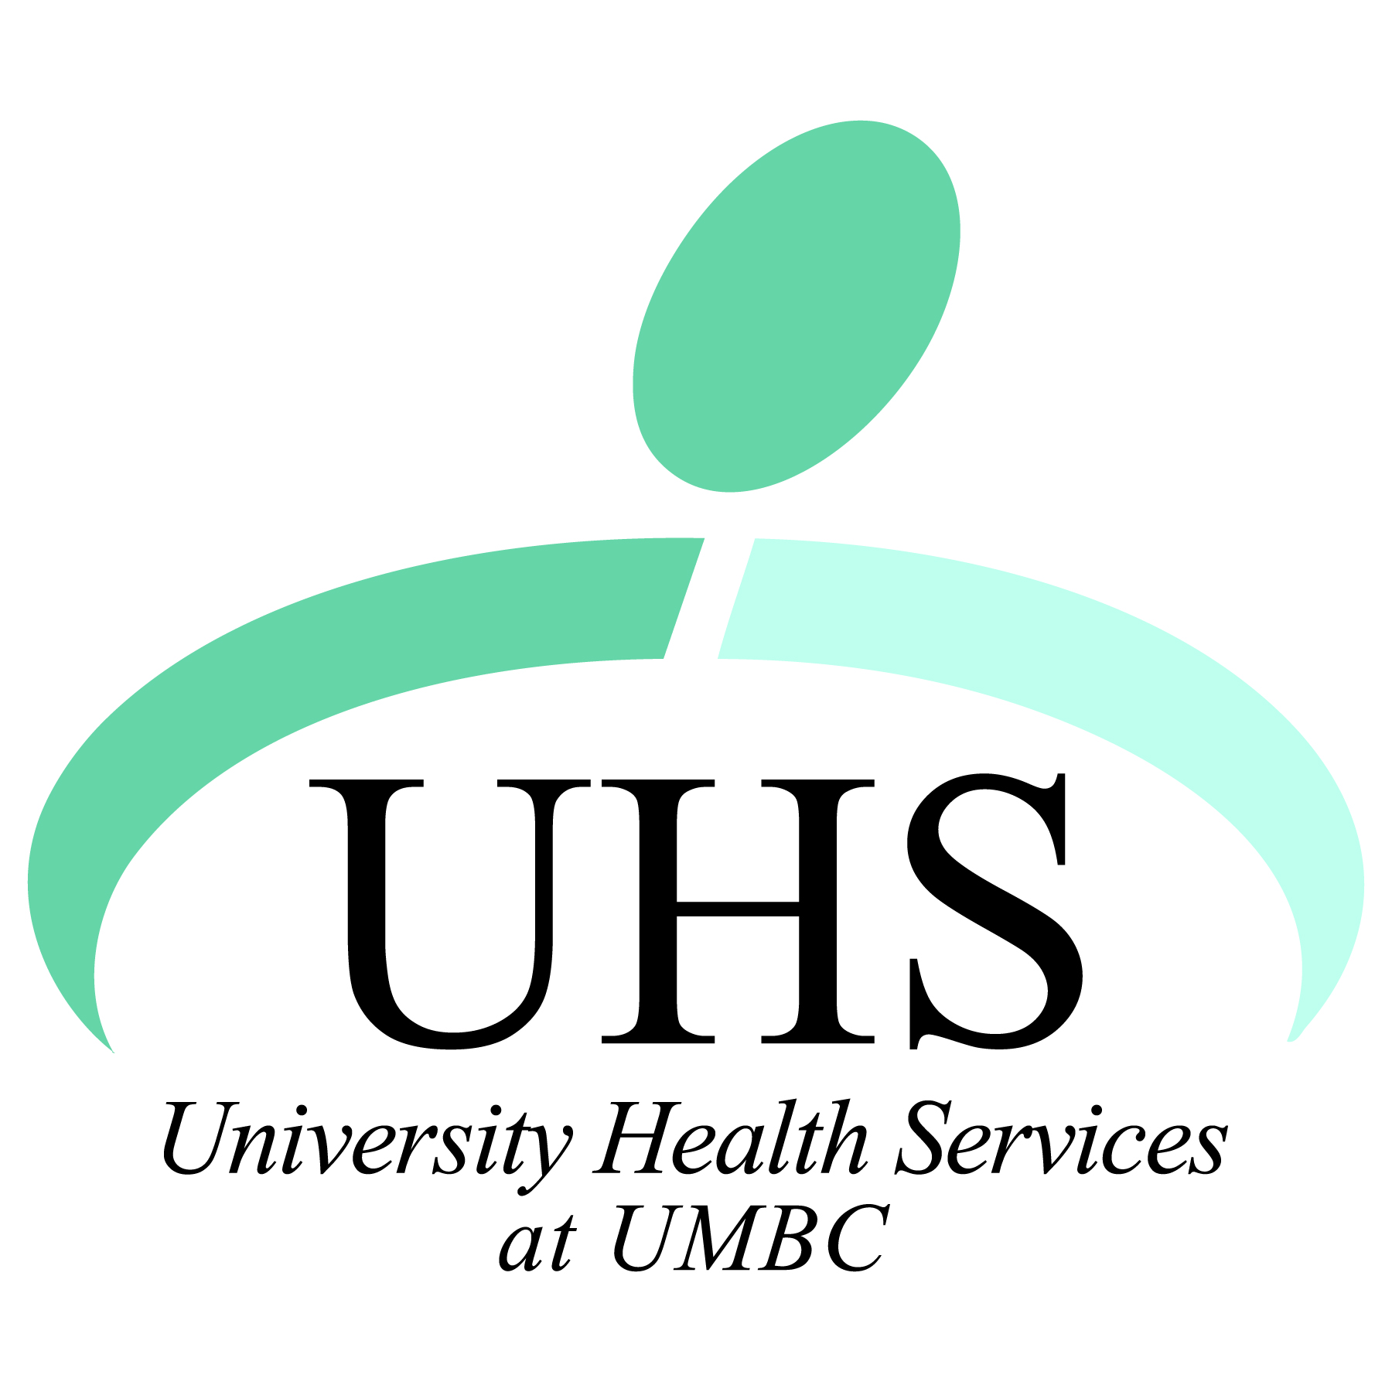

**Interested in Health Care?  
Want to Make a Difference at UMBC?**

**Join the   
Student Health Advisory Committee (SHAC)   
at University Health Services**

The Student Health Advisory Committee (SHAC) acts as a student voice to the staff and administration of University Health Services. SHAC is an advisory board of students who function as liaisons between UMBC students and UHS staff to help improve services and provide students with the best experience possible at UHS. Aside from their advisory duties, SHAC members get involved in some outreach events and programming efforts sponsored by UHS. SHAC usually meets once a month during the academic year.

Join SHAC today! You’ll be providing a service to the UMBC community while building your leadership skills.  
  
Meeting times are **12-1pm** on the following dates this fall:

*September 17*

*October 8*

*November 12*

*December 10*  
  
**Application deadline: Friday, September 7th**

Please contact Alison Rohrbach, [arohrbach@umbc.edu](mailto:arohrbach@umbc.edu), for more information.

**Student Health Advisory Committee**

**Member Application**

|  |  |
| --- | --- |
| **Name:** |  |
| **Expected Graduation Date:** |  |
| **UMBC Email:** |  |
| **Phone:** |  |
| **Major:** |  |
| **Other Campus Groups or Organizations You Belong To:** |  |

**Please answer the following questions on a separate sheet of paper.**

1. Why do you want to become a member of SHAC?
2. What qualities and skills do you possess that would make you a good fit for SHAC?
3. What do you see as the top 3 priorities for UMBC’s University Health Services? How would you address these priorities if you were a member of SHAC?

**Please submit applications to Alison Rohrbach at arohrbach@umbc.edu, drop them off at the front desk of University Health Services or fax to (410) 455-1125.**