Freedom From Smoking
It’s okay to be a quitter





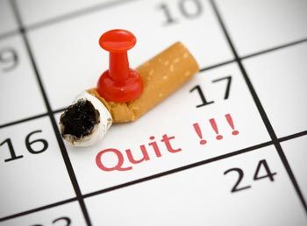

What: Freedom From Smoking Course
Where: The Commons, Room 318
When: Fridays, April 5 – May 10, 12-1pm

This 6-week course will help you quit smoking by discussing the obstacles you’ll face and how to conquer them. This class is FREE for students, faculty, staff, and the general public and quit smoking medications are available to those who qualify.

Sponsored by: University Health Services, Office of Health Education

For more information or to register for this quit smoking course,
call 410-455-1558 or email mdark1@umbc.edu.

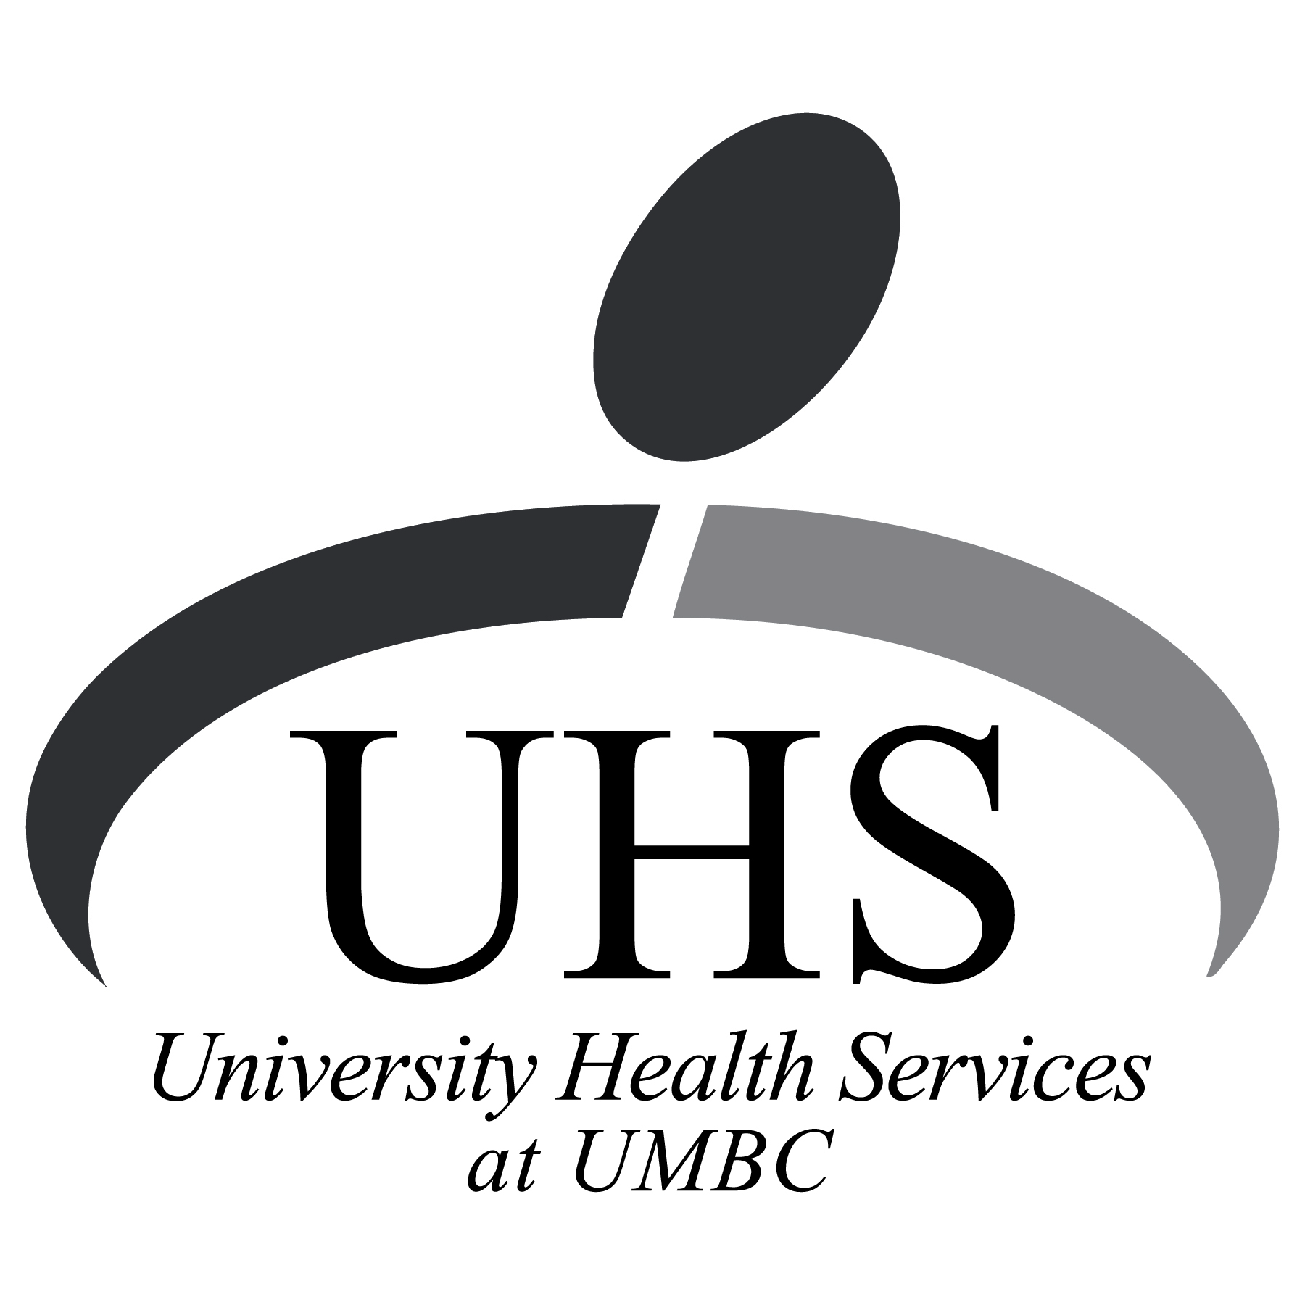
This program is made possible by funding from the Baltimore County Department of Health and the Maryland Cigarette Restitution Fund.

