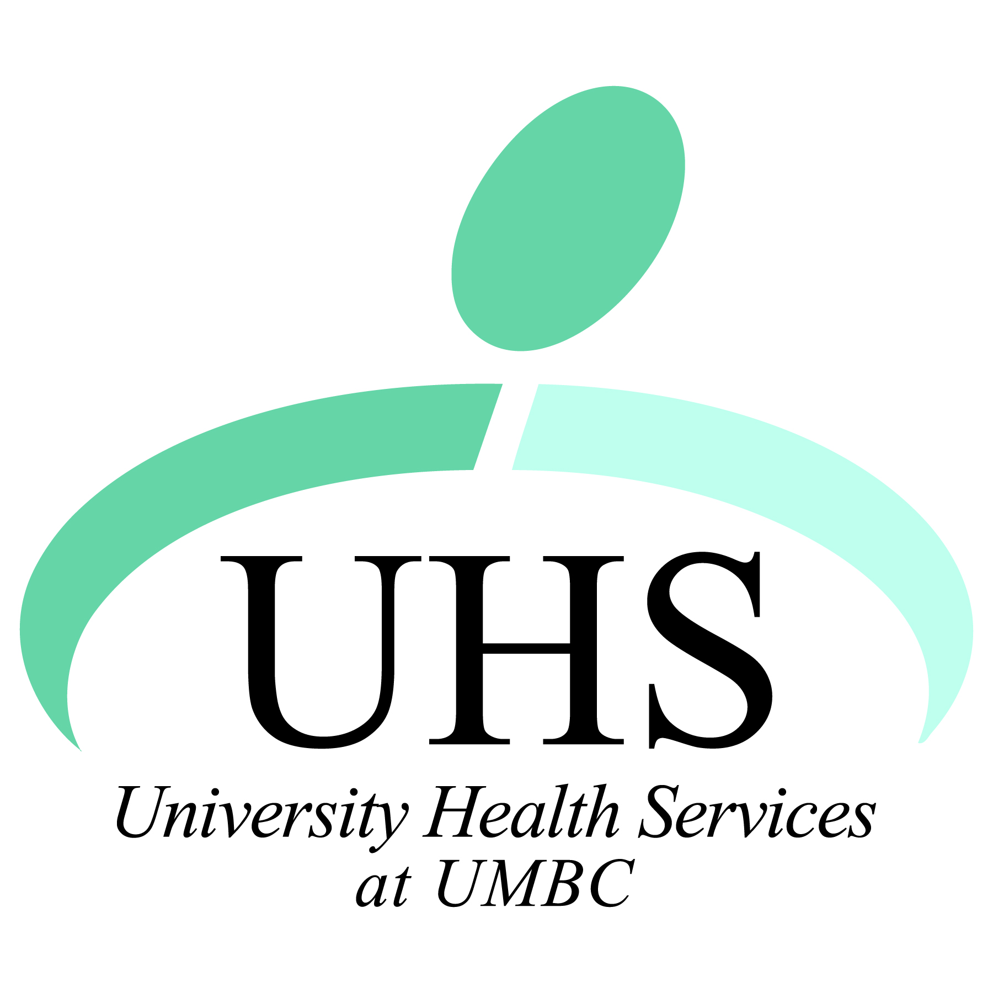
Interested in Health Care Administration?
Want to Make a Difference at UMBC?
Join the
Student Health Advisory Committee (SHAC)
at University Health Services
The Student Health Advisory Committee (SHAC) is looking for new members who will act as a student voice to the staff and administration of University Health Services. Members will function as liaisons between UMBC students and UHS staff to help improve services and provide students with the best experience possible at UHS. Aside from their advisory duties, SHAC members get involved in some outreach events and programming efforts sponsored by UHS.
Join SHAC today! You’ll be providing a service to the UMBC community while building your leadership skills.
Meeting times are 12-1pm on the following dates this spring and members are expected to attend all meetings:
February 25
March 25
April 22
May 13
Application deadline: Friday, February 15th, 4pm

Please contact Michael Dark, mdark1@umbc.edu, for more information.
Student Health Advisory Committee
Membership Application
Name:
Expected Graduation Date:
UMBC Email:
Phone:
Major:
GPA:
Other Campus Groups or Organizations You Belong To:
Where you heard about SHAC:

Please answer the following questions on a separate sheet of paper.

- Why do you want to become a member of SHAC?

- What qualities and skills do you possess that would make you a good fit for SHAC?

- What do you see as the top 3 priorities for UMBC’s University Health Services? How would you address these priorities if you were a member of SHAC?

Please submit applications to Michael Dark at mdark1@umbc.edu, drop them off at the front desk of University Health Services, or fax to (410) 455-1125.

