**Wretched Girls, Wretched Boys, and the Medieval Origins of the "European Marriage Pattern"**

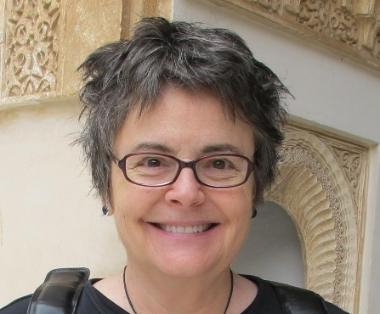

Professor Judith Bennett, Emerita USC

"Girl Effect," a new buzzword in development circles, argues that economies grow when girls marry later and get more schooling. This lecture skeptically examines its historical equivalent--the idea that "Girlpower" drove the extraordinary development of modern Europe. Professor Bennett shows, first, that late marriage began in Europe long before 1500, and second, that the impetus for this distinctive "European Marriage Pattern" was poverty, not prudential investment in girls.

**DEPARTMENT OF HISTORY**

**ANNUAL WEBB LECTURE**

Thursday, November 10, 2016

4:00pm

Library Gallery

*Refreshments served following the lecture