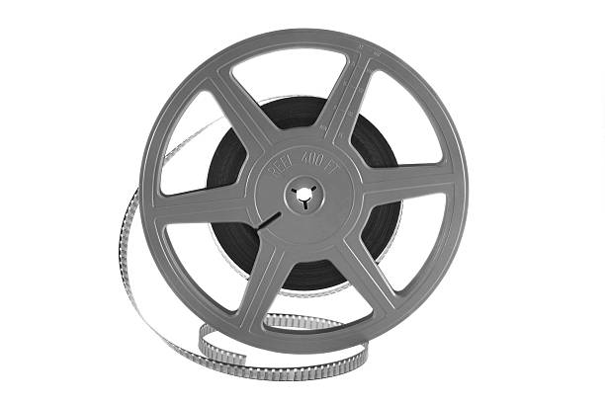

HISTORY IN THE NEWS

Come join us for a conversation led by

Professor Meredith Oyen

on “Walls, Borders, Visas: Today’s Immigration Headlines in Historical Context”



All students welcome.

PIZZA will be served.

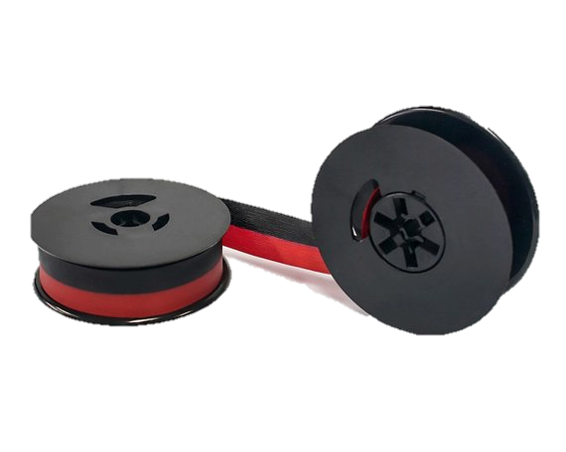



Wednesday, February 27, at noon

in the History Department Classroom

(Fine Arts 533).

Questions?

email Prof. Froide at [froide@umbc.edu](mailto:froide@umbc.edu" \t "_blank)