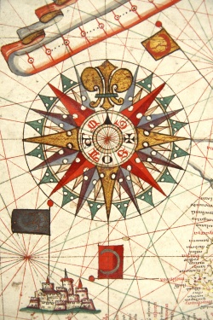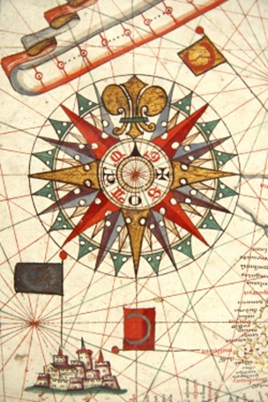
To satisfy the History Major, students must complete 24 credits of Elective History Courses. These must be chosen from the upper (300 and 400) level and include a minimum of 9 credits in U.S. history and a minimum of 12 credits in European, Asian, Latin American, Middle Eastern or African history.

History 2021 Summer Course Offerings

Session I (06/01/21-06/25/21)
HIST 347 The United States Since 1945 4 Weeks Howard Smead
Online, TBA. Counts towards: Social Sciences (GEP or GFR)
An examination of American history from the 1940s through the 1990s. Primary emphasis is given to political, social, and economic history. Recommended Preparation: Any 100 level social science course.

HIST 360 Islam in Africa 4 Weeks Gloria Chuku
Online Mon/Wed/Fri 1:00-4:10 Counts towards: Culture (GEP or GFR), Social Sciences (GEP or GFR)
This course is presented to provide the student with an introduction and overview of the history of Islam in Africa: its origins, philosophical thought, praxis, and expansion. Recommended Preparation: one of the following: AFST 211, AFST 212, HIST 242, HIST 243.

HIST 381 From Samurai to Salariman: Japanese History through Film and Literature 4 Weeks Constantine Vaporis
Online, TBA. Counts towards: Culture (GEP or GFR)
A study of Japanese history from 1600 to the present through the media of film and literature. It also explores the relationship between history and drama, in particular how they can illuminate or conceal basic truths and values of the past. Views of life and modern times, obsessions with honor and suicide, the changing role of women in society, the encounter between Japanese and foreign cultures, and themes of war and pacifism will be investigated. Recommended Preparation: Any 100 level social science course.

HIST 382 Pacific Crossings: Race, War, and Gender in Asian Migrations 4 Weeks Meredith Oyen
Online, TBA. Counts towards: Culture (GEP), Social Sciences (GEP)
In this course, we will study the transnational history of Asian migrations from the mid-nineteenth century to the present, placing particular focus on Chinese, Japanese, Korean, Filipino, Indian, Vietnamese, and Hmong migrations. We will examine the tumultuous history that both sparked migrations and, at times, tried to prevent them in an effort to understand what was happening in homelands left behind and American destinations, along with the networks of communication and travel that connect them. Recommended Preparation: Any lower level social science course.

Session II (07/12/21-08/20/21)
HIST 103 East-Asian Civilization 6 Weeks Julie Oakes
Online Tu/Thu 9:00-12:10. Counts towards: Culture (GEP or GFR), Social Sciences (GEP or GFR)
A history of traditional society in East Asia, focusing on China and Japan, but touching also on Korea and Vietnam. This course will introduce the principal elements of East Asian civilization before the intrusion of the West in the 19th century. It also will provide an essential historical perspective to developments in contemporary East Asia.

HIST 306 The First World War 4 Weeks Mary Laurents
Online, meets TBA. Counts towards: Social Sciences (GEP or GFR)
Origins, nature, and impact of the First World War. Particular emphasis is placed on the military, diplomatic, social, scientific, and technological developments, events of the war years, and how this first total war affected the subsequent history of the United States and Europe. Recommended Preparation: Any 100-level social science course, junior/senior status, or permission of the instructor.

HIST 320 Atlantic Revolutions on Film 6 Weeks Terry Boulton
Online, asynchronous. Counts towards: Culture (GEP)
This course uses documentary and feature-length films to examine the revolutions that spread across the Atlantic World in the late 18th-19th century, a period often called the “Age of Revolutions.” Students will view films on the American, French, Haitian, and Latin American revolutions to analyze how film is used to portray history and why filmmakers have treated each of these revolutions so differently. Recommended Preparation: HIST 340.

For a complete list of courses that satisfy the History Major, consult the website: history.umbc.edu.

