Honors College Fall Contests!

1. Design the 2023-2024 Honors College T-Shirt!
It has been our tradition in the Honors College to have the students design a t-shirt for us each year...and we want you to be a part! Not a particularly artsy person? No worries! Our past winners have come from all majors.

Here are the guidelines:

1. Designs must be in one color and appear on only one side of a shirt.

2. Designs should include graphics and (appropriate) words only, with no background. They should not include copyrighted material.

3. Designs must include the words "UMBC Honors College."

4. Please submit in either a "print ready file in AI" OR a HIGH-RES PDF.

The deadline for submissions is Thursday, September 14th, by 11:59pm to honorscollege@umbc.edu. Voting will begin Friday, September 15th and run through Monday, September 18th at 11:59 pm.

Check out some of the previous winning designs to get those creative juices flowing!

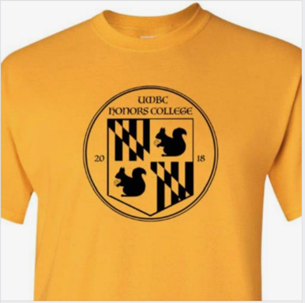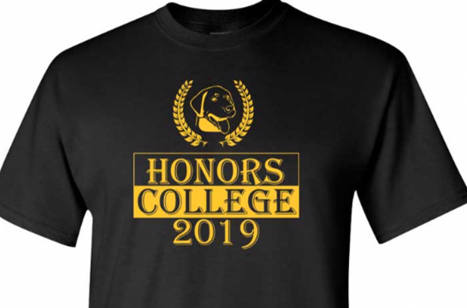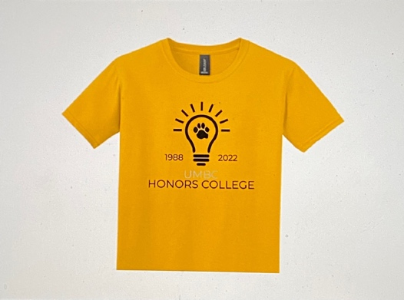

2. HCC Freshman and Transfer Rep Elections!
We hope your first few days at UMBC have been great! We know there are many exciting new opportunities here...and we are going to present you with another one :-)

The HCC – the Honors College Council – is our student government organization that plans exciting events for our students, such as Lunches-in-the-Lounge (LITL), movie nights, the Retriever Trivia Bowl, and many more! Every fall, the HCC brings on two freshman reps and one transfer rep to infuse the council with new energy and new ideas...and that Rep could be you!

If you are interested in running, please send a one-paragraph blurb to honorscollege@umbc.edu by Sunday (9/24), 11:59pm, as to why you think you'd be a good addition to the HCC; in addition, please send a photo so the voters can put a name to a face. Once we get the blurbs and photos, we will make a ballot and send it to you all to vote!

Again, it is a GREAT way to get to know more folks in the Honors College and have an active role in planning Honors College events. If you have any questions, you can email Yachi Madaan, the HCC President, for more information at yachimn09@umbc.edu!

3. Halloween Costume Photo Contest!
Too old, perhaps, to Trick or Treat? But you are NEVER too old for a Halloween Costume Contest—especially when it is based on your cosplay game!

Here is what you need to know/do to join in on the fun:
- By 11:59pm on Thursday, October 26th, send us two separate images: 1) a .jpeg, screenshot, etc., of the character or person you are dressing as, 2) a photo of yourself dressed as that character or person.
- Send to honorscollege@umbc.edu with the email title: Costume Contest: Your Last Name
- We will compile a "ballot" and open voting on Friday, October 27th. Yes, there will be PRIZES for the Best Costume in a number of different categories.

Please keep in mind that this is a family show, so to speak; also, if you have an idea but are concerned it might be an example of cultural appropriation (vs. one of cultural appreciation), ask one of us in the Honors College. We'd be happy to talk it through with you!

Winners will be announced—you guessed it—on Halloween. Enjoy some of these past submissions!

