August/September
2019
Sunday | Monday | Tuesday | Wednesday | Thursday | Friday | Saturday
 | AUGUST | 27  Induction 12:30-3pm Sherman Hall  Convocation 3:30pm UMBC Event Center | 28  Welcome Cookies starts at 9 am  Honors College Lounge | 29 | 30 | 31
1 | 2 | 3 | 4 | 5 | 6 | 7
 | Labor Day—No Classes |  | Fall Involvement Fest 12-2pm Erickson Field
8 | 9 | 10 | 11 | 12 | 13 | 14
 | First Day of Forum  4-6pm Sherman 003  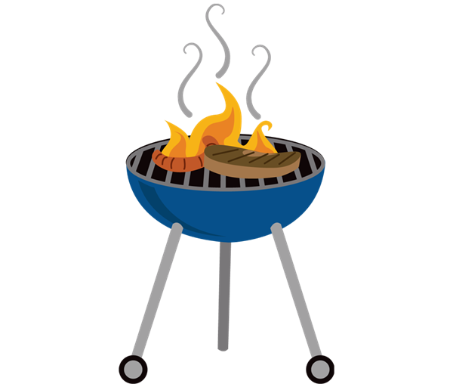  Annual Picnic 6:30- 8pm |  |  |  |  | 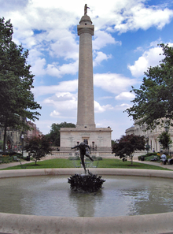  Tour of Baltimore’s Mt. Vernon Neighborhood
15 | 16 | 17 | 18 | 19 | 20 | 21
 | Meet & Greet with HC Staff  6:30-8:30 pm  SUS Basement Community Lounge |  | 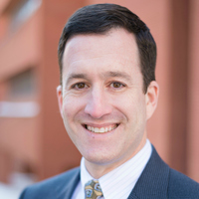  Lunch in the Lounge: David Hoffman  12-1pm  Honors College Lounge
22 | 23 | 24 | 25 | 26 | 27 | 28
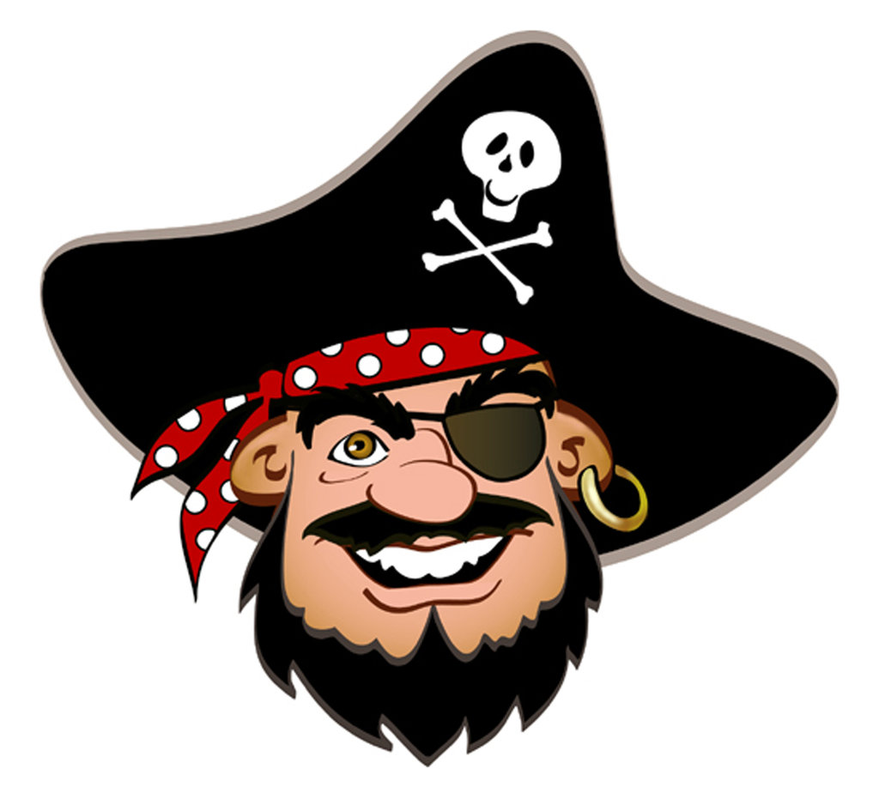
MD Renaissance Festival—Pirate Weekend

29 | 30

