PeopleSoft 9.2 Finance Fundamentals

Participant Manual

Version 1
June 2018

Introduction

PeopleSoft is a web-based application that is used to store and process UMBC's data resources. It provides a large suite of integrated software applications that manage data and communications for human resources, accounting and finance systems. The PeopleSoft system provides accurate, timely information ensuring sound business recommendations and decisions.

Learning Objectives

The purpose of this course is to provide basic PeopleSoft Finance knowledge, information and tools to effectively navigate and within PeopleSoft Finance 9.2.

After completing this course, you will be able to:

- Access and understand the use of the PeopleSoft Finance database.
- Identify and use chartfields in PeopleSoft Finance transactions
- Navigate PeopleSoft Finance menus and individual pages.
- View data in PeopleSoft Finance using features such as reports and queries.
- Use the UMBC RT ticketing system to request help.

How to Use this Manual

Throughout this manual and course, you will notice several different presentation methods being used to present the material. As you progress through the course, an attempt has been made to notify you in the manual which presentation method will be used for each section of the course. The various approaches that you will encounter, and their impact to you, the learner, include:

Discussion: A presentation outside of the application, or a discussion by the Instructor. This approach is used to present new materials and context prior to moving onto the next level of the course.

Demonstration: The Instructor will demonstrate on the instructor’s computer how to complete a task in PeopleSoft. It is meant to provide an example of how to accomplish a task prior to having you perform the same task. At this time, you should not follow along with the instructor on your computer, unless instructed to do so.

Hands-on Practice: You will follow along with the instructor on your computer while performing a task in PeopleSoft.

Stand-alone Practice: You will complete the steps presented in the course materials to accomplish a task on your computer, without the instructor following along on the instructor computer.

Informational: Information is provided in the manual for your information, but may not be covered by the instructor in the course.

TIP
Tips provide you with best practices.

The course section(s) of the manual include step by step instructions for performing each task, along with explanations where appropriate. Whenever possible, the steps and explanations have been created to provide a general overview of the entire system.

Please note that updated copies of all supporting documentation can be found at: https://financialservices.umbc.edu/9-2-training/ and on the TAP (Toolkit for Administrative Professionals) page.

Course Overview

Field | Description
Audience | This course is for any of the following end users of the PeopleSoft Finance system:  - are new to PeopleSoft Finance or  - need a refresher course in PeopleSoft Finance fundamentals.  End users can be any staff/faculty on the UMBC campus: department directors, accountants, business service specialists, faculty in any department, administrative assistants, divisional coordinators etc.
Prerequisites | PeopleSoft Security Access forms approved based on user roles  A basic knowledge of computers is required.  NOTE: An accounting background is not necessary for using PeopleSoft for different accounting functions.
What is covered in this Class? | The purpose of this course is to provide basic PeopleSoft Finance knowledge, information and tools to effectively navigate and within PeopleSoft Finance 9.2.  After completing this course, you will be able to:  - Access and understand the use of the PeopleSoft Finance database.  - Identify and use chartfields in PeopleSoft Finance transactions  - Navigate PeopleSoft Finance menus and individual pages.  - View data in PeopleSoft Finance using features such as reports, inquiries and queries.  - Use the UMBC RT ticketing system to request help.  Hands-on practice will be combined along with the demonstration of different activities performed in PeopleSoft Finance.
Length | The length of this course is 2 hours.

Training Agenda

TOPIC | TIME
INTRODUCTION | 5 minutes
LEARNING OBJECTIVES | 5 minutes
MODULE 1: PEOPLESOFT BASICS | 10 minutes
MODULE 2: PEOPLESOFT FINANCE TERMINOLOGY | 10 minutes
MODULE 3: ACCESSING PEOPLESOFT FINANCE | 10 minutes
MODULE 4: NAVIGATING IN PEOPLESOFT FINANCE | 30 minutes
MODULE 5: RUNNING REPORTS USING PEOPLESOFT | 20 minutes
MODULE 6: RUNNING QUERIES USING PEOPLESOFT | 5 minutes
MODULE 7: REX FINANCE REPORTS | 10 minutes
MODULE 8: GETTING HELP | 5 minutes
CLOSING QUESTIONS | 10 minutes

Module 1: PeopleSoft Basics

The purpose of this module is to introduce basic PeopleSoft concepts, which will prepare you for using the system.

At the end of this module, you will be able to:

- Discuss the purpose of each of the PeopleSoft Databases
- Discuss PeopleSoft Security

UMBC PeopleSoft Databases

PeopleSoft provides a single system for multiple users to enter and retrieve data that is necessary for the University to record and manage transactions and provides detailed information to make decisions in the form of reports.

PeopleSoft is a relational database. Relational databases provide multiple locations for data to be stored and retrieved. These data items are known as attribute values or fields.

The data is stored in tables which allows for the generation of queries, which can be delivered to the user in the form of a report. This information is provided in real time, there is no delay in the accessing of information once data has been input.

UMBC uses 3 PeopleSoft databases:
Finance, Human Resources and Student Administration.

Database | Why is it used? | URL
Finance | This database stores information related to departmental financial activities. You can use this database to process and locate: P-card transactions, Journal Entries, Grants, Projects, Accounts Payable and Accounts Receivable activities, General Ledger and other financial activities. | https://financialservices.umbc.edu/
Human Resources | PeopleSoft Human Resources, which is used to enter and report on human resource activities, such as Payroll. | https://hr.umbc.edu/
Student Administration | Student Administration which consists of Student Recruitment, Admissions, Student Records, Financial Aid, Student Billing, and Academic Advisement. | http://enrollment.umbc.edu/sa/

TIP: CHANGING PASSWORDS IN PEOPLESOFT

Changing your password in one PeopleSoft database does not impact other PeopleSoft database passwords.

Security Rights for Accessing PeopleSoft Databases
Discussion

Before you can use PeopleSoft, you are granted security access rights into the application. Your security access is dependent upon your role within UMBC. You can be granted several different access rights into PeopleSoft for each database as well as each form or table in the application. The different types of access rights you may receive include:

- No Access: If you have no access to a particular area of the application, you will not be able to see an option on your PeopleSoft work center. For example, if you do not work with Grants, you will not be able to see the Grants menu option.

- View Only Access: if you have view only access to an area of the application, you will be able to see the option on your PeopleSoft menu, but you would only be able to view the information on the screen. Most reports in PeopleSoft are view only, which means you are unable to effect the information in the database, regardless of the buttons or actions you take with the report

- Edit Access: If you have been granted edit access to an area of the application, you will be able to input information into the application. Depending on the level of edit access you have been granted, you may or may not be able to also delete information.

If you require a level of access that you do not have in the application, please complete a Security Access Form and return it to the appropriate team for processing. Instructions for completing the form and where to send it for processing are included in the security form information section of the website.
Security forms are located here .

Which Database are you Accessing?
Discussion

To identify which database is being accessed, look at the URL for each.

- The Finance website’s URL starts with fsprd (fsprd stands for finance production database.)

- The Human Resource website’s URL starts with csprd (csprd stands for campus solutions production database.)

- The Student Administration website’s URL also starts with csprd under the Student Administration page accessed through myUMBC.

Module Summary:
- There are separate and distinct PeopleSoft databases implemented at UMBC: Finance, Human Resources and Student Administration.

- It is recommended that you access PeopleSoft via myUMBC.

TIP: USING MORE THAN ONE PEOPLESOFT DATABASE
In order to use two PeopleSoft products at the same time, please open two different
Internet Browsers.
For example, access PeopleSoft Finance in Internet Explorer and Human Resources using Firefox.
This will prevent error messages and disruptions.

Module 2: PeopleSoft Finance Terminology

The purpose of this module is to introduce basic PeopleSoft concepts, which will prepare you for using the system.

At the end of this module, you will be able to:

- Discuss chartfields, chart strings and UMBC accounting principals

PeopleSoft Finance Terminology

In order to process a transaction in PeopleSoft, users must use codes called Chartfields. Chartfields are informational fields that categorize transactions and apply the transactions to budgets.

A series of chartfields is referred to as a Chartstring. Every action in PeopleSoft requires a Chartfield String in order to submit paperwork and enter, research, and interpret data in the PeopleSoft databases.

Chartfields and Chartfield Strings are required to:

- Generate reports
- Access data
- Perform transactions in PeopleSoft
- Complete forms
- Allocate expenses

When departments make purchases, allocate expenses, and receive revenue, all paperwork associated to these activities requires that the appropriate chartfields be completed in order for the Finance Departments to process the paperwork.

There are 10 chartfields in PeopleSoft Finance, however, not all chartfields are required for every transaction. Some chartfields are specific to grants or sponsored accounts.

For example, chartfields associated to General Ledger transactions are commonly referred to as GL Chartfields. The Chartstring for the GL includes:

- Business Unit
- Department
- Fund Code
- Account
- Prog Fin
- Fiscal Year

Chartfields Explained

The following table provide definitions and examples of commonly used chartfields.

Chartfield | Example | Definition
Business Unit | UMBC1  (all PS 9.2 Finance transactions are under the default) | A set of financial records, business practices and reporting requirements
Department ID | 10118 – New Media | An organizational unit responsible for business transactions
Fund | 1111 = State Fund  1113 – Self Supporting Fund (DRIF)  1253 = Grant Fund | Identifies the source of UMBC funding
Account | Revenue – 4XXXXXX  Payroll – 6XXXXXX  Operating Costs- 7XXXXXX | Classifies business transactions by categories that include assets,  liabilities, net asset (fund balance), revenue and expenditures.
Project/Grant | 00000444 CASPR | Provides link for financial transactions to the grant management database
Prog Fin  (Program Financial) | 011- Instruction- General  012 Instruction- Special  021 Research Institutes/Centers  022 Research – Individual | Codes that categorize the expenses. All department budgets have been created with specific Prog Fins to be applied to transactions

Financial and HR Terminology

Below is a chart of commonly used terms that relate to financial processing within PeopleSoft.

Term | Definition
Job Data | Information used to identify an employee’s title, status, compensation, classification, and benefits eligibility required to generate pay for services rendered, as well as other on/off campus reporting activities.
Personnel Data | Key information outlining employee personal attributes such as name, address, race, birthplace, social security number, citizenship and visa status, veteran’s status, etc. required for University, State and Federal reporting as well as payroll taxation.
Time Entry | Mechanism used by departments to record hours worked, leave taken and other exceptions to employee which ultimately result in payment to the employee.
New Hire Personnel Action Request (PAR) | Document used to gather personnel and job data for new employees.
Change PAR | On-line mechanism used by departments to request changes to personnel and job data for existing employees.
Combination Code | A PeopleSoft generated number used by the HR database to encapsulate the Chartfield String used in PeopleSoft Finance and identify funding source for positions/jobs.
Position Management | A term to describe the actions related to the classification and compensation activities within the university.
Department Budget Earnings | Identifies how current and future payroll funds for a position are to be distributed financially across fund sources.
Retro | Refers to the Retroactive Change Form, which is used to modify how payroll was distributed historically.
General Ledger | The final ledger in the financial system which holds all financial transactions used for external and summary financial reporting and financial management.
Commitment Control | Finances that have been reserved for a specific financial transaction, prior to final approval and posting to the General Ledger.
P-card | Procurement Card – similar to a credit card used for purchases
Project | An event or activity that has a specific beginning and end date.
Grants/Contract | Money awarded to departments by a Sponsor for the purpose of providing products and/or services for a specific project.
State Funded | Money appropriated to UMBC by the State of for the purpose of administering education services to students.
Pre-encumbrance | Money requested to be used for a specific purpose – a Requisition.
Encumbrance | Money approved and reserved to be used for a specific purpose – a Purchase Order.
Journal Entry | Adjustment made directly in the General Ledger
Journal ID | Transaction identification number used to identify Journal Entries. This number appears on budget detail reports and is used to research budget line item details.

Module 3: Accessing PeopleSoft 9.2 Finance

The purpose of this module is to provide step by step instructions to access PeopleSoft 9.2 Finance.
At the end of this module, you will be able to:

- Locate the link via the myUMBC portal
- Save the PeopleSoft Finance link as a favorite

Accessing PeopleSoft Finance
Hands-on Practice

This section will walk you through the procedure for accessing PeopleSoft Finance.

TIP: WEB BROWSER
It is recommended that you use the most current version of Internet Explorer for accessing PeopleSoft.

It is recommended that you access PeopleSoft Finance via myUMBC. The steps to access PeopleSoft are below:

- Open Internet Explorer by clicking Start Programs Internet Explorer.

- Type www.umbc.edu in the Address Bar and press the Enter button on your keyboard.

- The following webpage displays:

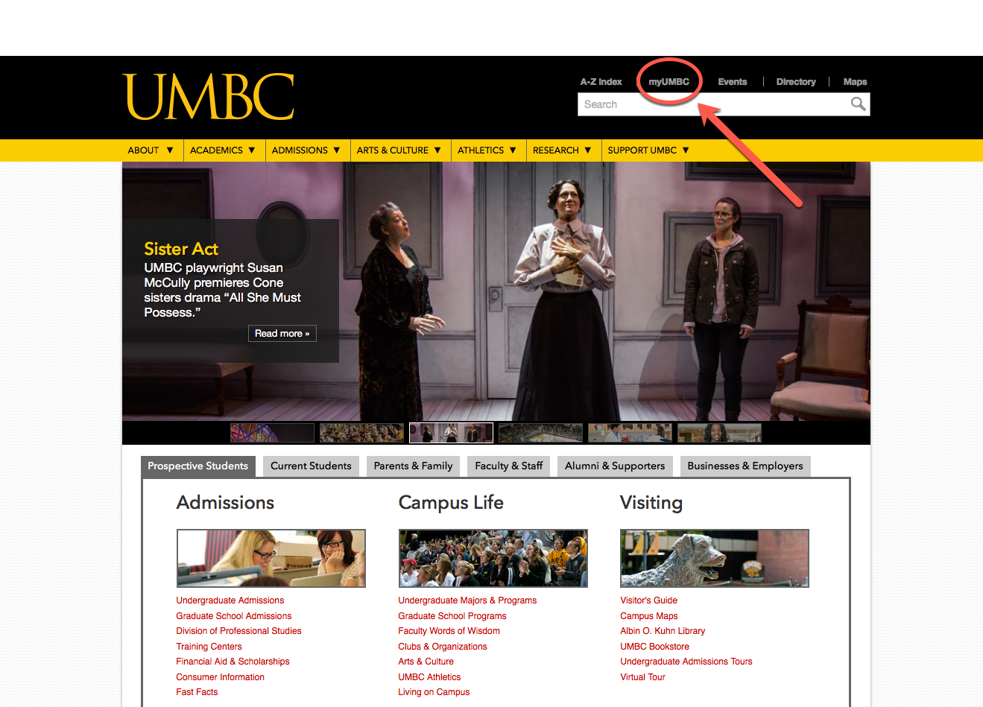

- Click the myUMBC link. The myUMBC webpage displays. (Alternately, you may type my.umbc.edu in the Address Bar in Internet Explorer and access the myUMBC webpage directly.)

- Click the green Log In button in the top right corner.

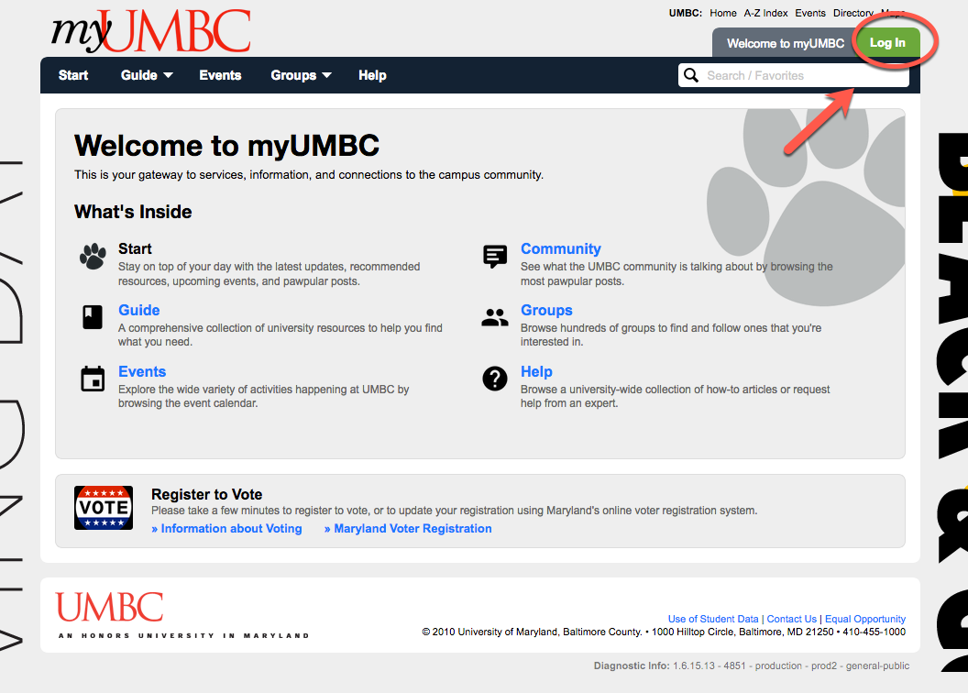

- Type your username and password in the Username and Password fields on this webpage.

- Click the Log In button.

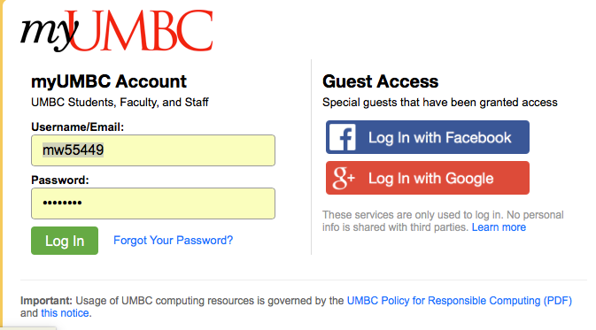

The following webpage displays. By selecting Staff, you will display the department options based on your specific role at UMBC.

- Click the Guide drop down menu.

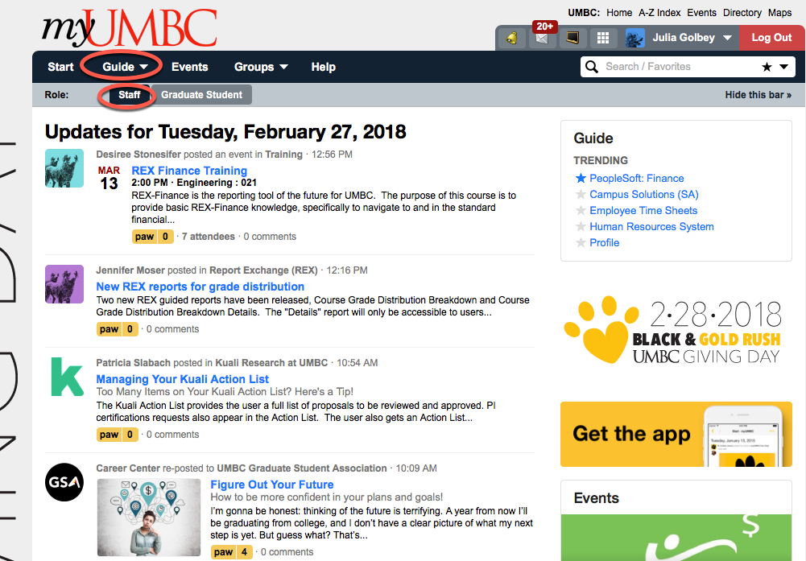

- Click on Financial Services and Accounting

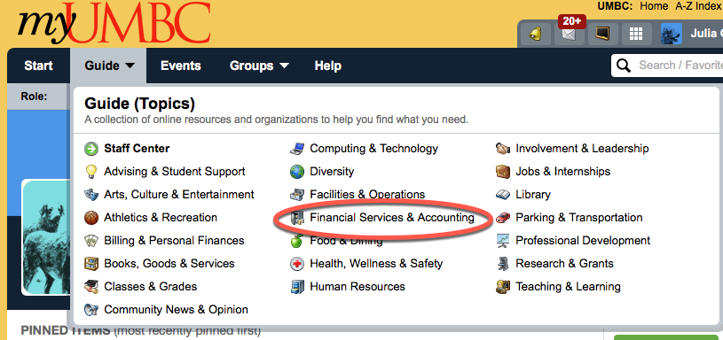

- Click on PeopleSoft: Finance

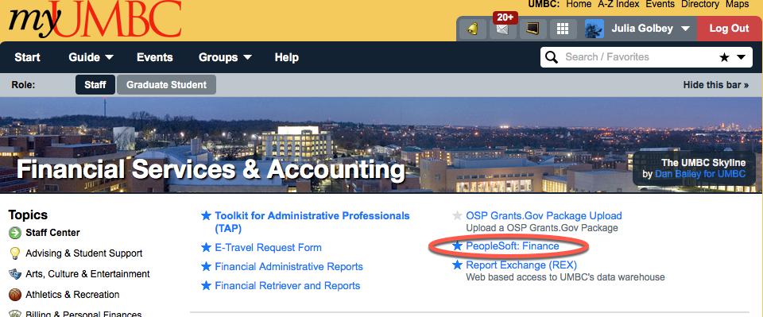

TIP: FAVORITES

To make a menu option a Favorite, please click on the Star to the left of each option. It will appear on the left hand column under Favorites. This saves you a few steps when using myUMBC to get to PeopleSoft.

TIP: INACTIVITY WARNING
If you are inactive in PeopleSoft for 120 minutes, the system will display a warning sign informing you that you will be logged off. It is very important that you save your work or the current information that you are working on will be lost.

Module 4: Navigating in PeopleSoft

The purpose of this module is to identify and learn the most common navigation tools available in PeopleSoft 9.2 Finance.

At the end of this module, you will be able to:

- Access the Campus WorkCenter
- Identify pending items within the WorkCenter
- Identify Different Navigation Icons.

PeopleSoft Finance Landing Page - Employee Self Service

The Employee Self Service page is the default page you will see when logging into PeopleSoft Finance. All campus users can use the Campus Workcenter to access everything that they regularly use in PeopleSoft. Departmental Approvers and Central Employees may also see a tile called Approvals.

If you see additional tiles, it means that you have more of a centralized role. Use those tiles to access menu options that relate to central tasks.

Note: Your WorkCenter is configured based on your security access, therefore there may be less tiles. All PeopleSoft Finance users will have the tile labeled Campus WorkCenter.

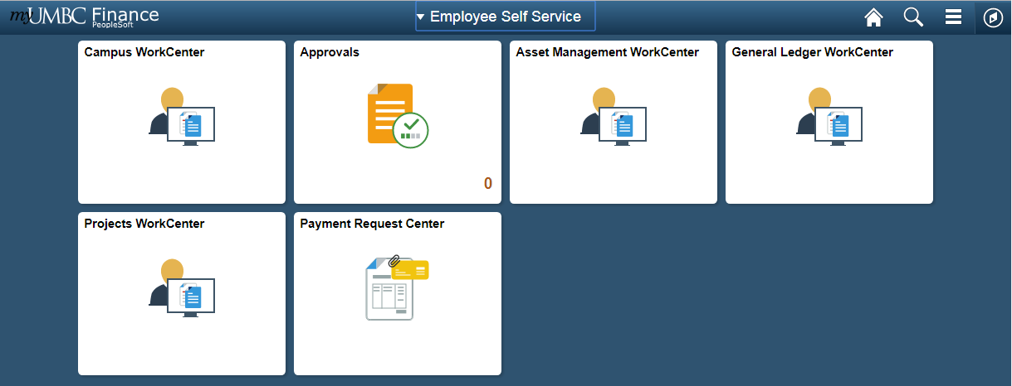

Navigation Bar
Search
Home

In addition to tiles, the WorkCenter has icons at the top right: Home, Search and the Navigation Bar.
We will discuss the navigation tools in this module.

PeopleSoft WorkCenter
Hands-on Practice / Demonstration

All Workcenters are divided into four general areas, called pagelets. On the left-hand side you will see the navigation bar, with two tabs, and two sections on each tab.

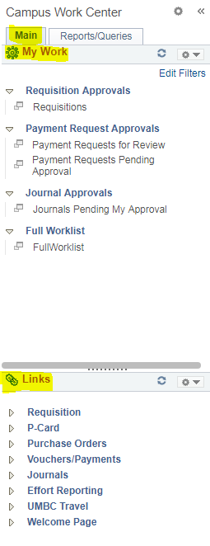

There are additional navigational tools for the pagelets that appear when your cursor hovers in the area: one is a right-hand vertical scroll area. You can left-click the scroll once it appears, hold down the cursor and drag the scroll bar up or down.

TIP: RIGHT CLICK IN PEOPLESOFT
Point to the desired hyperlink and RIGHT CLICK, then select “Open in a new tab” or “Open in a new window” to open the application in a new tab/window, while leaving the current window opened as well.

Using the My Work Section

Hands-on Practice / Demonstration

On the main tab, you will see a My Work section with hyperlinks to task pages.

The My Work pagelet can include links to events and notification alerts, prioritized items needing immediate attention, and work list tasks for workflow approval.

The hyperlinks ONLY become active when you have tasks to complete in that section. Otherwise, the hyperlink is grayed out and you cannot click on it. Hyperlinks are only visible to a user if they have access to the corresponding pages they link to. When a user has work to do, the hyperlink becomes clickable. A number will display in parenthesis next to the link letting you know how many items require attention in that area.

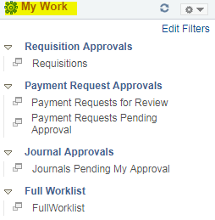
After clicking on Requisition Approvals, the hyperlink Requisitions is shown. However, as there are no pending items, the hyperlink is grey.

TIP: SINGLE CLICK IN PEOPLESOFT
You only need to SINGLE CLICK a button or link to execute actions/commands anywhere in PeopleSoft.

Links

Hands-on Practice / Demonstration

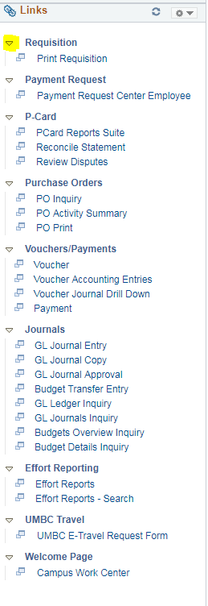
The Links pagelet makes it possible for you to access your most commonly-used pages with full functionality without ever leaving your Workcenter.

Each pagelet can include group headings. Group headings are used to place similar pages and links into logical groupings, and are expandable and collapsible.

If you do not have access to all links under a group heading, that group heading will not appear for you.
The group headings themselves are not clickable. You have to select the dropdown arrow next to the group heading to expand the menu options, which opens up all links related to that group heading. Those links are clickable.

The Links pagelet can include additional links to pages and other areas of interest including links that are external to your organization.

You can personalize (from the list enabled by your system administrator) which links appear on your Workcenter.

Navigating with Breadcrumbs

Hands-on Practice / Demonstration

Once inside a work center, you will also notice that a top menu bar appears, showing “breadcrumbs” of where you’ve been. The breadcrumbs are not visible on the Employee Self Service page (the Home page)

This is an interactive bar that shows menu options.

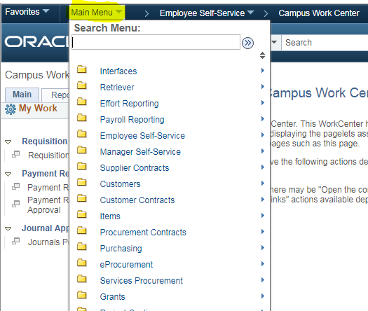

NavBar: Navigator

Hands-on Practice / Demonstration

You can access the menu options by clicking on the compass symbol called NavBar in top right hand corner of every page. This will bring up a side menu bar.

From there, click on the Navigator Menu option. This will bring up the main menu options.

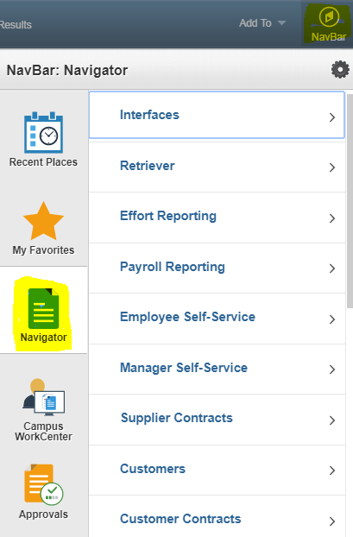

As a general tip, if you drill down to a specific menu option, the next time you go into Navigator it will “remember” the last menu option you drilled down to. So you may have to hit the back bar at the top of the navigator menu tree to see the main menu options again.

Favorites

Hands-on Practice / Demonstration

You can get to your favorites by one of two ways. The first is by using the top breadcrumb bar. The favorites will be right next to the main breadcrumbs, in the top left hand corner:

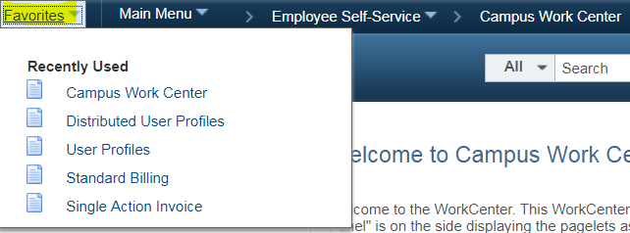

NOTE: You cannot access the breadcrumb bar from the home page (the Employee Self Service page).
The second way to access your favorites is by clicking on the NavBar icon in the top right hand corner of any page, which looks like a compass.
This will bring up a right hand side menu, and Favorites will be the second tile on this menu.

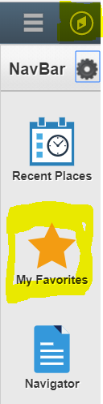

Add Favorites

Hands-on Practice / Demonstration

To add to your Favorites, go to the page that you would like to add. Once there, look at the top bar on the right hand side. Select the dropdown arrow next to “Add To” and select Favorites.

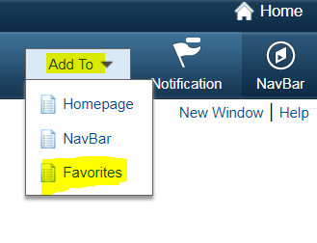

Edit the Description (if needed) and click OK
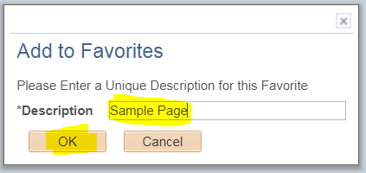

You will now see this link in your favorites when you navigate to them.

Delete Favorites
Hands-on Practice / Demonstration

To delete favorites, go to the Favorites tile from the NavBar. After clicking on the tile, an additional side menu appears. Click on the top link that says Edit Favorites
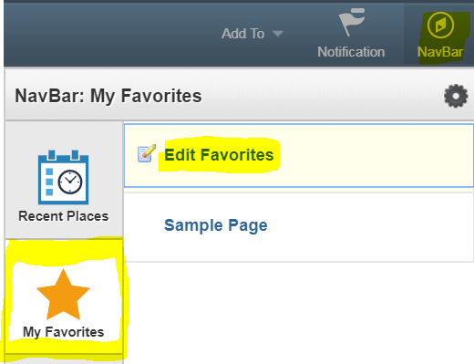
From there it will bring you to a page that lists out all your Favorites. Click on the box with a – sign next to the favorite you would like to delete.

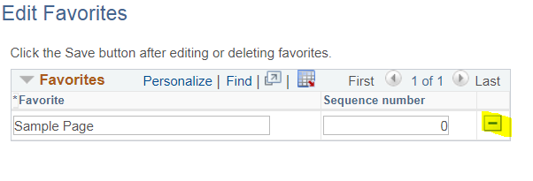

Click OK to the delete confirmation message.
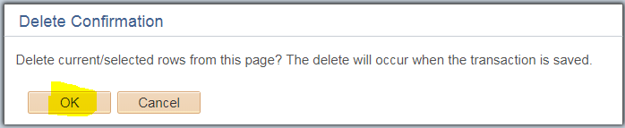

You will no longer see that Favorite in your Favorites bar.

Search

PeopleSoft 9.2 comes equipped with Elastic Search, a feature that allows you to search for anything, much like you would with a Google search. It allows you to access menu options such as Add/Update Journal Entry, and specific items such as a specific Journal Entry.

If you are looking for a specific item, and you do not have the item ID, use search terms for other data about the item such as Entry Date, or Created By.

There are three main places that you can access the search menu, in Employee Self Service, in the Breadcrumbs menu bar, and via the Workcenters.

Search from Employee Self Service

From the Employee Self Service page, you can locate the search menu by clicking on the magnifying glass.
Put your search terms in the Search field and click enter.

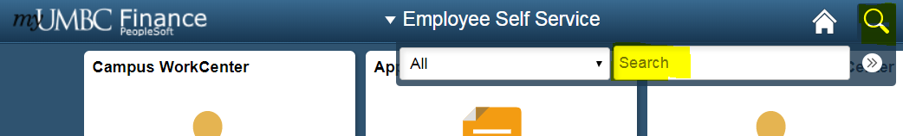

To get to a more advanced search, click on the >> button next to Search. It will bring you to a blank page with a search pane on the left hand side. Click More Options to see more advanced search settings and fields.
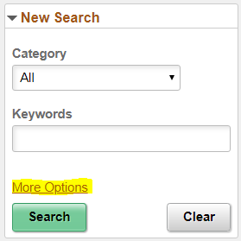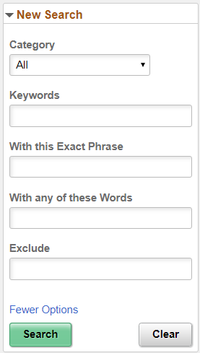

Search from Workcenters

From any Workcenter page, you can search by typing in search terms in the search bar at the top of the page.

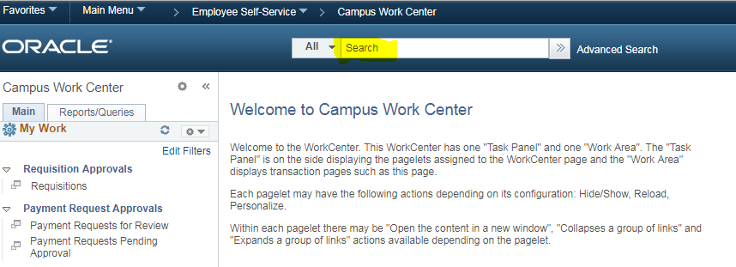

Select the All button to bring up different categories. This will filter your search results so that they only relate to that specific category.

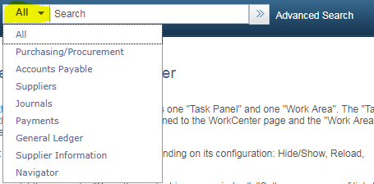

For a more advanced search, click on Advanced Search. It will bring you to a page with more advanced fields and filter criteria.

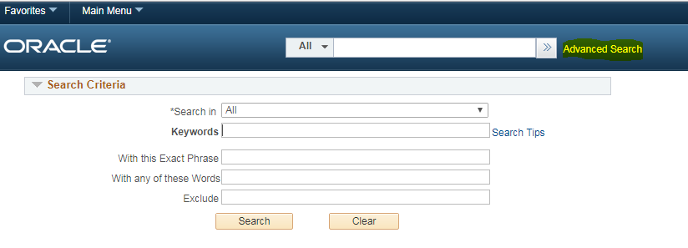

Search from Breadcrumbs Search Bar

You can also search for menu items when clicking on the dropdown menu options from the breadcrumbs search bar. Just enter your search terms in the search field.

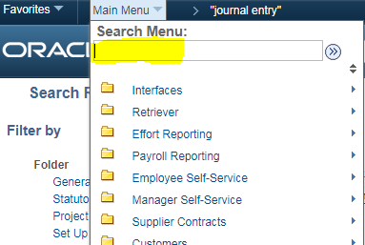

Filtering Search Results

The Search Results page will list out a series of clickable links to specific menu options or items. It tells you how many total results there are. You can use this as a meter and use more information to narrow the search results.

A category menu on the side will allow you to show items only related to that category. Click on the link that most relates to what you’re looking for.

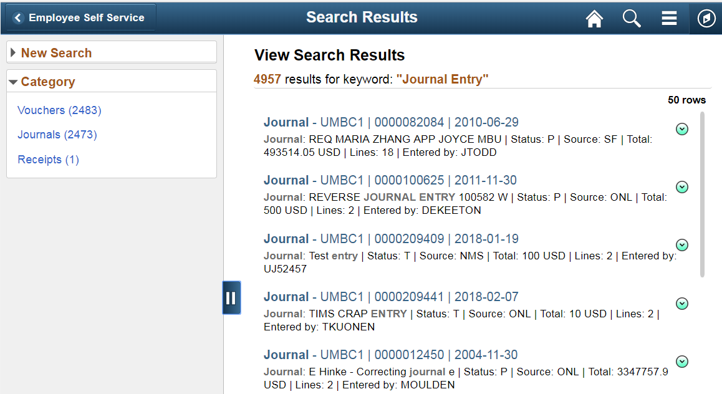

You can conduct a new search by selecting the arrow next to New Search in the top left hand corner. Select More Options for a more advanced search.

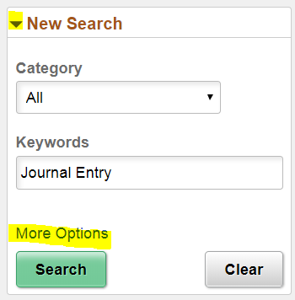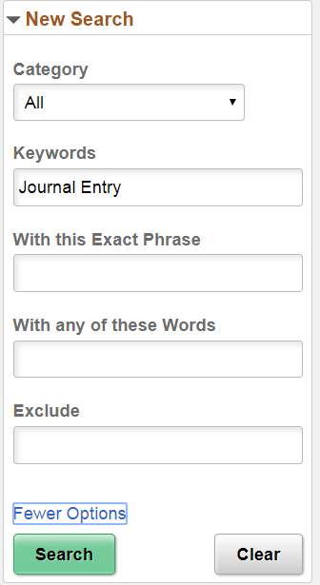

Note: For advanced search tips, be sure to click on the link Search Tips. A popup will appear with some helpful tips to maximize the advanced search features.

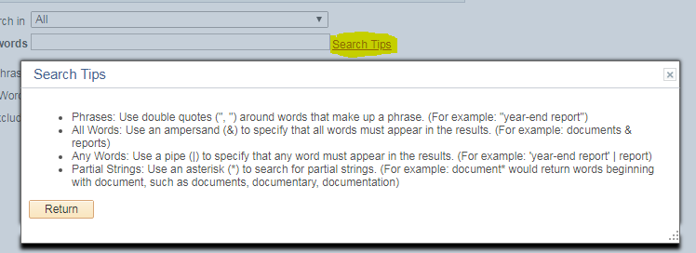

Common Navigation Icons

Discussion

Icon | Function
 | The Search icon appears on various screens throughout PeopleSoft. The icon indicates that you may select it to display appropriate values for a field. Click once on the icon to select it.
 | The Save button typically appears in the bottom left of the screen. It is recommended that you Save data on the active screen before proceeding to the next screen, or taking another action.
 | The Run button indicates that you want to ‘run’ a specific report based on the search parameters. Note: When the Run button appears, it typically means the information requested output as a Report (to a 3rd party software, such as Adobe Acrobat.)
 | The Fetch button indicates that you want to retrieve data that meets your search parameters and display it at the bottom of the screen. Note: The Fetch button and the Run button are used to perform similar actions in PeopleSoft.
 | Highlighted text indicates that the text is hyperlinked, and if selected, will take you to another screen in PeopleSoft.
 | Process Monitor is used when running reports. Click this link to go to the Process Monitor window to view a list of report requests, their statuses, and links to view the reports.
 | This collection of icons appears in some Retriever Reports when rows of information are collapsed or expanded. Selecting the arrows either expands or collapses rows.
 | The Refresh button refreshes the appearance of a page by updating the description fields for changes made.
 | When this icon appears in a PeopleSoft report, it indicates that the report can be exported to Excel. The icon typically appears on the header row of the report displayed on the screen.
 | The New Window link opens the current window in a new window. If you are performing certain functions in a window in PeopleSoft, you can click the New Window link to open a new window.
 | The Search button is used to return data based on information entered in search parameter fields.
 | Advanced Search displays additional search parameters for a search field.

TIP: USING YOUR BROWSER’S BUTTONS
DO NOT use your browser's (Internet Explorer’s) Back, Forward, or Refresh buttons when you are completing a transaction. If you press these buttons while you are in the middle of a transaction, the transaction will not be saved.

Module Summary:
- Navigate through the menu by expanding and collapsing the menu options. Select the desired menu item by clicking once on the item.
- Bookmark commonly used navigation using My Favorites.

Module 5: Running Reports Using PeopleSoft

This module will teach you to run basic and advanced reports in PeopleSoft.

At the end of this module, you will be able to:

- Discuss the difference between Reports and Queries in PeopleSoft
- Create a New Run Control ID, and use Existing Run Control IDs
- Enter Search Criteria (parameters) to return data in PeopleSoft.
- Perform the steps to run a report.
- REX Finance Reports

Reports and Queries

While using PeopleSoft, you will be using reports and queries to view information. The table below lists characteristics of each

Report | Query
- A report allows you to filter a large amount of data by specifying chart fields.  - Report data can be downloaded to an Excel or a PDF file. | - A query typically requires specific data to extract information from the database e.g. the PO #.  - A query is used to return very specific information to the user.

Reports Pagelet
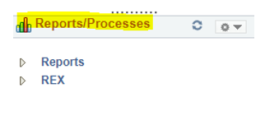
The Reports Pagelet on the WorkCenter include links to reports frequently used by the campus.

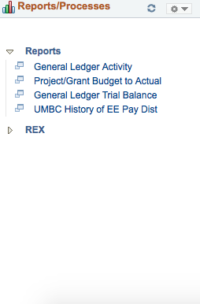

Each report is a hyperlink. These links take you directly to the Run Control page for the report or process.

Reporting Basics
Demonstration

When running reports in PeopleSoft, there are basic steps that are performed each time. This section will walk you through the basics for running a simple report in PeopleSoft.

The following examples will use the Transaction Detail by Department Report, located in the Financial Retriever and Reports database.

What is a Run Control ID?

When requesting a report in PeopleSoft, you must enter the parameters from which the report will be run, and eventually display data for you to view. To aid in running reports, PeopleSoft created a means to allow the user to save search parameters so he/she does not have to perform the same steps each time the same report is requested. Run Control IDs are how PeopleSoft identifies saved search parameters for reports.

Add a Run Control ID

- Click the Add a New Value tab.

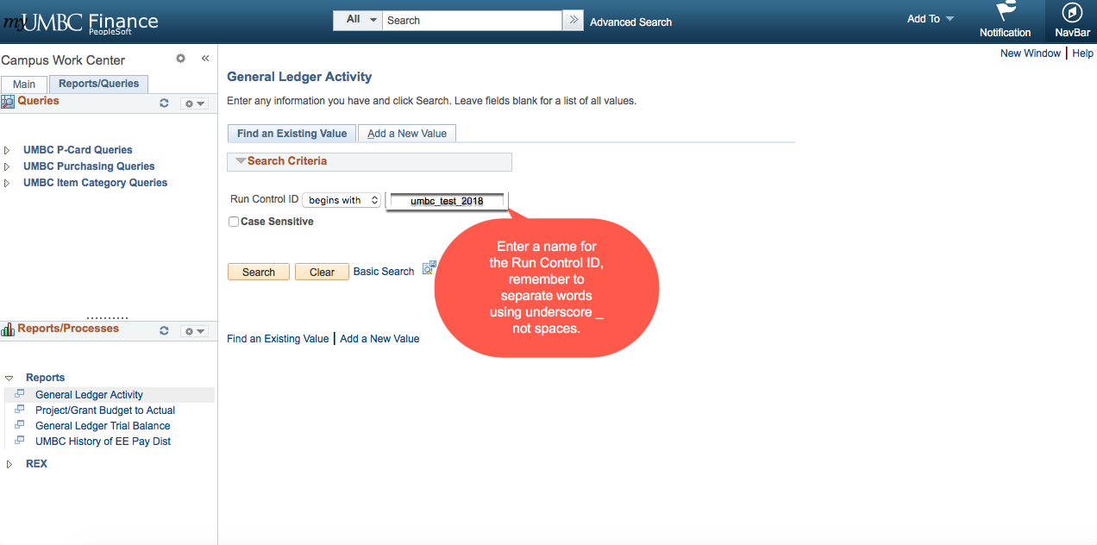

- Enter a name for the Run Control ID. The name cannot contain any spaces, however, you can use the underscore key _ to separate words within the run control ID.

- Click the Add Button to open the Run Control search parameters screen for the selected report.

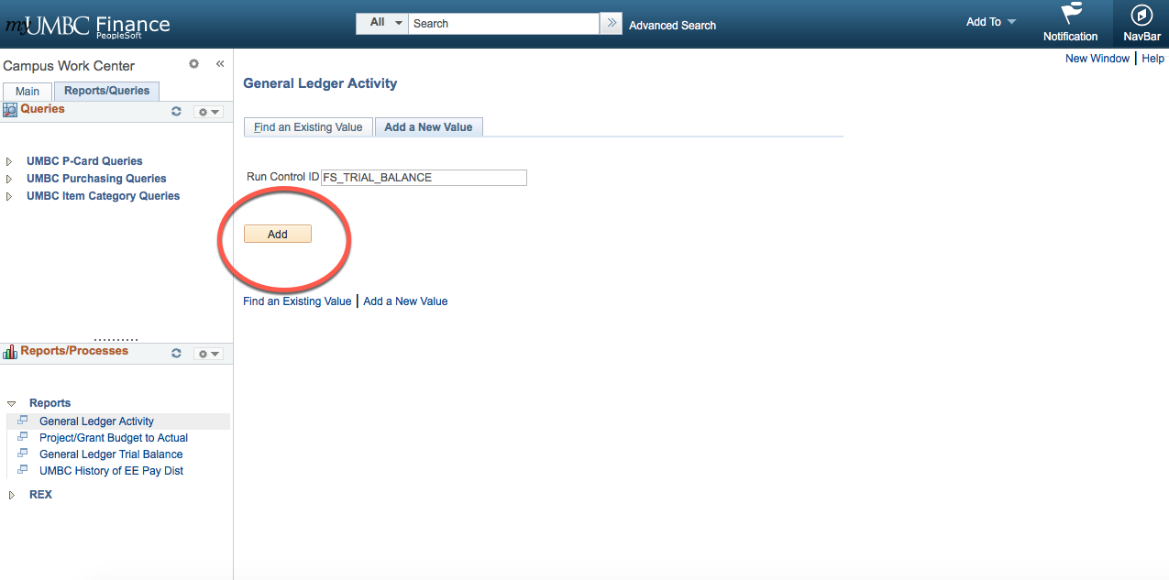

- To save a new Run Control ID, you must enter Search Criteria for the report and select the “Save Search Criteria” link.

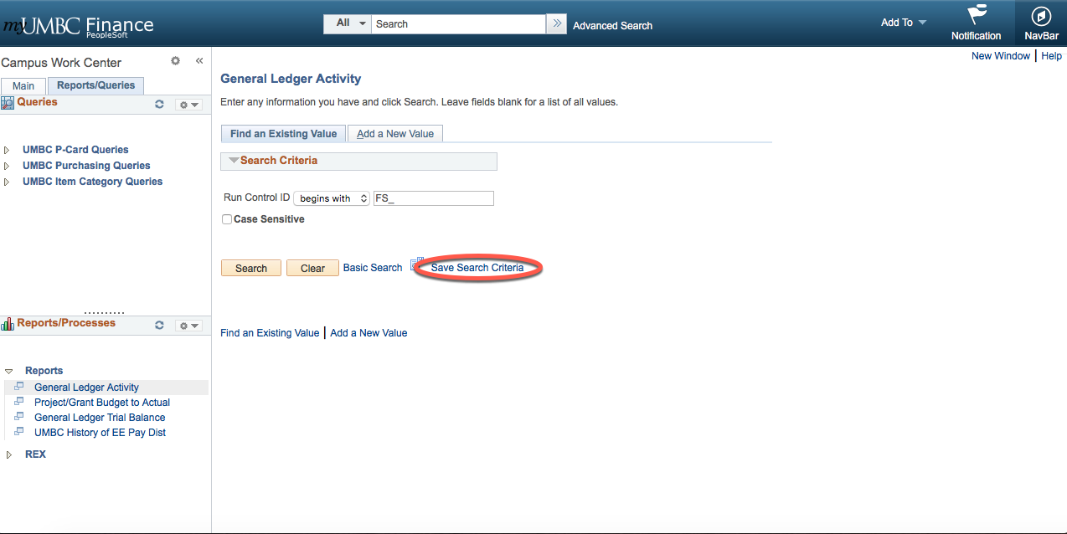

TIP: NAMING THE RUN CONTROL ID
- Once you create a Run Control ID, you cannot change it. Hence, your Run Control ID should represent the report you will be running.

- Run Control IDs are unique to the database in which they are created. Therefore, Run Control IDs created in PeopleSoft Finance are not available in any other PeopleSoft database.

Specifying Search Criteria

The Business Unit /Data Range screen displays when the Run Control ID is created. Populate the appropriate chart fields to return the desired data for the report.

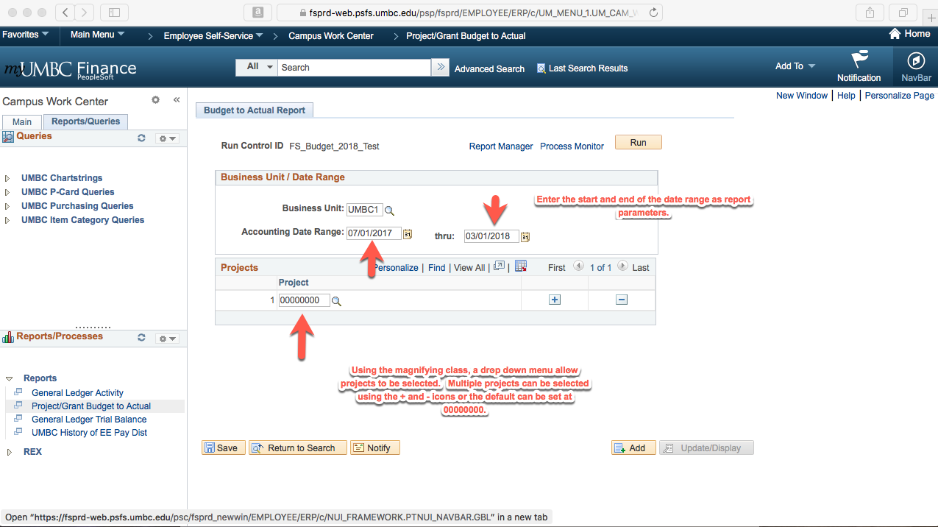

Populating Search Field Basics:

- Business Unit = UMBC1. This is the default for all PeopleSoft transactions at UMBC.

- The Accounting Date Range must have a start and end date for the reporting data.
NOTE: The Fiscal Year spans July 1, 20xx June 30, 20xx (i.e., FY 2018 is July 1, 2017 through June 30, 2018)

- If you are unsure about a particular chart field, use the button to search for that specific chart field.

TIP: MOVING FROM FIELD TO FIELD
You can use any of these methods for moving from one field to another on the PeopleSoft screen:
1. Use the Tab button on your keyboard.
2. Use your mouse to left-click in a new field.
3. Use the icon to populate each field, then click in a new field.

Running the Report

Once the Search Parameters have been entered, you are ready to run the report.

- Click the Run button.

- The Process Scheduler Request screen displays.

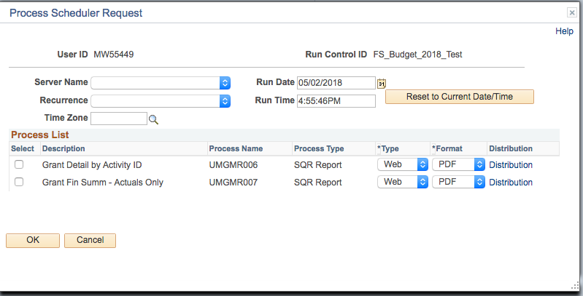
Indicates the report selected to run.
Report details
Identifies to the reporting application when to run the report.
Server on which the report will run.

- If the Server Name is editable, it should be blank.

- The Run Date and Run Time fields are automatically populated when you reach this screen. Do not change the settings in these fields.

- Check the listed under Process List.

- Click the OK button.

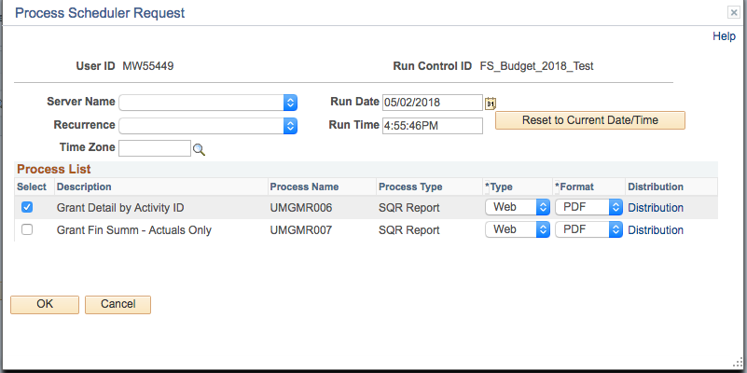

- The Process List confirms that the report is now scheduled to be run. Clicking the Refresh button will push the Run Status from Queued to Success, which indicates the report is completed.

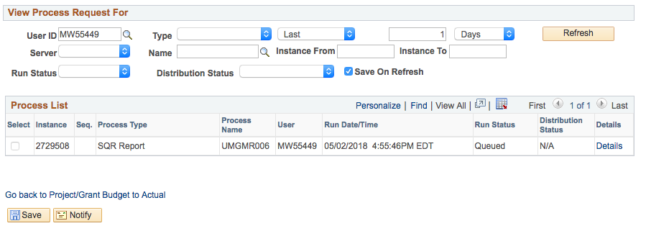

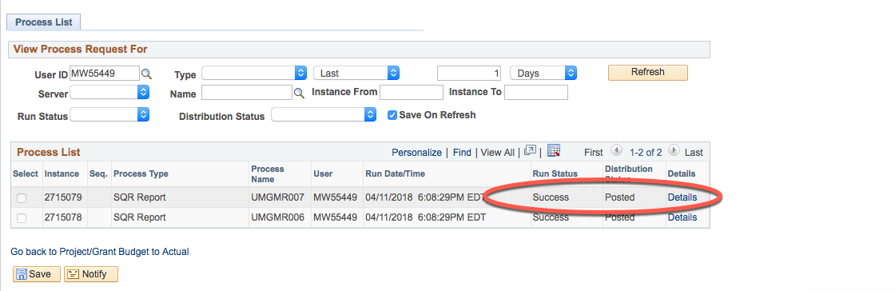

- Click the Details Link to access the PDF report.

Locating and Viewing your Report

A Process Instance is the number that displays below the Run button. It indicates that your report has been scheduled.

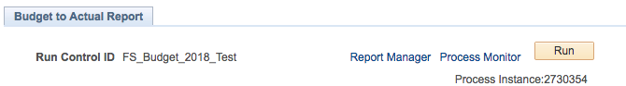

- Click the Process Monitor link. The Process List screen displays.

- Click the Refresh button until the Run Status and Distribution Status display Success and Posted.

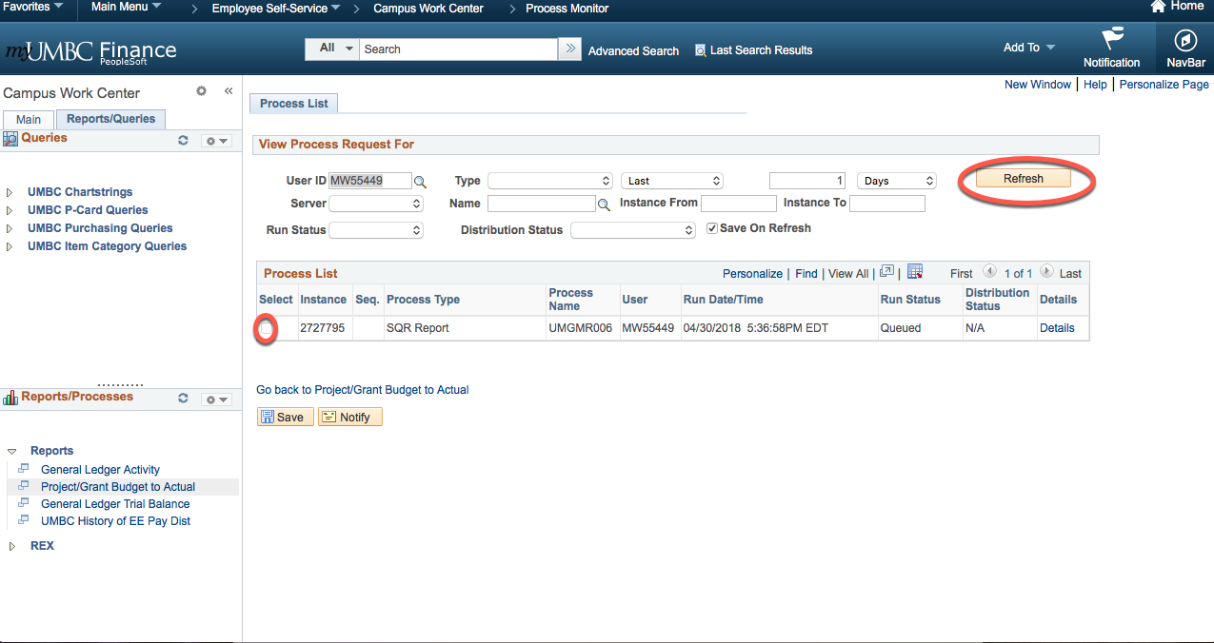

Click the Details link listed under Process List. The Process Detail screen displays.

- Click the View Log/Trace link. This link will take you to the hyperlink of the report.

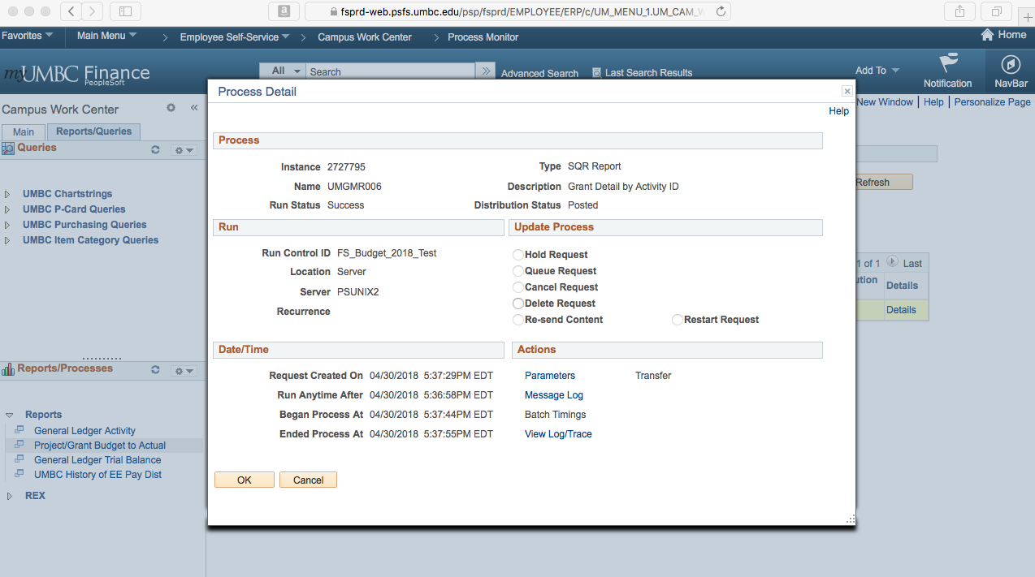
- Click the REPORT hyperlink to view the Distribution Details.

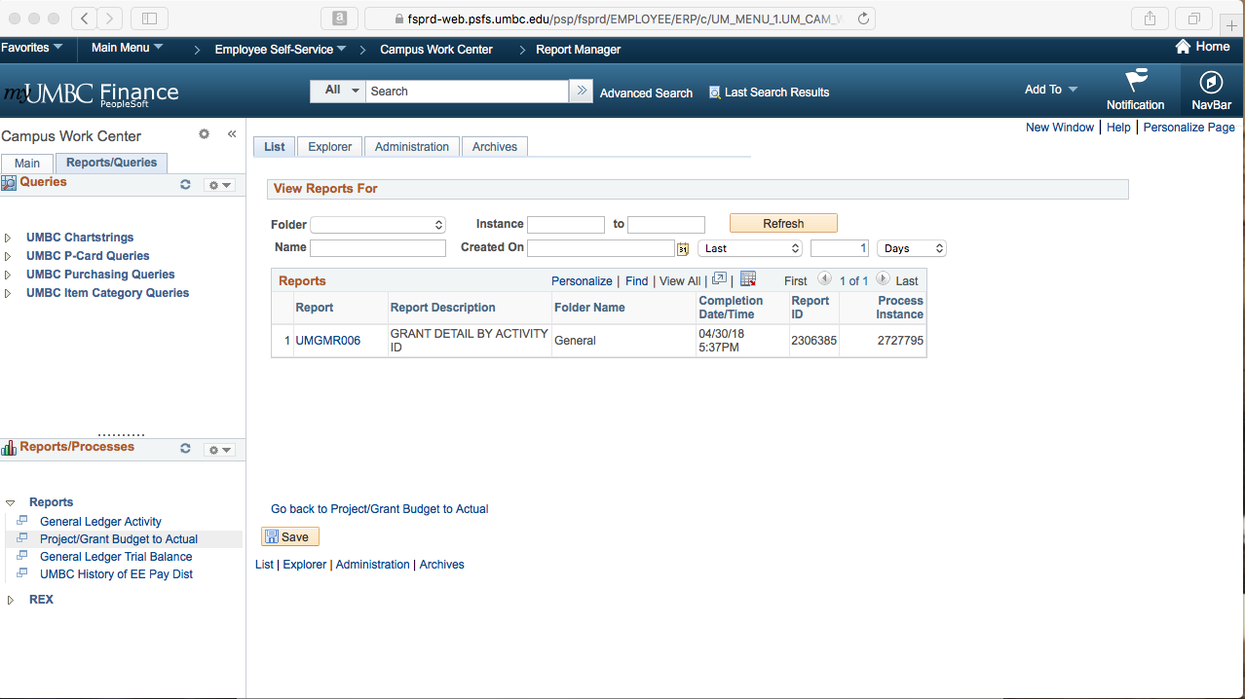
Report Hyperlink

- Under the File List, locate the report with the .PDF extension. This is the printable report.

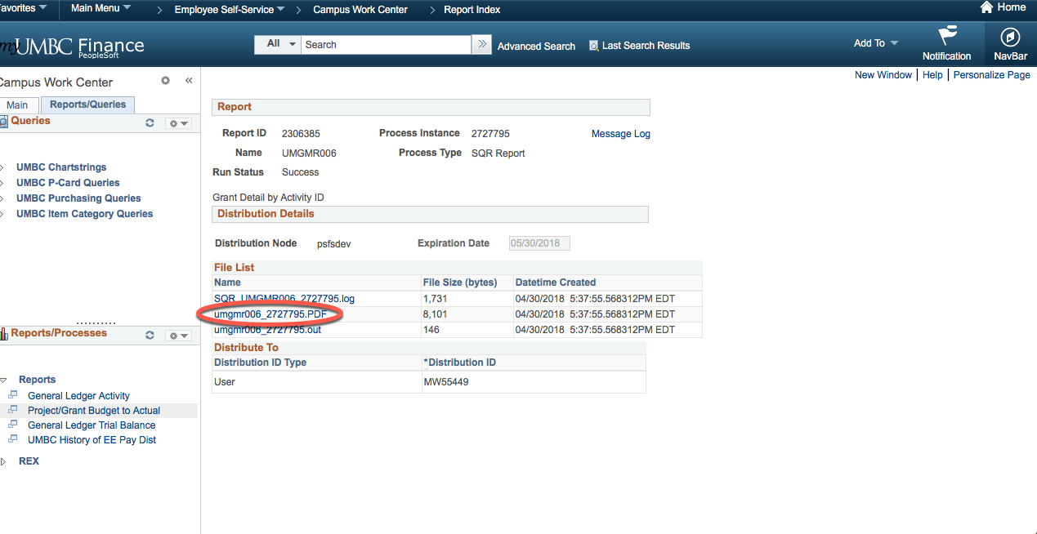
Report Hyperlink

Exiting a Report

To exit from a displayed report, and run another report in the same database, click on a menu option from the main menu. The Run Control ID for the selected menu option is displayed. It is recommended that you save your inquiries reports before exiting by clicking on the Save button.

Practice: Reporting Basics
Practice Exercise
Tasks | Run a Transaction Detail Report by Department  - Create a new Run Control ID  - Enter Search Parameters for the report  - Run the report.  - View the report.
Run Control | Create a new Run Control ID: Test_01
Chartfield Criteria  Note: Wherever the chart fields are not specified, keep them at their default values (blank or 0000(s)) to return all results. | - Fiscal Year: 2018  - Budget Period: 2018  - From/To Period: 1-2  - Department #: 10118  - Fund #: 0000

Module 6: Running Queries Using PeopleSoft

In this module, you will learn the steps to run queries in PeopleSoft Finance.

At the end of this module, you will be able to:

- Run queries in PeopleSoft Finance.

Queries
Demonstration / Discussion

What is a query?

A query is a tool that allows you to extract data from the PeopleSoft database based on your specified parameters. You can view the data on the screen or export the data to a format that can be customized according to your preferences (using Excel.)

Queries Section
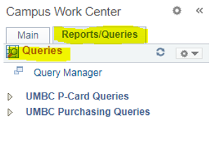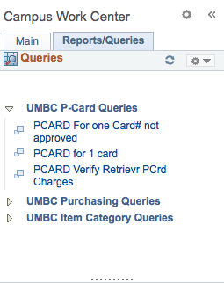

The Queries pagelet can include links to Query Manager, public queries, and pivot grids.
If there is a Query that you think will benefit the campus, you can reach out to IT to have a link added to the Campus Workcenter.
All queries that show up in the Workcenter will be available to everyone, so we cannot configure it for the individual user.
However, you can also view all your query favorites when you go to the Query Manager.

Practice: Searching a Query

Practice Exercise
Tasks | - Search a Query  - Export the Query output to Excel.
Query | Query Search Parameter: “UM_AR_JRNL_DRILL”
Additional Search Criteria | Once the above query is located, use the following search criteria to obtain the results of the query:  - Journal ID: ARDJ010485  - Account #: 7089900

Module Summary
- To run a query, search for a query using specified parameters and view the query.

Module 7: REX Financial Reports

REX Financial Reports is a robust feature of the UMBC REX Data warehouse. Based on the Microsoft reporting platform, the financial reports include payroll and sponsored accounts with drillable hyperlinked data. Reports can be set up as subscriptions and are accessible to non-PeopleSoft users.
There is a monthly training session for REX Finance as well as video tutorials and documentation that can be found on the Financial Services TAP page.

Module 8: Getting Help

Receiving Updates via E-mail
You will receive UMBC PeopleSoft announcements via e-mail from Financial Services.

UMBC RT Help Desk System
UMBC Technical Staff follows questions and issues using RT Ticket System. For instructions how to enter a ticket, please do the following:

1 .Go to http://my.umbc.edu
2. Click Help -> Request Help
3. Enter your myUMBC username and password when prompted and click Login
4. Click the New Ticket link located on the left column
5. Select a queue which best describes the issue, for example:

PeopleSoft Finance please select Finance Queue
PeopleSoft Human Resources please select Human Resources Queue
PeopleSoft Student Administration please select Student Administration

- Enter a brief but specific summary on the Subject: line, for example,
PSUNX Error in General Ledger Report
is more helpful than
error in PeopleSoft

- Enter a thorough description of the problem, include specifics such as error messages and what was tried to diagnose the problem. You can also take a screen shot of a page or error message and send as an attachment.
- Select a subcategory from the list
- Click Create ticket button
- Review submitted ticket (a copy will also be sent to your email)

Links Associated with PeopleSoft
This section provides the links to websites associated with PeopleSoft (see below.) The Departments section is available on the Departments tab of the website.

Financial Services

Business Services

Human Resources

Procurement

Department of Information Technology (DoIT)
Next Steps

Now that you have completed PeopleSoft Finance 9.2 Fundamentals, you are ready to take the next level of courses to build on your skillset.

The training sessions are held monthly and are created as standalone modules. They include:

- PeopleSoft Requisitions
- PeopleSoft Payment Requests
- PeopleSoft Journal Entries

Please register for training on the MyUMBC Training page

If you feel you need additional training not covered in existing modules, please contact Julia Golbey, Training Coordinator at golbeyj1@umbc.edu.

Finally, please check your email for a survey link to give us feedback on your training experience and help guide us in improving our curriculum.

Thank you for your participation!

