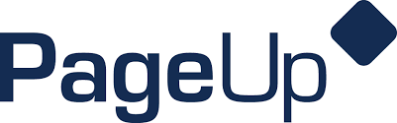

A Change is Coming... PageUp is getting a New Look.

Phase 2 - Hiring Manager Dashboard

PageUp continues updating their interface to meet the changing needs of their customers. With a simplified design, you’ll have easy access to all features you currently use as well as a fresh new look and feel that works across your mobile, tablet, and desktop devices.
Functionality will remain the same. The design is being simplified and enhanced. One new benefit is for mobile users. The new design will include touch friendly big buttons and input fields to easily move though tasks and flows.
What is changing? – The Hiring Manager Dashboard
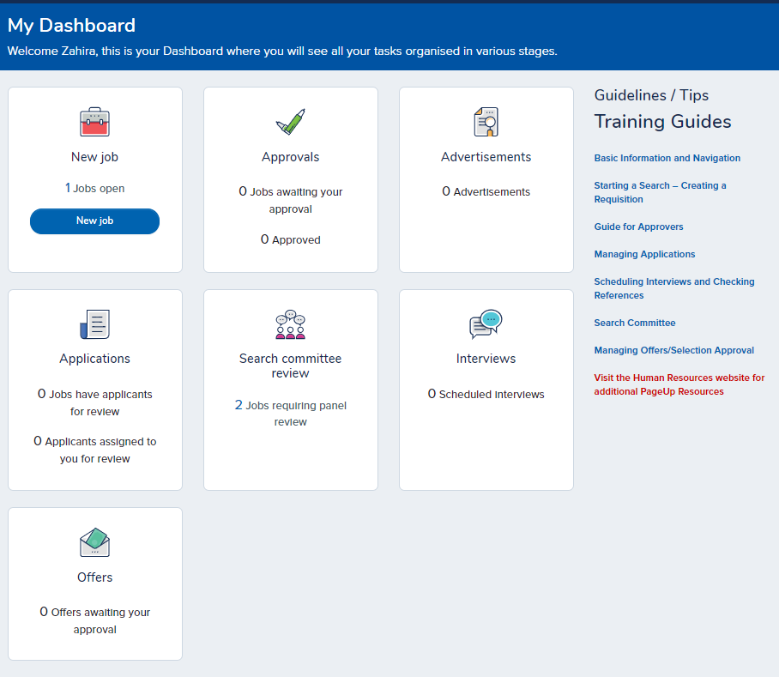
The rainbow “bubbles” are going away and being replaced with the screen above. The same functionality will exist. Simply click on the words within the box that applies to the function or area that you are interested in viewing. For example: to locate your open jobs, click on “Jobs Open” under New Job box.
Note: Interviews scheduled will only show up if you are using the Event/Interview feature.
Training Guides are easily accessible on the right side of the screen by clicking on the hyperlink.
These changes will go live on October 3, 2018.

Note: Currently, only the Hiring manager dashboard is changing. Additional changes to the HR Liaison dashboard and Search Committee screens will continue over the upcoming months. Human Resources will send out notices of the changes as each navigation screen is implemented.
HR 9/10/18

