ETS QUICK GUIDE (THIS WILL BE AN ATTACHMENT AND A BIGGER SCREENSHOT)
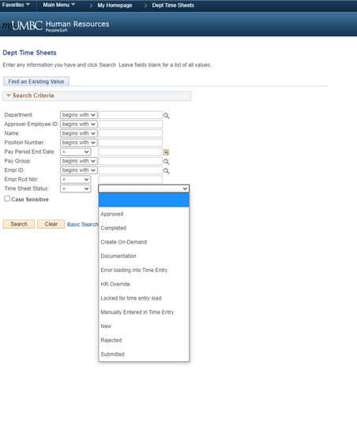
NAVIGATION: UMBC Time and Leave Processing > Employee Time Sheets > Dept Time Sheets

