New PageUp Feature
Email Notifications for New Applications

A new feature has been added to the job requisition in PageUp.

PageUp will send an email notification to users listed in the notification box each time a new application is submitted for the position.
To use the feature, scroll down to the bottom of the job requisition form to the Users and Approvals section. Click the radio button to Yes. Add the email address(es) of the user(s) that would like to receive notifications. You may enter multiple email addresses.
The feature is available on new and existing job requisitions.
Note: We do not recommend using this feature for positions that will receive a large number of applications. You will receive an email notification for EACH application submitted. The feature is best used for positions that are specialized and/or do not receive a large applicant pool.
You may stop the email notifications at any time by going to the job requisition and turning off the notifications. Remember to hit SAVE.

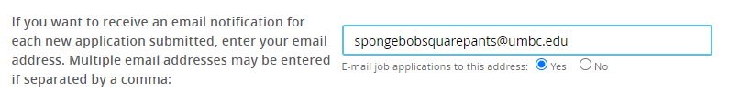

If you have any questions, please contact Kim Harris or Annie Byrd at hrrecruitment@umbc.edu

