Instructions for Posting a Position on Linkedin
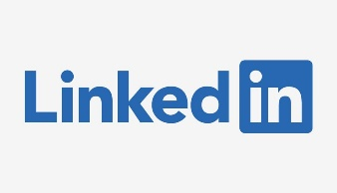
LinkedIn Free Job Posting

You can post one job for free with your LinkedIn account! Consider posting the job that you have open in your department to recruit more applicants. Your job posting will show on the UMBC Linkedin page reaching over 99,000 followers. Once your job is posted, you can reach even more potential applicants by sharing your post.

- Log-in to your personal LinkedIn account at linkedin.com or create an account.
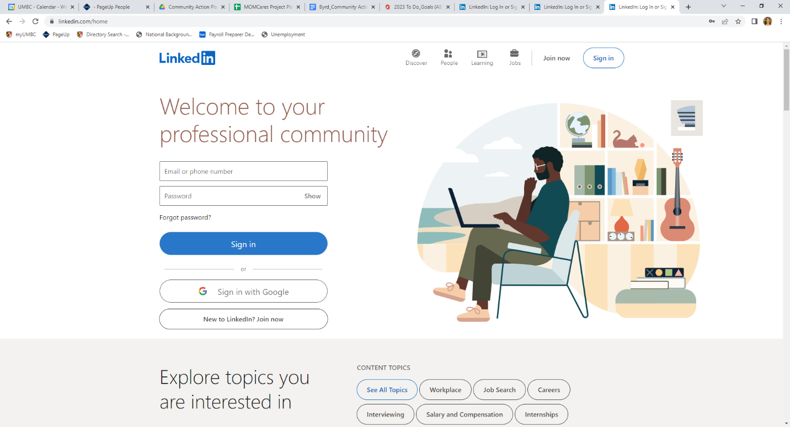
- Be sure you are connected to UMBC. By connecting to UMBC, your job posting should pull over to the UMBC LinkedIn page. You can connect by showing you are a current employee at UMBC and also by following UMBC.
*Note: LinkedIn does change their algorithms from time to time. This may change how jobs appear on the UMBC LinkedIn page.

A. Show you are a current employee by listing your position under the experience section.
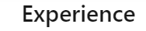
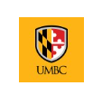

B. Under Interests, follow UMBC on LinkedIn.
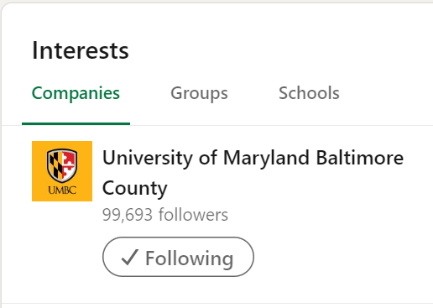

- To start the free job posting, click on the “Jobs” icon on the top banner.
- Click on “Post a free job”
- Fill in the required fields and click start job post.
Note:
Work place type: Be sure to select the correct option. List hybrid only if a hybrid work schedule is available for the position.
- Complete the description.
It is helpful to open the job posting on the UMBC Jobs website and copy and paste the various headings and content sections from your job posting. Your content of the minimum and preferred qualifications must match exactly to the PageUp job posting. It is highly recommended that all content match.
We recommend using the following fields and content in your job listing on Linkedin:
Position Overview
Why Work at UMBC
Responsibilities
Minimum Qualifications
Preferred Qualifications
Closing Date (usually open until filled)
Salary
At the bottom of the description - Add the sentence:

For full job posting and application instructions, visit our website at: Insert the apply URL Here

- Select skills that match the qualifications. Delete skills that auto-populated and do not match.
Click next to move to the next step.
- Select that applications should be received “at an external website”.
Applicants must apply in PageUp to be considered for the position.

Please use the customized URL for Linkedin so that the application source can be tracked correctly. The URL for Linkedin will be under the Notes tab on the Job Requisition. This URL will send applicants directly to the job posting on the UMBC Jobs website to submit their application materials.

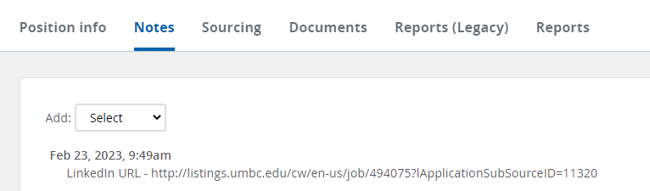

- You may now preview the job posting by clicking the Preview button. Make any edits as needed. Once you are satisfied, click “Post Job for Free” button.

- Congratulations the job has been posted on LinkedIn.

- Share the job posting with your network and ask coworkers and other colleagues in your network (connections on LinkedIn) to share your job posting to help spread the word.

- Delete the job posting once it is filled or no longer needed.
Things to Remember
- Remove the job posting from your account once the job is filled or you no longer need to post.
- You may respond to individuals that send direct messages. Remember to direct them to apply in PageUp in order to be considered for the position.
- You may only post one job at any given time. You will need to remove a job posting if you wish to post another job. Typically, most applicants respond within the first two weeks of the job posting. Feel free to swap out the jobs as often as needed. You may also want to consider asking other coworkers in your department to post a position to utilize as many free postings as possible.

To delete or change the job posting, click on Manage Jobs.

Click the three dots to open the side menu. Select close job.

Note: You may also share the job in a posting or a message from this side menu.
