Preferred Pronouns for Applicants Available in PageUp

A new feature has been added to PageUp. Applicants now have the ability to indicate pronouns.
The ability to select pronouns will be prompted during the application stage (new applicants). Current or former applicants may add pronouns by logging into their account and updating the profile section.
This feature was added in late December 2023. The majority of applicants that applied prior to this date will not have pronouns listed on their applicant card unless they updated their profile. As we move forward, this feature will begin to be utilized.
Pronouns (if selected) will show on the applicant card (see screenshot below).

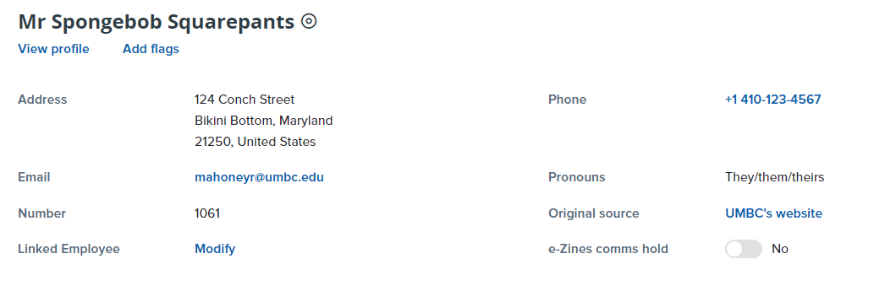
Pronouns are NOT a required field. Applicants have the option to leave this field blank. In addition, applicants have multiple options including “Prefer not to say” and “Let me tell you”.
As a reminder, pronoun information may not be used when making recruitment and hiring decisions. Please refer to the UMBC Discrimination and Equal Opportunity Policy.
The provided pronouns may be used for verbal communication (telephone calls and interviews) and for personalized (custom) written communications. PageUp communication templates in the system do not make reference to pronouns; therefore, no adjustments are necessary.
If you have any questions, please contact a member of the Talent Acquisition staff at hrtalent@umbc.edu.

