

**A Change is Coming... PageUp is getting a New Look.**

PageUp is in the process of updating their interface to meet the changing needs of their customers. With a simplified design, you’ll have easy access to all features you currently do as well as a fresh new look and feel that works across your mobile, tablet and desktop devices.

Functionality will remain the same. The design is being simplified and enhanced. One new benefit is for mobile users. The new design will include touch friendly big buttons and input fields to easily move though tasks and flows.

**What is changing?**

The hamburger menu will be moved to the left side (it is currently on the right side) with the menu on a darker background. The Home button will be removed. Users will click the PageUp logo in the upper left corner for the Home screen.

Hamburger menu

Home Button



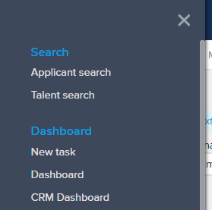

The links on the top bar will be moved from the left to the right side of the screen.

These changes will go live on **August 20, 2018.**

Additional changes to navigation screens will continue over the upcoming months. Human Resources will send out notices of the changes as each navigation screen is implemented.

HR 8/15/18