Requisition Reports Instructions
Advertising Sources Report
The Advertising Sources report shows the number of completed applications, and the source of each, in an easy to read chart. This data will allow you to analyze which advertising sources are bringing in the most qualified applicants. You can use this information when advertising future positions to get the most out of your advertising budget.
This report is available to Hiring Managers, HR Liaisons, and Search Committee Chairs that are listed on the requisition. Search Chairs must be listed in both the Search Committee AND Users and Approvals sections to view the report.
From the job requisition, click on the top tab that says REPORTS
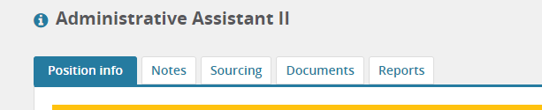
Under Advertising Sources - Click on the title.
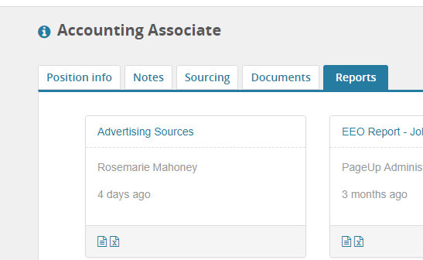

Applications are grouped by source
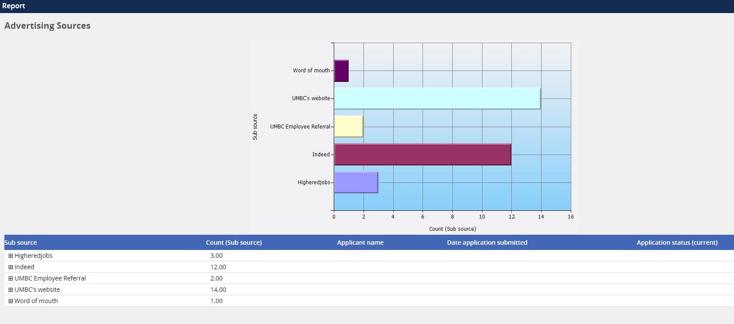

By clicking on the name of the source, you will be able to view each application and their current status.
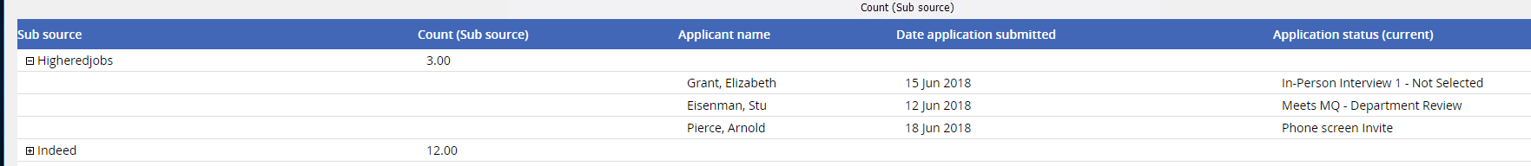

To download the report into an Excel spreadsheet, select Excel (2007+) File and hit Export

Hit Download

Open file on bottom left side of screen.
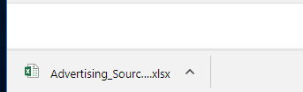

Remember, advertising is not just about how many applications were submitted. The quality of the applications is important. Consider which source had the most applicants that made it to the interview stage.

Reviewing EEO Diversity Data—by Requisition
Note: The “two or more races” category may not show on your report. Only requisitions approved after 4/17/2018 will have this category available.

Overview
Hiring Managers can access the Job Diversity - EEO report from the “Reports” tab on the requisition card. This chart will give non-identifying demographic data on applicants by various statuses (all applications, search committee member review, phone screen, in-person interview 1 and in-person interview 2).

To view data, please follow the steps below:
Step 1: Click on the reports tab located on the requisition card.
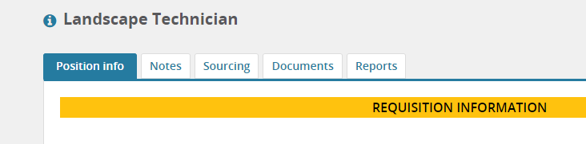

Step 2: Click on the Excel icon located on the bottom of the report.

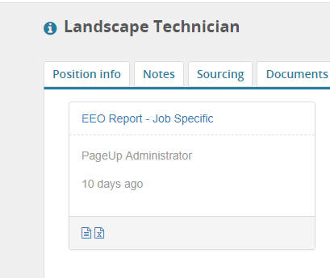

Step 3: Click ‘download report’. Once the report is downloaded, double click on Enable Editing. The graph will not show until Enable Edit is clicked.

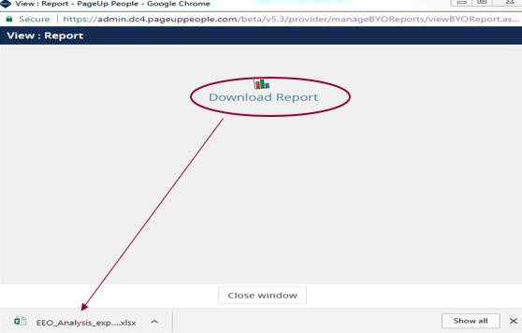

Non-identifying demographic data will pull in from applications specific to one job by race, disability, gender, and veteran status.

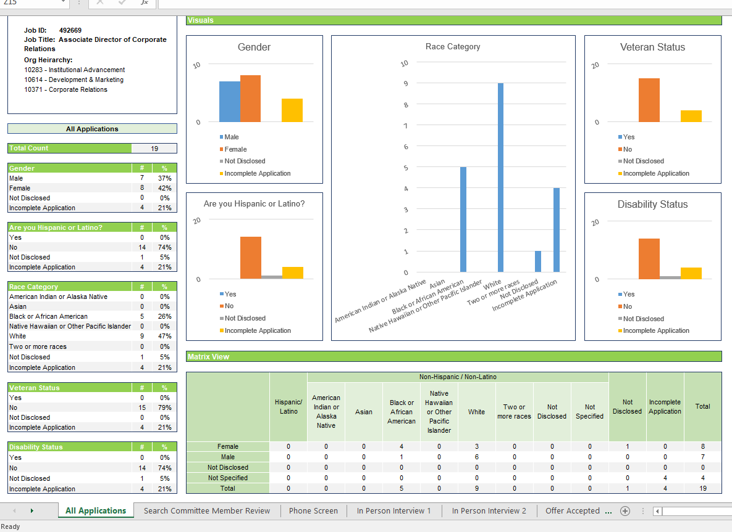

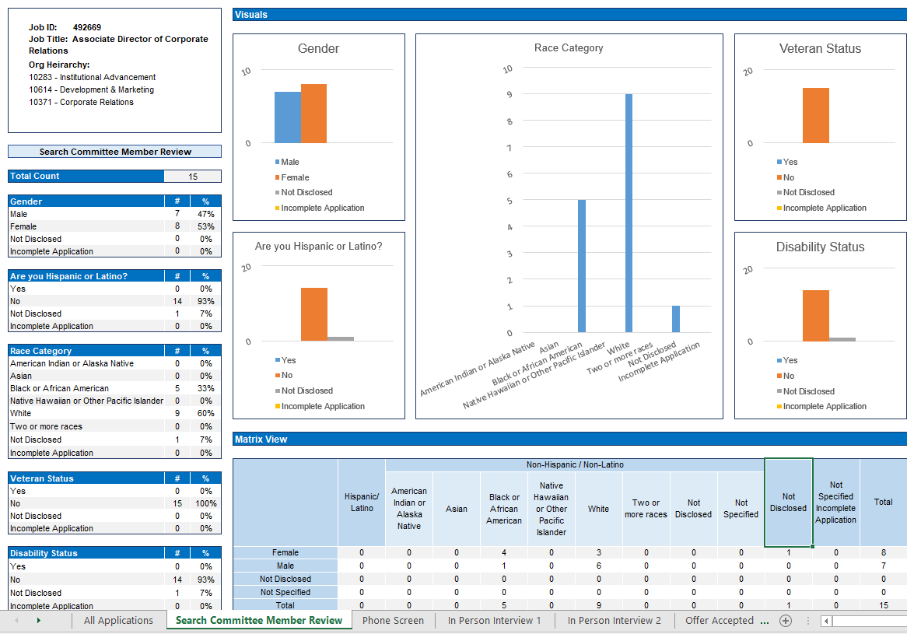

To view demographic information for applicants at a specific application status (i.e. search committee member review, phone screen, in-person interview 1) click on the tabs at the bottom of the Excel document.

Event/Interview Bookings Report

The Event/Interview Bookings report lists all the interviews that candidates have been invited to, along with the dates/times of their scheduled interviews. This is helpful to have as a quick one-report reference on the status of your interviews.
This report is available to Hiring Managers, HR Liaisons, and Search Committee Chairs that are listed on the requisition. Search Chairs must be listed in both the Search Committee AND Users and Approvals sections to view the report.
From the job requisition, click on the top tab that says REPORTS

Under Event/Interview Bookings - Click on the title.

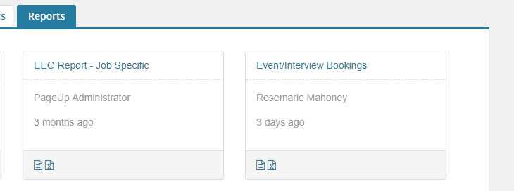

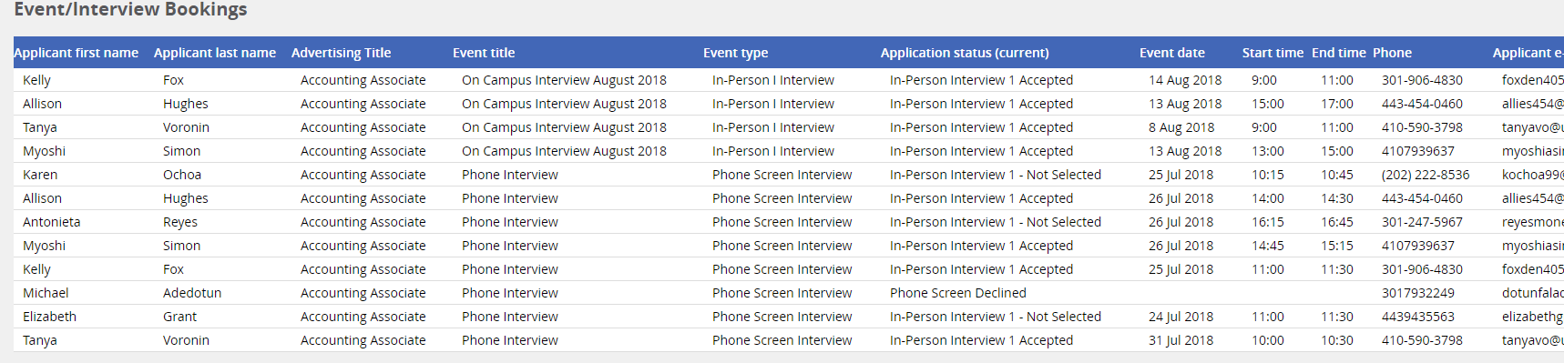

The report lists:
Applicant’s first and last name
Title of the position
Type of Event: Phone Screen, Skype, In-Person I, In-Person 2
Current Application Status – this will show if they were invited, accepted, declined or did not respond to the invitation.
Event date – date of interview
Start Time and End Time - 24 hour European format
Applicant’s Primary Phone Number
Applicant’s e-mail.

To download the report into an excel spreadsheet, select Excel (2007+) File and hit Export

Hit Download

Open file on bottom left side of screen.
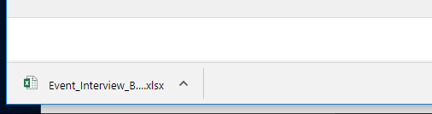

Search Committee Member Responses Report

The Search Committee Panel Report lists all the outcome responses from the search committee members for each applicant reviewed. It can be accessed and downloaded into Excel.
This report is available to Hiring Managers, HR Liaisons, and Search Committee Chairs that are listed on the requisition. Search Chairs must be listed in both the Search Committee AND Users and Approvals sections.
From the job requisition, click on the top tab that says REPORTS

Under Search Committee Member Responses Report - Click on the “X” Excel – Templated Data icon.
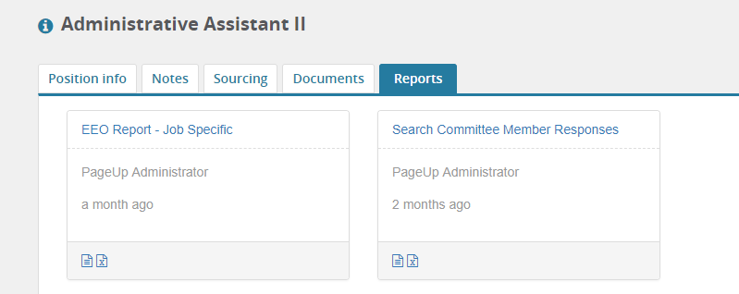

If you would like to view all the committee member responses from all applications associated with this job, you will not need to filter by application submitted date. In this case, click on the “eye” for BOTH dates, and the message will let you know the filter has been ignored.

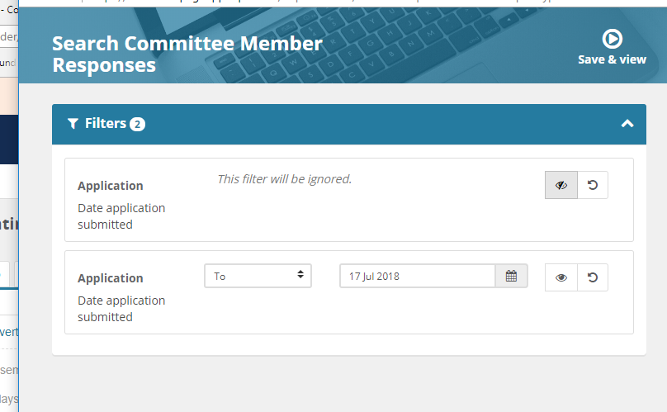

However, if you have had your search re-opened and have previous applications that have already been reviewed and eliminated as prospective candidates, you will need to select the date range of applications submitted.
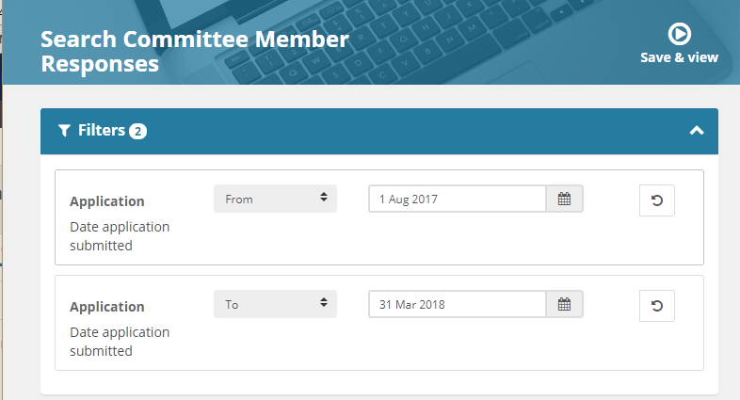

Application submitted dates can be found on the applicant grid.

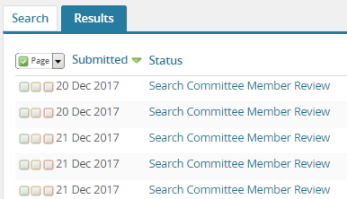

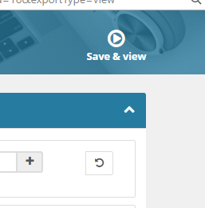
Click Save & view

Click on Download Report
At the bottom left side of your computer screen, click on the downloaded report:
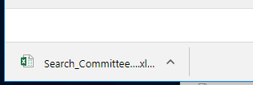

You will now be able to view ALL the responses from each search committee member who has rated the applicants.
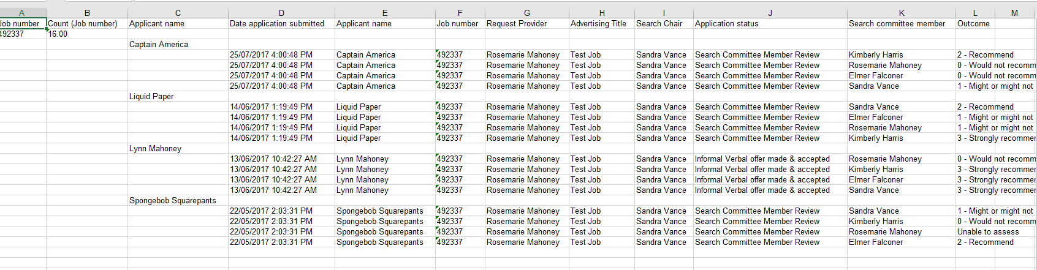

You may wish to add another column for additional remarks after reviewing more information with your search committee.

