

**A Change is Coming... PageUp is getting a New Look.**

**Phase 3 – Requisition Page**

PageUp continues updating their interface to meet the changing needs of their customers. This month, PageUp has made some subtle changes to the Requisitions page.

**What is changing?**

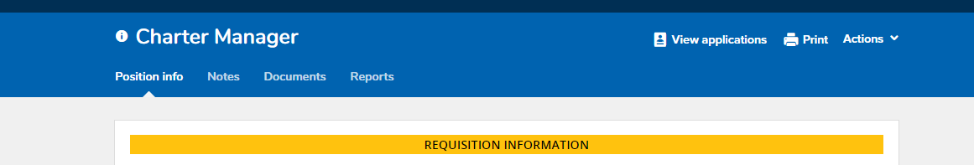

The “view applications” link will now be located on the right side.

The tabs for Position Info, Notes, Documents and Reports will appear as links in the blue banner instead of tabs.

The Actions dropdown button will now contain the History, Revision History and Copy Job functions.

**Note: Additional changes to the HR Liaison dashboard and Search Committee screens will continue over the upcoming months. Human Resources will send out notices of the changes as each navigation screen is implemented.**

HR 1/7/19