Changes to Offer Card for Staff and Faculty

Position Details section will be shared for both Staff and Faculty to fill out.

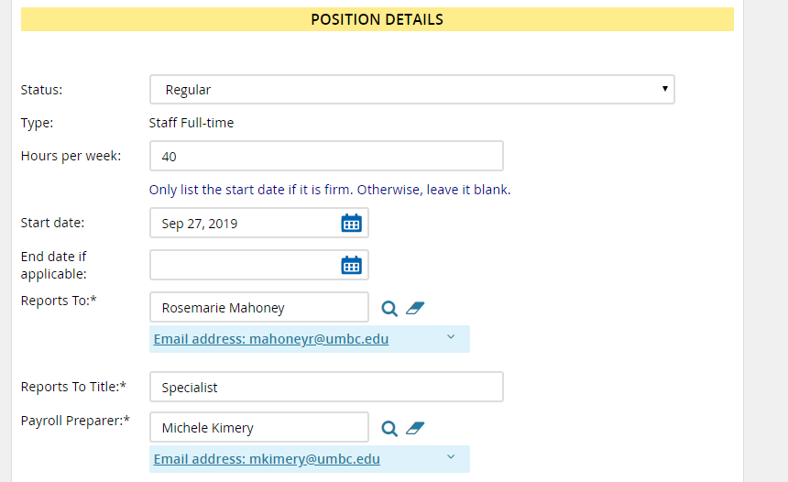

Staff hires will have their own section similar to past configurations
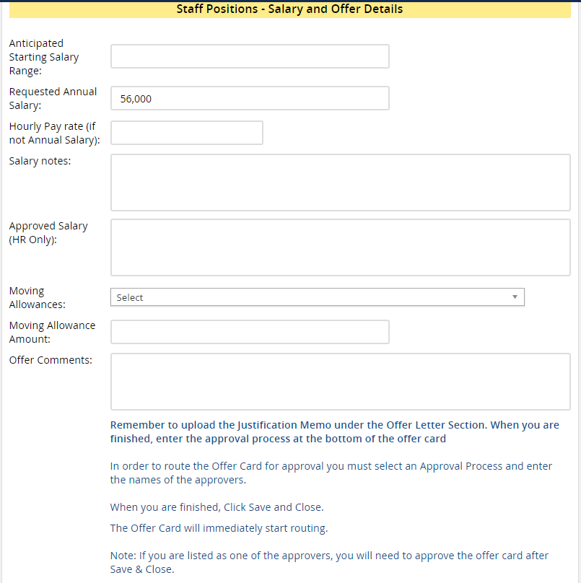

Faculty – Salary and Offer Details section 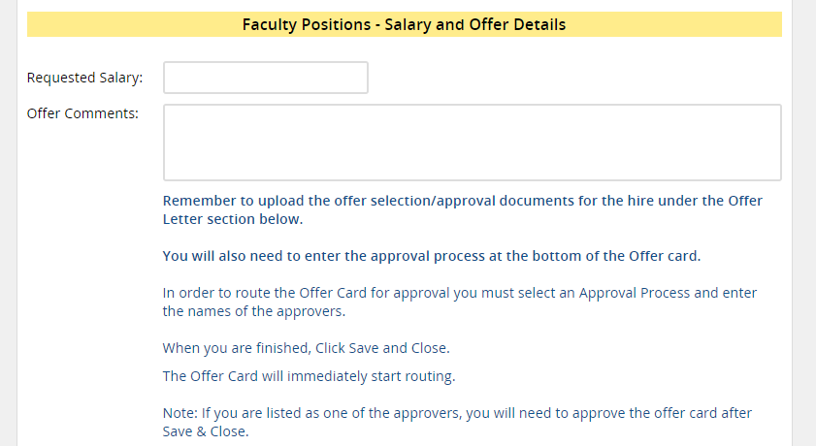

The offer letter section, previously used only by HR will now allow you to upload the Justification Memo in this area and allow for faculty to upload many of their other required documents.
