Fully Furnished Condo for Rent

Location: Located in Pikesville near i-695, apx 20 min to UMBC. Good and safe community, reliable building management and peaceful neighbors. Walking distance to Metro Subway station.
Unit: 2 bed 2 bath. 1002 sqft plus balcony. 2 assigned parking lots. Fully furnished: queen bed, futons, dinning and tea tables, bedroom set, closets, lights, sofa and love seat. TV and microwave are included. Also includes modem and wifi router. Full kitchen set. Laundry located in every level of the building. Simply, move in with your luggage and live!

Rent: $1,400/Mo. Electricity, water and gas is paid by us up to $150 per month, you shall pay the amount over $150. Deposit is $1400 and fully refundable if there is nothing broken after rent. Lease can be 6-month or 1 year long.

You: The renter(s) can be yourself, your family or you and one roommate. You need to be responsible, clean and reasonable. Please be friendly to the neighborhood. Drug and drama free. Also, NO PARTY. The whole building is smoke free in and out of the units. The rent and utilities should be paid by 1st of each month. Each day late will result in $50 penalty per day.

If interested, please contact Zihou Zhang @ 540-327-0936. We will arrange a tour.

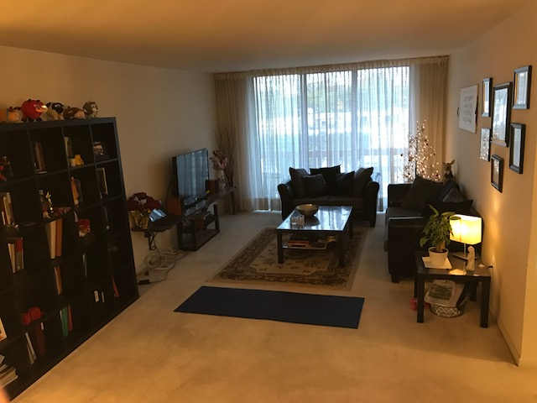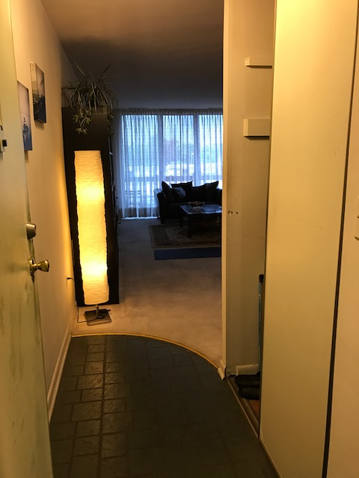
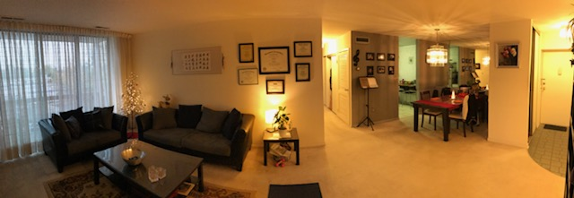
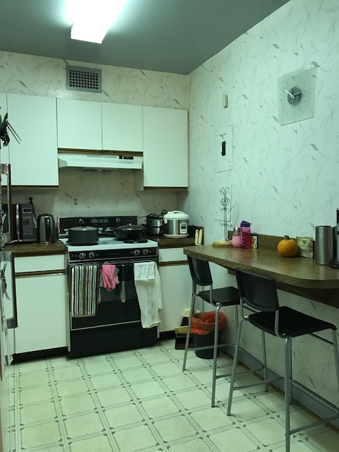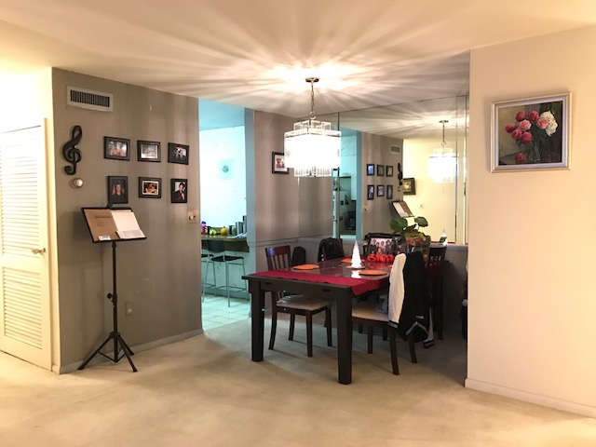
Living Room, dining room and kitchen
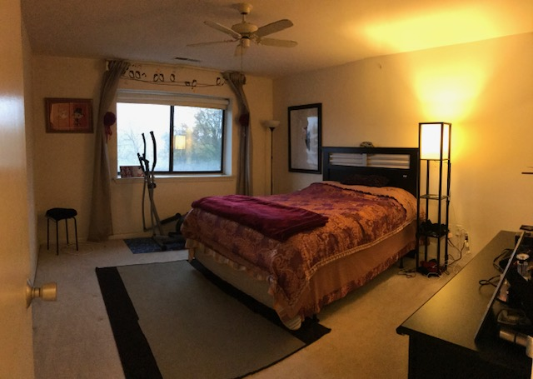
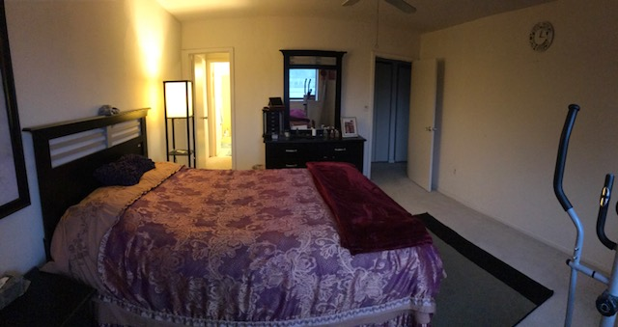
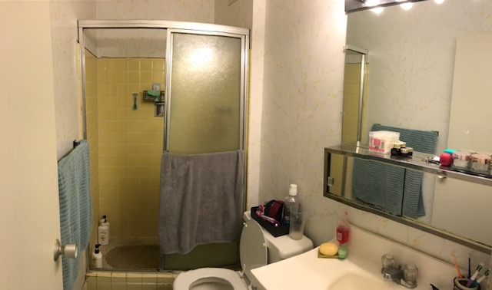
Master bedroom
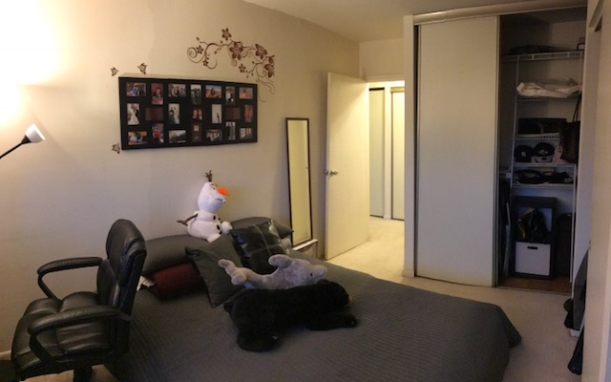
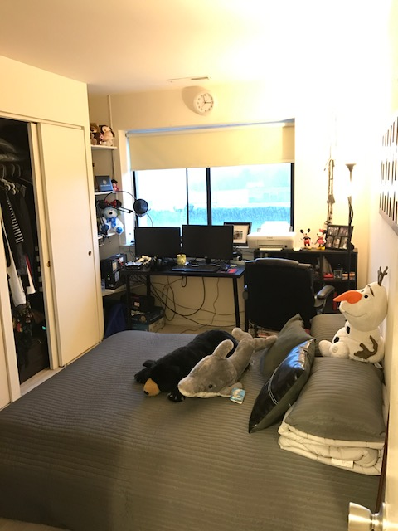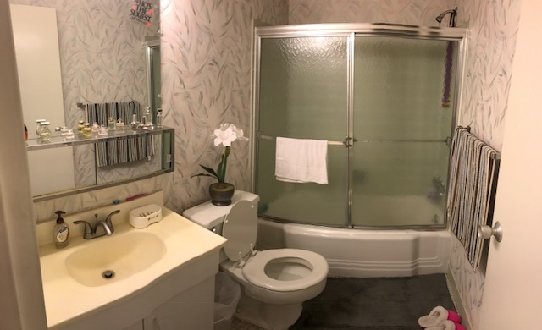
Secondary bedroom and another restroom (Please ignore the computer that will be dumped)

