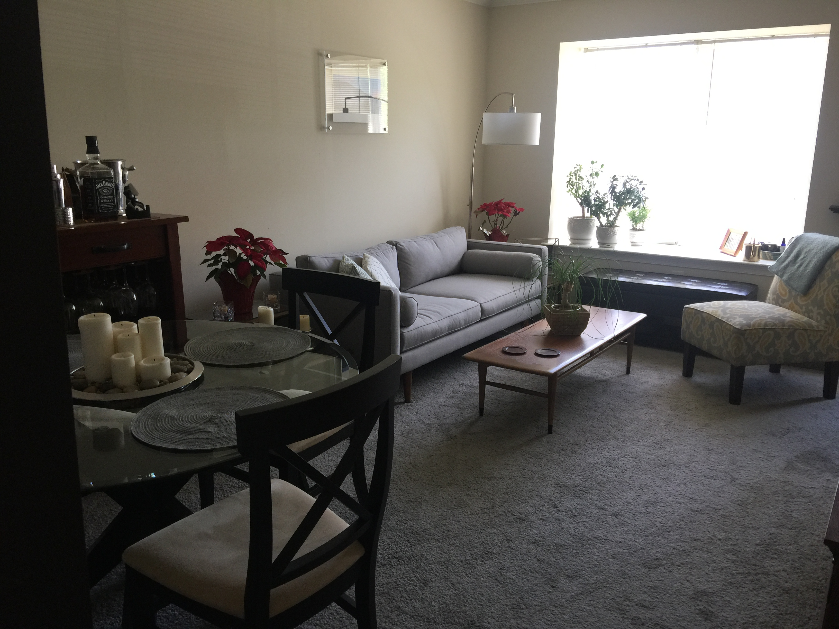
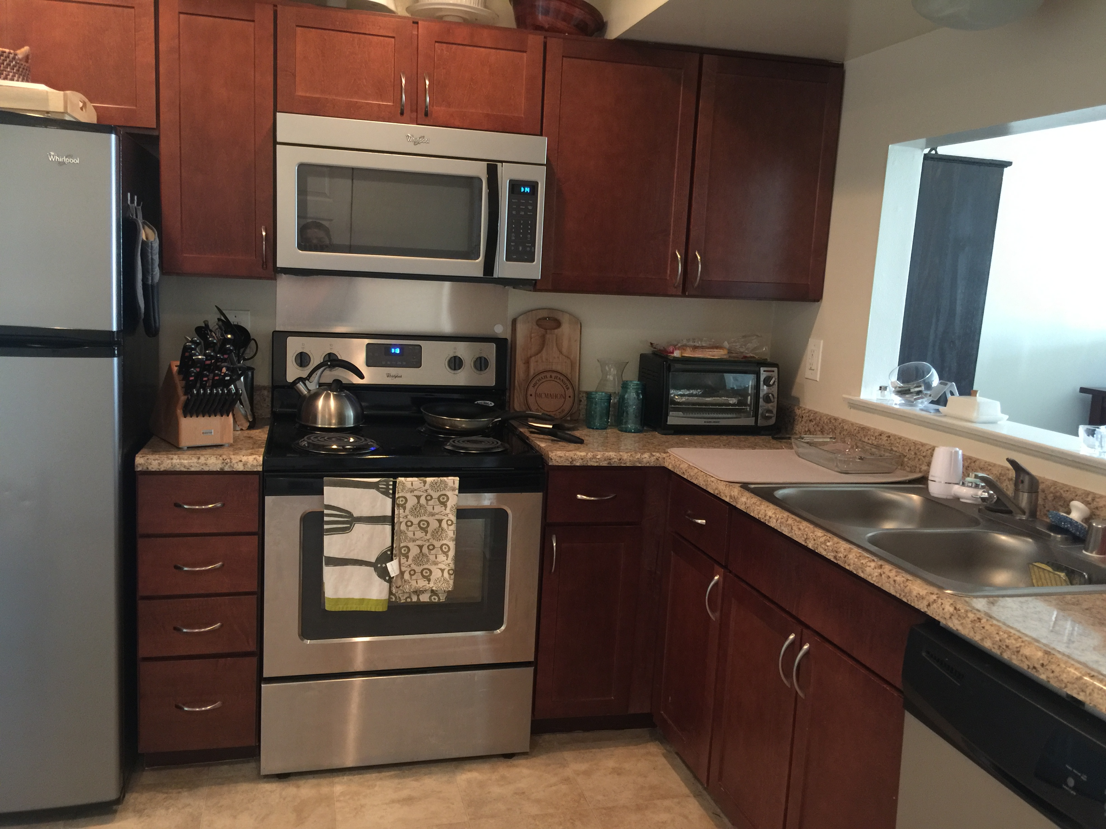
(646) 301-8357
Townhome for rent
(646) 301-8357
Townhome for rent
(646) 301-8357
Townhome for rent
(646) 301-8357
Townhome for rent
(646) 301-8357
Townhome for rent
(646) 301-8357
Townhome for rent
(646) 301-8357
Townhome for rent
(646) 301-8357
Townhome for rent
(646) 301-8357
Townhome for rent
(646) 301-8357
Townhome for rent
Townhome for Rent
2 miles from UMBC

Available June 1st

I am moving and need to rent this townhome. It is available June 1st and has 2 bedrooms and 1 and ½ baths. It’s perfect for roommates and very close to UMBC, on the shuttle bus route. $1586.00 per month. Located in the Arbutus/Halethorpe area. A great place to live!
- 2 Bedrooms
- 1 and ½ Bathrooms
- Great location

(646) 301-8357

