Occupational Safety in Research - Compliance Guide
Occupational Safety Topic: Hazard Identification and Control
Created 10/2024
Introduction:
One of the most important elements in having a safe and healthy workplace is having a clearly defined process for identifying and controlling workplace hazards. The Hazard Identification and Control Procedure has been developed to assist lab and research managers and staff by providing a framework for identifying and controlling hazards in their areas. All departments, including research and laboratory areas, must take adequate steps to ensure their areas are free from recognized and foreseeable hazards.
By using the resources provided, labs can ensure that there is a high level of awareness of existing hazards, as well as any new hazards that may present themselves when conditions in the workplace change. Following the processes described in this procedure ensures that proactive measures can be taken to control hazards before an incident occurs.
The Four Step Hazard Control Cycle:
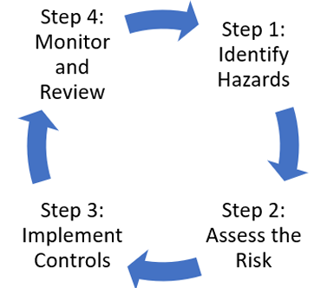
Step 1: Identify Hazards
The first step is to identify the hazards. This can be through formal or informal processes, such as:
- Reviewing the equipment, tasks, and materials involved in the work
- Reviewing experience, such as past incidents or near misses
- Reviewing publicly available information on incidents and near-misses from similar organizations, such as other higher education or research institutions.
Hazards can generally be placed into physical, chemical, or biological categories.
For more details on this step, please refer to pages 2-4 of the Hazard Identification and Control procedure.

Step 2: Assess the Risk
The goal of a risk assessment is to provide a framework for decision-making for the employer when deciding which hazard controls to implement and how to implement them.
Essentially, a risk assessment seeks to determine:
- The type of harm that exposure to the hazard could cause
- Severity of the harm
- The likelihood of the harm occurring
- Whether any pre-existing controls put in place are currently effective at controlling the hazard
There are a variety of factors that can contribute to the risk level. Factors can include things like employee experience level, frequency of the work, the amount of people involved, and the conditions of the work environment. The level of risk typically increases as the likelihood of harm and its severity increases.
Risk assessments should be documented whenever possible, and should always be documented for work that falls under the following categories:
- There is a moderate to high risk of harm
- A new task or process is introduced, or a significant change is made to an existing task or process
- The task or the work is complex, presents many hazards, or involves multiple work groups, phases, or stages.
- When the assessment is required by legislation, accreditation, or licensure.
Two common and effective methods of risk assessments are the 5x5 Risk Assessment and the Job Hazard Analysis.
These methods are explained in greater detail in pages 5-7 of the procedure. Templates for both the 5x5 and the Job Hazard Analysis are available on the ESH webpage and the below links, to assist with completing and documenting risk assessments.
5x5 Risk Assessment Template
Job Hazard Analysis Template
This is not an exhaustive list of risk assessment methods, there are many, and one might find one method favorable over another, depending on the scope, complexity, and hazards of the work being assessed.
Step 3: Implement Controls
Once hazards have been identified and their associated risks, the next step is to select and implement controls for each hazard. This is where the concept of the Hierarchy of Controls comes into play, which is a systematic method of ranking the effectiveness of safety controls, as shown in the picture below.
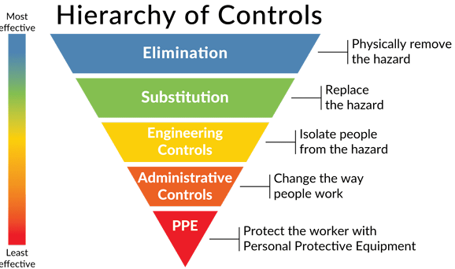

As the picture above describes, there are a wide range of possibilities when deciding which controls to implement. The goal should always be to implement the most effective method of control that is feasible. If multiple hazards are identified, priority should be given to the hazards with the greatest risk. For more information on how to utilize the hierarchy of controls, refer to pages 7-9 of the procedure.
- Note: Personal Protective Equipment
If Personal Protective Equipment (PPE) is identified as an appropriate control measure, a PPE Hazard Assessment must be completed to ensure the appropriate PPE is selected for the job, task, or activity. Employees must also be trained on how to effectively use the PPE.
PPE hazard assessments and trainings must be documented. This can be completed using the PPE Hazard Assessment and Selection Guide from the ESH web page.
Step 4: Monitor and Review
The final step is to monitor and review the assessment and the controls that were implemented. This is done to ensure that the controls are effective, or if additional or different control measures are necessary. Below are examples of critical times to review any new or existing control measures.
- When new employees or researchers are hired/brought on
- New machinery, tools, or equipment is introduced
- Following an incident or near-miss
- On a periodic basis, at least annually
Effectively identifying and controlling workplace hazards is a continuous process and is a critical part of an effective workplace safety and health program. Using the tools and templates provided will help you facilitate this process in your work area.
For any additional questions regarding hazard identification or performing risk assessments, contact ESH at esh@umbc.edu.

