Occupational Safety in Research - Compliance Guide
Occupational Safety Topic: Hazard Communication
Created 10/2024
Introduction:
Hazard Communication refers to the processes and procedures put into place to ensure that employees are aware of the chemicals they work with and the hazards that they may pose, so that they can be well-informed and protect themselves from those hazards.
Hazard Communication also commonly goes by “Haz Com”, or “Right to Know”. Hazard Communication processes and procedures at UMBC are largely driven from the OSHA Hazard Communication Standard, 1910.1200.
Hazard Communication Requirements
- Training
  - Those who handle or work with chemicals in any fashion must receive Haz Com training to understand chemical hazards and being able to identify and protect against them. This training is required initially, before handling or working with chemicals, and then every three (3) years afterwards. The training is offered online and can be completed through either Webnet or CITI.

  - Chemical users must be familiar with Safety Data Sheets (SDS), including how to read and understand them and how to access them. Paper copies of SDS’s are acceptable as long as they are readily available to the chemical users. UMBC also has an electronic online database for SDS access. Principal Investigators can be given access to this online database to be able to add, upload, or update SDS’s for their labs. Reach out to ESH for assistance with access to the SDS database. Instructions for accessing the online database can be found on ESH’s website (safety.umbc.edu) under Research Safety > SDS Online.

- Chemical Labeling – all chemicals must have appropriate labels.
  - Primary Label
    - A primary container is generally a large storage container such as a drum, or a tank, typically coming from the manufacturer. Primary containers containing a hazardous chemical must have a label affixed to it that states at a minimum:
      - Product name/identifier
      - Appropriate hazard warnings
      - Name and address of chemical manufacturer
    - In most cases, manufacturers will have these labels already applied to their containers when they are delivered. However, if a primary container does not come with an appropriate label, an appropriate primary container label must be created and applied.

  - Secondary Label
    - Chemicals that are transferred from a primary container to a different container, such as a smaller container like a bucket or jug, the new container must have a secondary container label.
    - The label must have at least:
      - Product name/identifier
      - General hazard information using words, pictures, or a combination.
Handwritten secondary labeling is acceptable as long as the necessary information is included and is legible. The information is taken from the primary container label or the SDS.
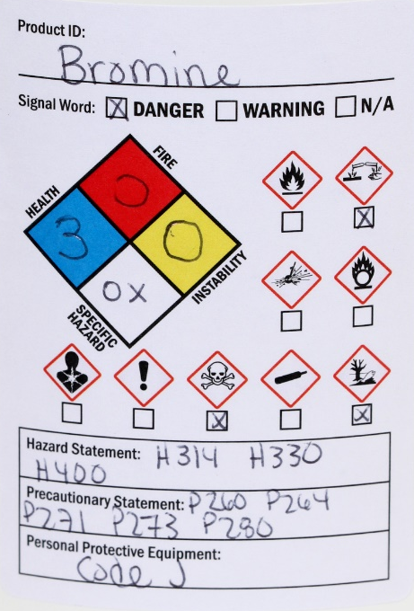
Below is an example of a write-on secondary container label.

- Chemical Inventory
  - Principal investigators and other lab management personnel shall maintain a current inventory of the chemicals in their areas. The inventory must include the name of the chemical, including the common name if applicable (such as Clorox) and the quantity. There is no specific format requirement for the inventory, as long as the necessary information is listed. Inventories must be submitted at least annually to ESH (esh@umbc.edu).

For more information on Hazard Communication or if there are any questions, please contact ESH at esh@umbc.edu.

